Chemokines, Cytokines and Soluble Factors Tested in RBM Rodent Map 1.6
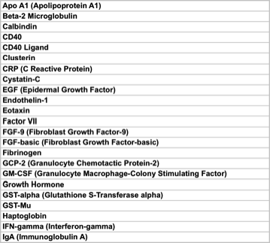 |  | 