S3 Appendix: Linguistic data

Table A: Linguistic information on the word forms used for Castanospermum australe within the sequence of Aboriginal languages covering the distribution of the species. Rows of the table are arranged in a geographical sequence from north to south (see Figure S1 for more precise location).

Subgroup | Language | Form | Comments | Source
Yidinyic | Yidiny | junggurra(a)  wirrum |  | Dixon [73]
 | Djabugay | yiwurra |  | Patz (unpublished observations)
Yalanjic | Gugu Yalanji | baway |  | Hershberger and Hershberger [74]
Dyirbalic | Ngadjan (dialect of Dyirbal) | ganyjuu |  | Ngadjonji online [70]
 | Dyirbal | mirrany |  | Dixon [71]
 | Warrgamay | wanga
Maric | Warungu | ganyjurr ‘bean tree’ | Possible loan from Ngadjan Dyirbal ganyjuu, or source of Dyirbal loan (direction unknown) | Tsunoda [72]
Waka-Kabi | Butchulla (Batyala) | mia |  | Bell [65]
Durubalic | Yagara | mai | General word for ‘food’ in many languages; could be semantic shift or error in source | ASEDA Vocabulary 0703
Bandjalangic | Numinbah (Yugambeh variety) | boggum |  | Gresty [66]
 | Githabul | bugam |  | Sharpe [67]
 | Waalubal (Bandjalang) | bugam ‘beanball’
Gumbainygiric | Gumbaynggir | binyjaalga |  | Morelli [68]
 | Yaygirr | wiguuli |  | Morelli [69]

Figure A: Distribution of Eastern Australian Aboriginal language subgroups.

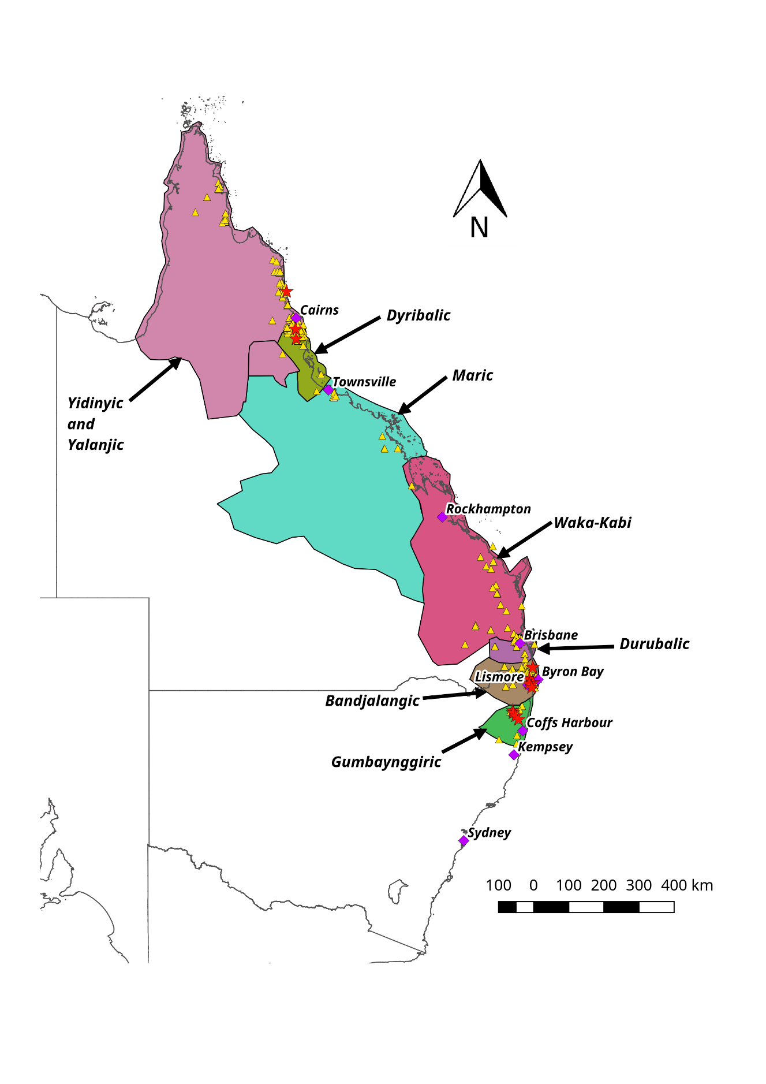

References:

- Bell J. A sketch grammar of the Badjala language of Gari (Fraser Island). http://cat.lib.unimelb.edu.au/search~S6?/dGram+negative+bacteria./dgram+negative+bacteria/-3%2C-1%2C0%2CB/frameset&FF=dgrammar+butchulla+language&1%2C1%2C. Cited 16 May 2017.
- Gresty JA. The Numinbah valley: its geography, history and Aboriginal associations. Queensland Geographical Journal. 1946; 51: 57-72.
- Sharpe MC. All Bundjalung and Yugambeh Dictionary (Armidale, NSW) https://margaretcsharpe.wordpress.com/. 2013. Cited 28 March 2017.
- Morelli S. Gumbaynggirr bijaarr jandaygam, ngaawa gugaarrigam: Gumbaynggirr dictionary and learner’s grammar, Muurrbay Aboriginal Language & Culture Co-operative. New South Wales: Nambucca Heads; 2008.
- Morelli S. Yaygirr. Muurrbay Aboriginal Culture Centre; 2001.
- Ngadjonji. Online vocabulary. http://www.earthsci.org/aboriginal/ngadjonji%20history/glossary/Ngadjon%20glossary.htm. Cited 28 March 2017.
- Dixon RM. The Dyirbal language of north Queensland. Cambridge: Cambridge University Press; 1972.
- Tsunoda T. A Grammar of Warrongo. Boston: Mouton Grammar Library 53 De Gruyter Mouton; 2011.
- Dixon RMW, T. Irvine, Words of our country: stories, place names and vocabulary in Yidiny, the Aboriginal language of the Cairns-Yarrabah region. University of Queensland Press; 1991.
- Hershberger HD, Hershberger R. Kuku-Yalanji Dictionary. Working papers of SIL-AAB, Series B Volume 7; 1986.

