The ARRIVE Guidelines Checklist
Animal Research: Reporting In Vivo Experiments
Carol Kilkenny¹, William J Browne², Innes C Cuthill³, Michael Emerson⁴ and Douglas G Altman⁵
¹The National Centre for the Replacement, Refinement and Reduction of Animals in Research, London, UK, ²School of Veterinary Science, University of Bristol, Bristol, UK, ³School of Biological Sciences, University of Bristol, Bristol, UK, ⁴National Heart and Lung Institute, Imperial College London, UK, ⁵Centre for Statistics in Medicine, University of Oxford, Oxford, UK.

 |  | ITEM | RECOMMENDATION | Section/  Paragraph
 |  |  |  | Title.
 |  |  |  | Abstract.
 | INTRODUCTION
 | 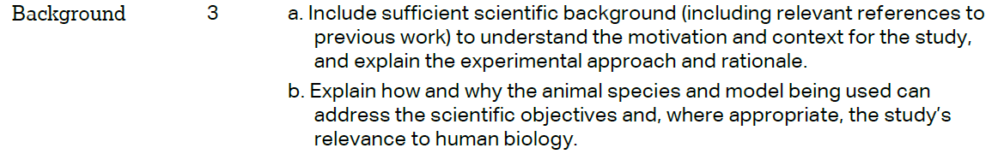 |  |  | Introduction/ 1st, 2nd paragraph. Introduction/3rd paragraph.
 |  |  |  | Introduction/ 4th paragraph.
 | METHODS
 |  |  |  | Materials and methods/ Institutional Animal Care and Use Committee (IACUC) Approval
 | 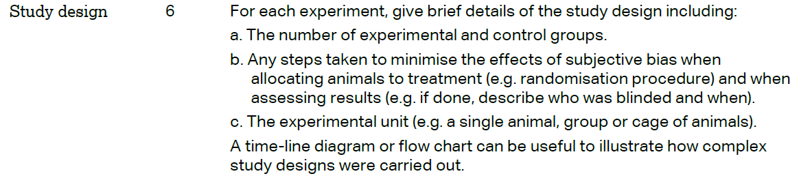 |  |  | Materials and methods/Mice experiments
 | 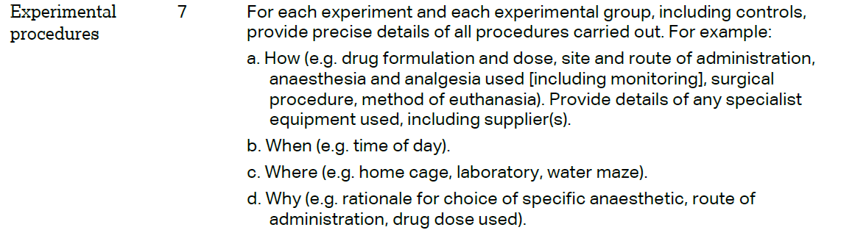 |  |  | Materials and methods/Mice experiments
 | 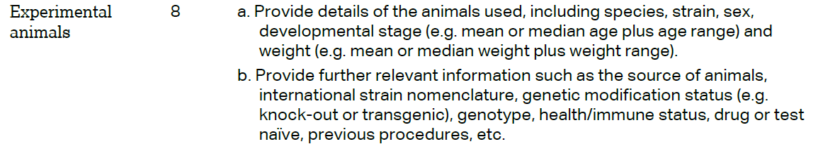 |  |  | Materials and methods/Mice experiments
The ARRIVE guidelines. Originally published in PLoS Biology, June 2010¹
 | 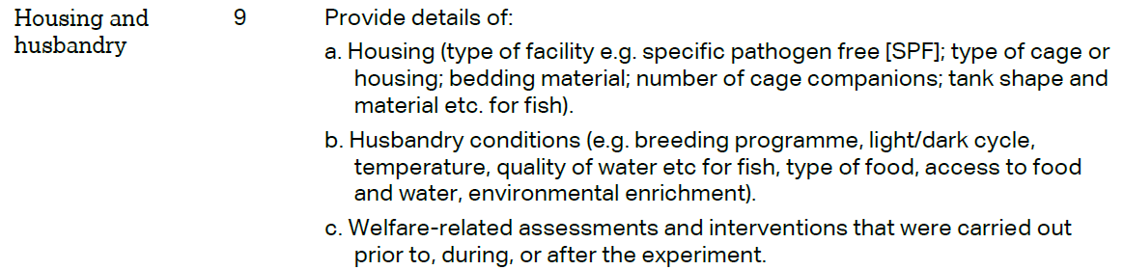 | Materials and methods/Mice experiments
 | 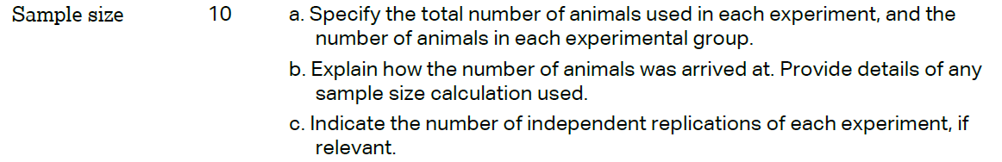 | Materials and methods/Mice experiments
 | 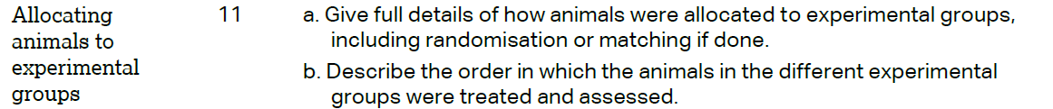 | Materials and methods/Mice experiments
 |  | Materials and methods/Mice experiments
 | 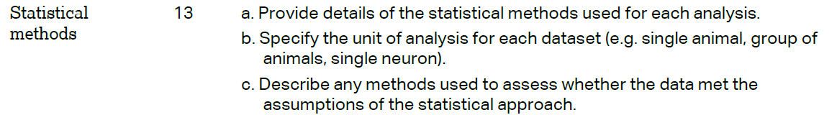 | Materials and methods/Statistical analyses
 | RESULTS
 |  | Results/ Type E bacteria reduce intestinal colonization by type A strains in-vivo.
 |  | Results/ Type E bacteria reduce intestinal colonization by type A strains in-vivo.
 |  | Results/ Type E bacteria reduce intestinal colonization by type A strains in-vivo.
 |  | Results/ Type E bacteria reduce intestinal colonization by type A strains in-vivo.
 | DISCUSSION
 | 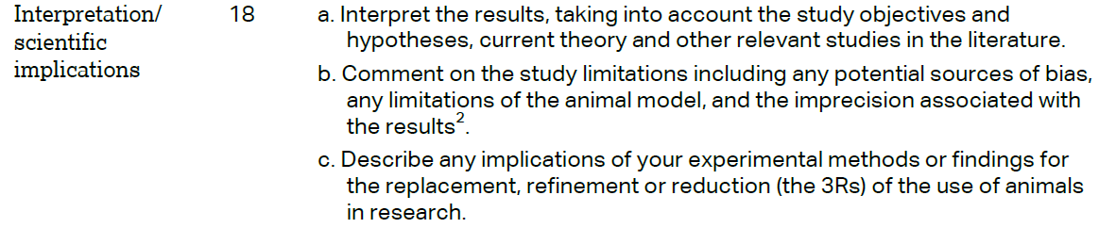 | Discussion/1st, 2nd, 3rd paragraph.  Discussion/4th, 5th paragraph.  Discussion/4th paragraph.
 |  | Discussion/ 2nd, 3rd paragraph.
 |  | Acknowledgements
