S2 Appendix. ROC curves from multiple logistic regressions
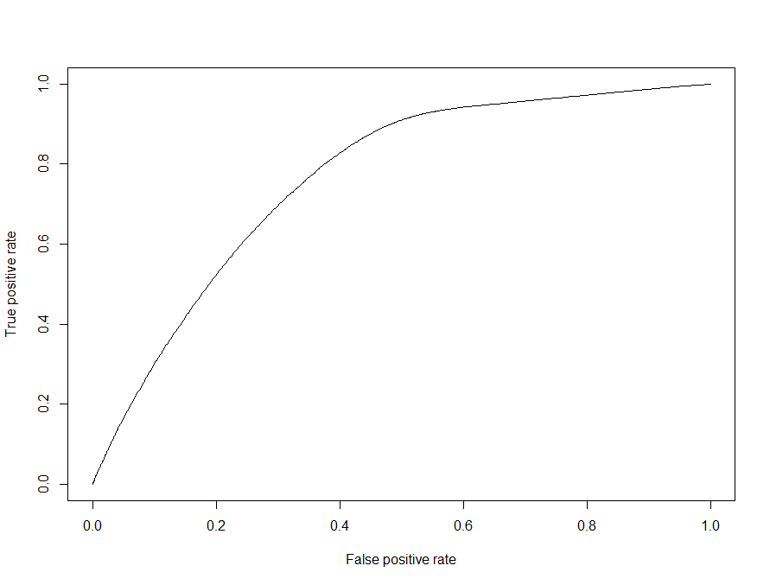
Fig A. ROC Curve - death as dependent variable and age, gender, race as independent variables. The prediction error is 29.7% and the area under the ROC curve is 0.76

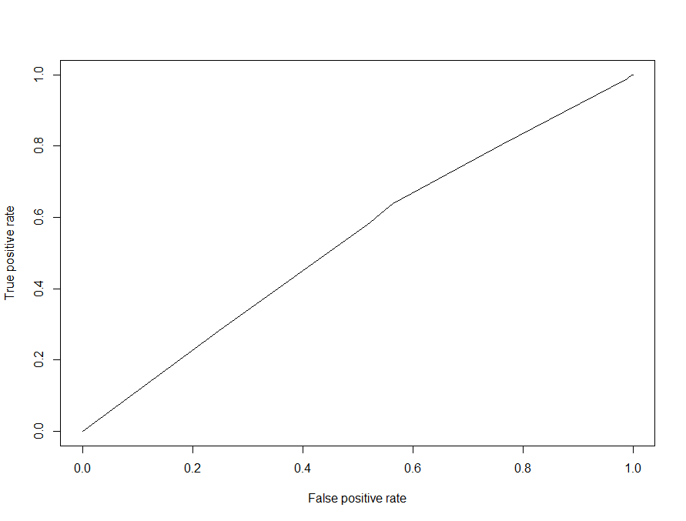
Fig B. ROC Curve - death as dependent variable and gender, race as independent variables. The prediction error is 46.7% and the area under the ROC curve is 0.54

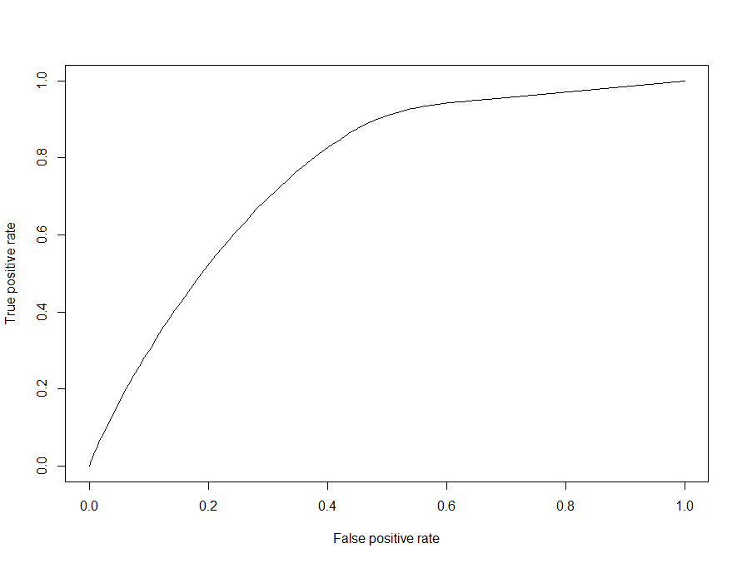
Fig C. ROC Curve - death as dependent variable and age as independent variable. The prediction error is 29.7% and the area under the ROC curve is 0.76

