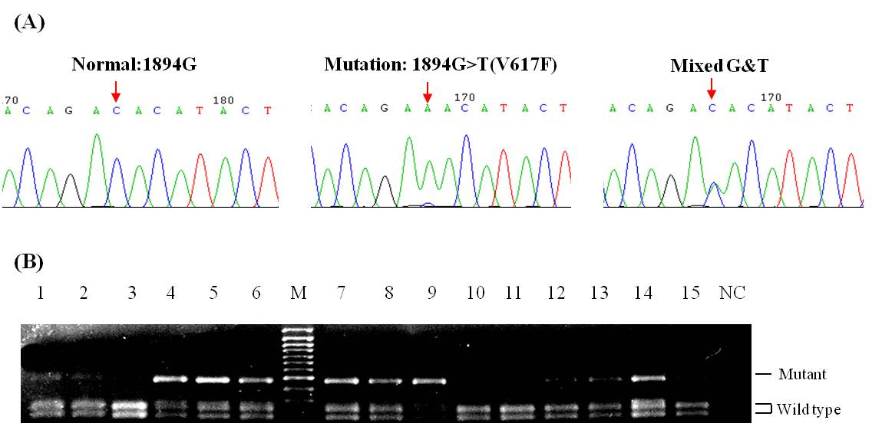
Figure S2. Detection of JAK2 mutation using direct sequencing (A) and REA (B). (A) Reverse chromatogram showed wild-type sequence and G toT mutation in JAK2 wild-type pattern in a patient with PMF (left panel). Mixed and mutant sequences in two patients with PV (center and right panel). Arrows indicate the relevant base. (B) JAK2 BsaXI digestion were used to genotype DNA from unfractionated peripheral blood leucocytes from patients with ET.

