Table S1. Comparison of those with and without cord DNA methylation and with and without three year DNA methylation
 | Without Cord DNA Methylation |  | With Cord DNA Methylation |  | Without Three-year Methylation |  | With Three-year DNA Methylation
 | N | % | N | % | N | % | N | %
Maternal Education
<HS | 228 | 40.28 | 100 | 35.97 | 45 | 39.82 | 55 | 33.33
HS | 201 | 35.51 | 96 | 34.53 | 29 | 25.66 | 67 | 40.61
>HS | 137 | 24.2 | 82 | 29.5 | 39 | 34.51 | 43 | 26.06
Marital Status
Married/Cohab. | 412 | 73.44 | 206 | 75.18 | 87 | 78.38 | 24 | 24.62
Unmarried | 149 | 26.56 | 68 | 24.82 | 119 | 73.01 | 44 | 26.99
Material Hardship
Yes | 266 | 47.00 | 120 | 43.01 | 48 | 42.11 | 72 | 43.64
No | 300 | 53.00 | 159 | 56.99 | 66 | 57.89 | 93 | 56.36
Public Assistance
Yes | 507 | 90.05 | 255 | 91.73 | 100 | 88.5 | 155 | 93.94
No | 56 | 9.95 | 23 | 8.27 | 13 | 11.5 | 10 | 6.06
Ethnicity
Dominican | 355 | 62.83 | 193 | 69.18 | 82 | 71.93 | 111 | 67.27
African American | 210 | 37.17 | 86 | 30.82 | 32 | 28.07 | 54 | 32.73
BMI
Underweight | 35 | 6.18 | 14 | 5.02 | 5 | 4.39 | 9 | 5.45
Normal weight | 268 | 47.35 | 125 | 44.8 | 51 | 44.74 | 74 | 44.85
Overweight | 115 | 20.32 | 62 | 22.22 | 22 | 19.3 | 40 | 24.24
Obese | 148 | 26.15 | 78 | 27.96 | 36 | 31.58 | 42 | 25.45
ETS
Yes | 189 | 33.87 | 93 | 33.94 | 35 | 31.25 | 58 | 35.8
No | 369 | 66.13 | 181 | 66.06 | 77 | 68.75 | 104 | 64.2
Former smoker
Yes | 117 | 22.9 | 47 | 18.15 | 21 | 19.63 | 26 | 17.11
No | 394 | 77.1 | 212 | 81.85 | 86 | 80.37 | 126 | 82.89
Sex
Male | 222 | 49.33 | 130 | 46.59 | 52 | 45.61 | 78 | 47.27
Female | 228 | 50.67 | 149 | 53.41 | 62 | 54.39 | 87 | 52.73
 | N | mean (SD) | N | mean (SD) | N | mean (SD) | N | mean (SD)
Maternal Height (in) | 557 | 63.0 (4.0) | 277 | 63.7 (3.5) | 112 | 63.0 (3.8) | 165 | 64.1 (3.2)
Pre-pregnancy weight | 557 | 146.0 (37.3) | 270 | 151.1 (38.1) | 111 | 148.8 (36.3) | 159 | 152.7 (39.3)
Weight gain | 406 | 36.8 (71.0) | 252 | 34.3 (16.1) | 100 | 30.9 (15.8) | 152 | 36.5 (16.0)
Maternal Age | 521 | 25.2 (4.9) | 279 | 25.1 (4.8) | 100 | 2.3 (2.5) | 159 | 2.5 (2.1)
Total PAH* | 434 | 2.34 (2.03) | 268 | 2.44 (2.29) | 114 | 25.0 (4.7) | 165 | 25.1 (4.9)

Table S2. Factors predicting absolute value of the change in DNA methylation over time (change = |log-three year meth – log-cord meth|)
 | Beta | Lower 95% CI | Upper 95% CI
Maternal Education
HS (vs. no HA) | -0.213 | -0.921 | 0.496
>HS (vs. no HA) | -0.660 | -1.465 | 0.145
Married/Cohab. (vs. unmarried) | -0.005 | -0.751 | 0.741
Material Hardship | 0.056 | -0.546 | 0.659
African American (vs. Dominican) | 0.285 | -0.449 | 1.020
Prenatal ETS | 0.097 | -0.638 | 0.832
Former smoker | -0.588 | -1.323 | 0.146
Male (vs. female) | 0.005 | -0.579 | 0.588
Multiparous (vs. nulliparous) | 0.066 | -0.621 | 0.753
Pre-pregnancy BMI | -0.056 | -0.108 | -0.004
Weight Gain | -0.008 | -0.029 | 0.012
Maternal Age | -0.022 | -0.099 | 0.055
Total PAH (ln-adjusted) | 0.142 | -0.269 | 0.553
Breast Fed | 0.029 | 0.000 | 0.057
ETS at 3 yrs | -0.185 | -0.978 | 0.607
Cord methylation | -0.011 | -0.239 | 0.218
Birthweight | 0.000 | -0.001 | 0.001
Gestational age | -0.091 | -0.333 | 0.151
R2 | 0.140
Adjusted R2 | 0.000

Figure S1. Partial regression plots from multiple regression analysis that test the
association between DNA methylation (cord or three year, as indicated) and pre-pregnancy maternal body mass index (BMI).
- All cord DNA methylation
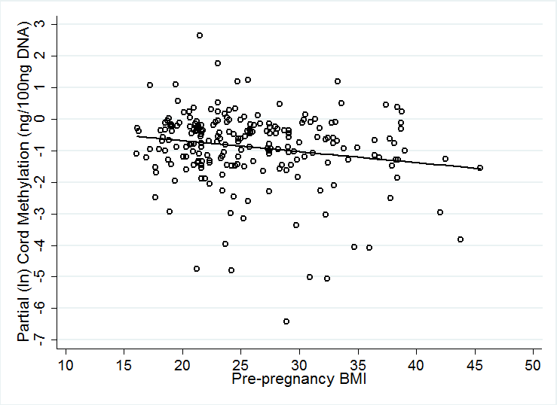
- Cord DNA methylation (subset with measured three year DNA methylation)
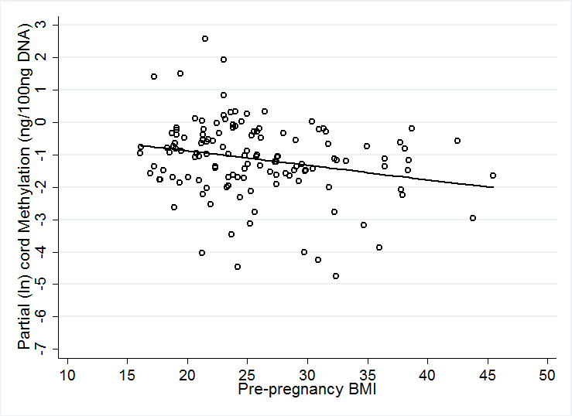

- Three year DNA methylation
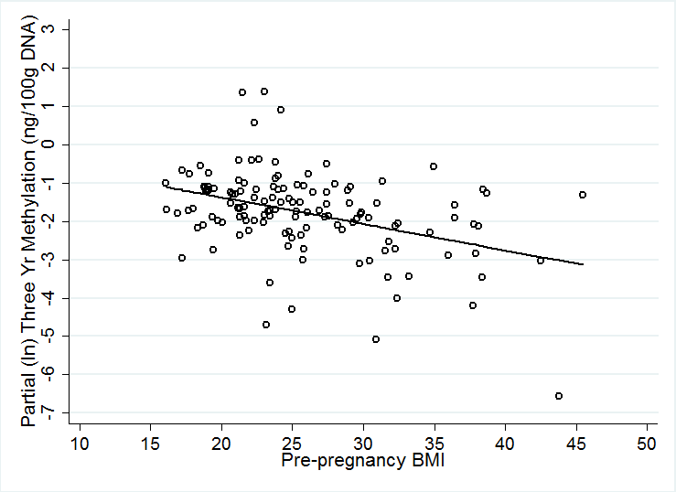
- Three year DNA methylation, adjusting for cord DNA methylation
