S5 Text. The impact of simplifications in the leaf geometry and transport processes on $A_{N}$ and $f_{rec}$

The model described in the main text of this manuscript makes various simplifications about both the leaf structure and the processes that take place in the leaf. These simplifications are:
1). It is assumed that (photo)respiration takes place in a cytosol compartment, rather than a loose mitochondrion in this compartment.
2). It is assumed that the light absorption does not vary with the leaf depth.
3). It is assumed that there is full CO₂ transport facilitation by carbon anhydrase.
4). It is assumed that $q$, $S_{m}/S$, $S_{c}/S_{m}$, $t_{wall}$, $t_{cyt}$ and $t_{str}$ do not vary in the $z$-dimension.
In Supplementary text 4, it is already shown that modelling loose mitochondria in either the inner cytosol or outer cytosol hardly affects the values of $A_{N}$ and $f_{rec}$ predicted by the default model. This demonstrates that, in the case of tomato, simplification 1 is reasonable. The aim of the current supplementary text is to show that the remaining three limitations also will not affect $A_{N}$. This will be done by comparing the values of $A_{N}$ predicted by the model in this study with the values predicted by the model in [1] that does not have simplifications 2, 3, and 4.

S5.1 Summary description 3-D model in [1]
The model described in [1] describes CO₂ transport, production, and consumption in tomato leaves. The leaf geometry is a discretized 3-D tomography [1], which was obtained by X-ray synchrotron microscopy [2]. Next, the mesophyll cells from the obtained 3-D leaf geometry were compartmented into a chloroplast layer that is exposed to the intercellular air space,
cytosol layer, and a vacuole. Finally, the chloroplast layer was subdivided into spherical chloroplasts and cytosol compartments in between. Additionally, the remaining compartments were subdivided into intercellular air space and the epidermis. Monte-Carlo ray tracing was applied to calculate the light absorption gradient within this geometry [3]. Stomatal opening was modelled by making a cylindrical air hole in the epidermis that connects the intercellular air space with the ambient air. This air hole is the stomatal aperture. Over this discretized geometry, a system of partial differential equations for CO₂ transport and HCO₃⁻ transport were solved. The equations that were used are listed below; the notation of symbols is adjusted in such a way that the notation is the same as the symbols used in the 2-D model from the current study:

$$\begin{aligned}∇∙D_{{CO}_{2},gas}∇\left[{CO}_{2}\right]=0\#\left(S5.1\right)\end{aligned}$$
$$\begin{aligned}∇∙{p_{eff,i}ζ_{i}D}_{{CO}_{2},water}∇\left[{CO}_{2}\right]-w_{i}+r_{p,i}+r_{d,i}-B=0\#\left(S5.2\right)\end{aligned}$$
$$\begin{aligned}∇∙{p_{eff,i}ζ_{i}D}_{{HCO}_{3},water}∇\left[{HCO}_{3}\right]+B=0\#\left(S5.3\right)\end{aligned}$$

where $B$ is the conversion rate of CO₂ into HCO₃⁻. The subscript $i$ indicates that the value depends on the compartment. $D_{{CO}_{2},gas}$ is the diffusion coefficient of CO₂ in the gas phase.
For the simulations with the 3-D model that are considered in this supplementary text, it is assumed that CO₂ transport is facilitated by carbon anhydrases in the cytosol and the stroma. In the presence of carbon anhydrases, $B$ was represented as [1,4]:

$$\begin{aligned}B=\frac{k_{CA}\left[CA\right]\left(\left[{CO}_{2}\right]-\frac{\left[H^{+}\right]\left[{HCO}_{3}^{-}\right]}{K_{eq}}\right)}{K_{CA,{CO}_{2}}+\frac{K_{CA,{CO}_{2}}\left[{HCO}_{3}^{-}\right]}{K_{CA,{HCO}_{3}^{-}}}+\left[{CO}_{2}\right]}\#\left(S5.4\right)\end{aligned}$$

where $k_{CA}$, $K_{eq}$, and $\left[CA\right]$ are the turnover rate, the equilibrium constant and the concentration of carbon anhydrases, respectively. $K_{CA,{CO}_{2}}$ and $K_{CA,{HCO}_{3}^{-}}$ are the Michaelis-Menten constants of hydration and dehydration, respectively. Equation (S5.4) implicitly assumes that the further dehydration of HCO₃⁻ into CO₃²⁻ is negligible under the pH levels in leaves.

S5.2 Quantification parameter values in the 2-D model and in the 3-D model
The parameter values in equation (S5.1 - S5.4) can be found in the supplementary material of the study in [1]. For the simulations in the current study, the same parameter values were used for $s$, ${S_{c\backslash O} }^{*}$, $R_{d}$, $V_{cmax}$, and $T_{p}$ as by [1]. For the anatomical parameters, it was assumed that $S_{m}/S=16$, $t_{str}=2.5 μm$, and $t_{cyt}=250 nm$. The values $t_{wall}=200 nm$ and $S_{c}/S_{m}=0.90$ were adopted from [1]. In the 3-D model in [1], it is assumed that the radius of the stomatal pore does not change with increased $C_{a}$. Unlike the 2-D model in the current study, the 3-D model does not use stomatal conductance as an implicit input value in the 3-D model. In order to use the same stomatal conductance as input for the 2-D model as for the model in [1], first $C_{i}$ and $A_{N}$ were calculated for each value of $C_{a}$ from the solution of the 3-D model:

$$\begin{aligned}W=\left(\iiint_{Stroma}{w dx dy dz}\right)S^{-1}\#\left(S5.5\right)\end{aligned}$$
$$\begin{aligned}R_{p}=\left(\iiint_{Stroma}{\frac{wγ^{*}}{\left[{CO}_{2}\right]} dx dy dz}\right)S^{-1}\#\left(S5.6\right)\end{aligned}$$
$$\begin{aligned}R_{d}=\left(\iiint_{Cytosol}{r_{d} dx dy dz}\right)S^{-1}\#\left(S5.7\right)\end{aligned}$$
$$\begin{aligned}C_{i}=RT\left(\iiint_{Intercellular air space}{\left[{CO}_{2}\right]} dx dy dz\right){\left(\iiint_{Intercellular air space}{dx dy dz} \right)}^{-1}\#\left(S5.8\right)\end{aligned}$$
$$\begin{aligned}A_{N}=W-R_{p}-R_{d}\#\left(S5.9\right)\end{aligned}$$
$$\begin{aligned}g_{s}=\frac{A_{N}}{C_{a}-C_{i}}\#\left(S5.10\right)\end{aligned}$$

S5.3 Comparison of simple 2-D model to complex 3-D model
For each combination of $C_{a}$ calculated values of $g_{s}$ (equations (S5.5-S5.10)) were used as input values for the 2-D model. Furthermore, the values of $J$, calculated by the 3-D model, were used as input for the 2-D model. The calculations are done for three of the six tomato leaf types examined in [1]. These leaf types are “Admiro lower leaf”, “Doloress lower leaf”, and “Growdena lower leaf”. Fig A shows diagrams, in which the values of $A_{N}$ for each value of $C_{a}$ predicted by the 2-D model are plotted against $A_{N}$ values for the same $C_{a}$ predicted by the 3-D model. This shows that all values of $A_{N}$, with a possible exception of the highest values of $C_{a}$ ($C_{a}=100 Pa$ and $C_{a}=150 Pa$) for Doloress lower leaf and Growdena lower leaf, are about the same for both the 2-D and the 3-D model.

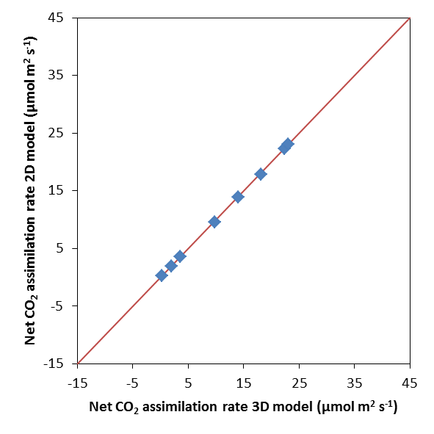  A | 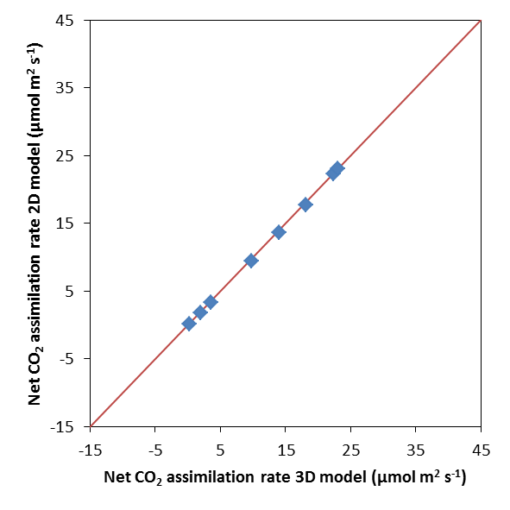  B
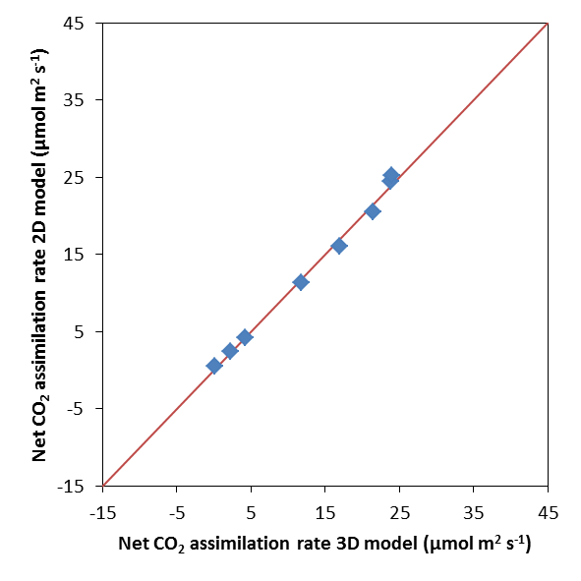  D  C | 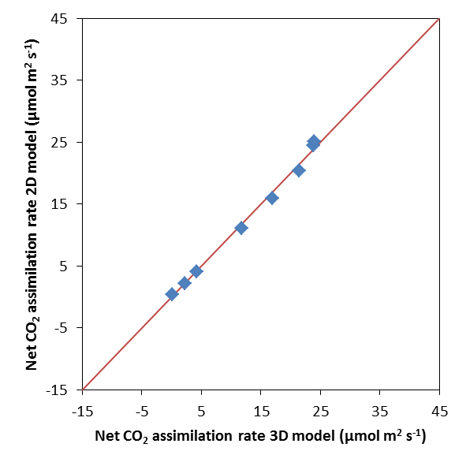
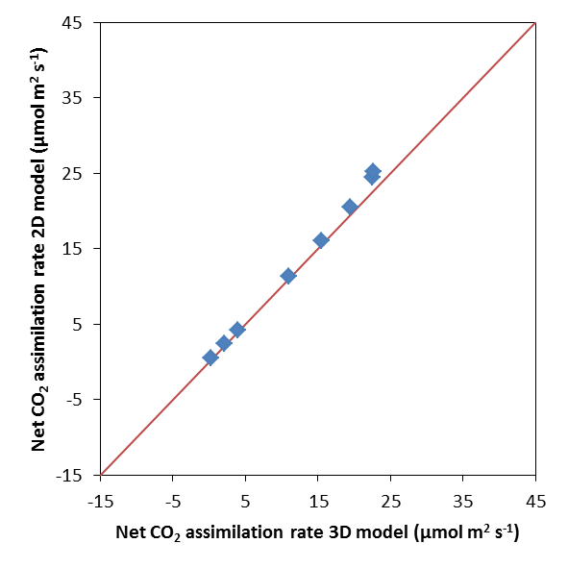  F  E | 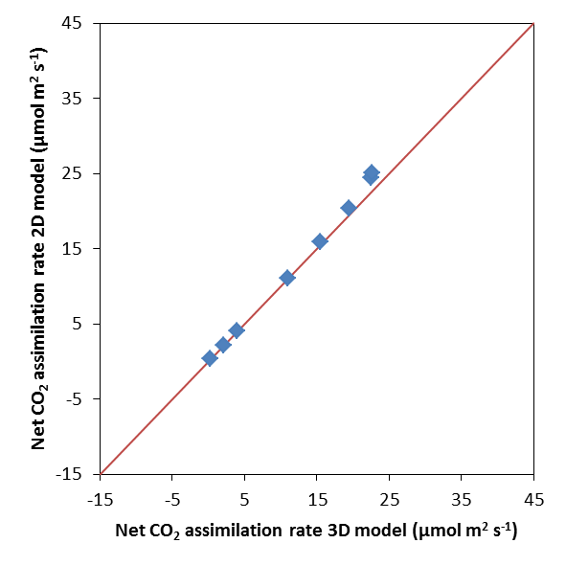
Fig A: Net CO₂ assimilation rate predicted by the 2-D model is plotted against the net CO₂ assimilation rate predicted by the 3-D model in [1] for three leaf types. These are “Admiro lower leaf” (A, D), “Doloress lower leaf” (B, E), “Growdena lower leaf” (C, F). Simulation with the 2-D model were run for two scenarios; (photo)respiratory CO₂ release takes place in the inner cytosol (A-C) or in the cytosol gaps (D-F). The solid line is the 1 to 1 line.

References
1. Ho QT, Berghuijs HNC, Watté R, Verboven P, Herremans E, et al. (2016) 3-D microscale modeling of CO₂ transport and light propagation in tomato leaves enlightens photosynthesis. Plant, Cell & Environment 39: 50-61.
2. Verboven P, Herremans E, Helfen L, Ho QT, Abera M, et al. (2015) Synchrotron X-ray computed laminography of the three-dimensional anatomy of tomato leaves. Plant Journal 81: 169-182.
3. Watté R, Aernouts B, Van Beers R, Herremans E, Ho QT, et al. (2015) Modeling the propagation of light in realistic tissue structures with MMC-fpf: a meshed Monte Carlo method with free phase function. Optics Express 23: 17467-17486.
4. Tholen D, Zhu XG (2011) The mechanistic basis of internal conductance: a theoretical analysis of mesophyll cell photosynthesis and CO₂ diffusion. Plant Physiology 156: 90-105.

