Sensitivity analysis by restricting studies with high risk of bias as measured by the New Castel Ottwa Scale (NOS) for observational studies
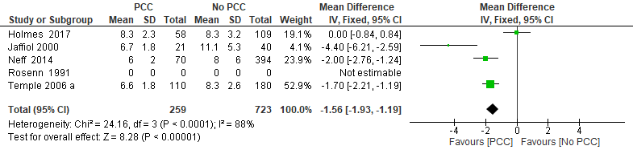
Supplementary Fig 1. Mean gestational age at the time of the first antenatal visit from four studies of women with pre-existing diabetes mellitus who did or did not receive preconception care, one study with high risk of bias is not estimated.
The black diamond represents the pooled difference estimate. Heterogeneity is quantified by I² statistics, an I² value ≥ 50 indicates substantial heterogeneity. Estimated results are presented as mean difference with 95% Confidence Interval. PCC= Preconception care; No PCC= No preconception care; CI= Confidence intervals.

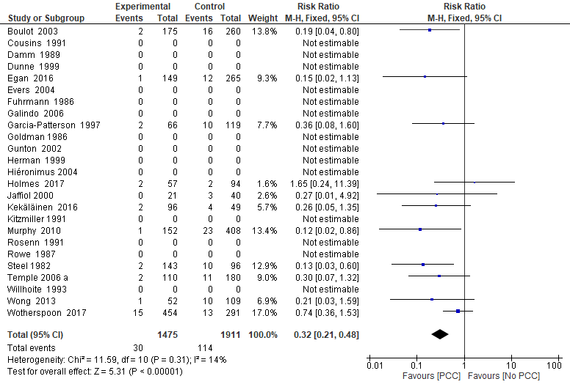
Supplementary Fig 2. Risk ratio for congenital malformation from 11 studies of women with pre-existing diabetes mellitus who did or did not receive preconception care, 14 studies with high risk of bias are not estimated.
The black diamond represents the pooled risk estimate. Heterogeneity is quantified by I² statistics, an I² value ≥ 50 indicates substantial heterogeneity. Estimated results are presented as risk ratio with 95% Confidence Interval. PCC= Preconception care; No PCC= No preconception care; CI= Confidence intervals.

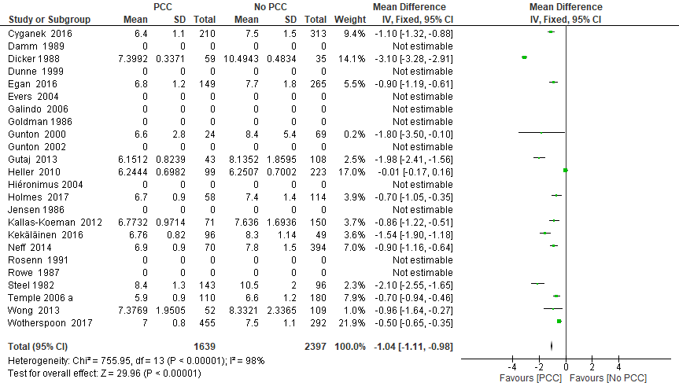
Supplementary Fig 3. First trimester mean value of glycosylated haemoglobin (HbA1c) from 14 studies of women with pre-existing diabetes mellitus who did or did not receive preconception care, 10 studies with high risk of bias are not estimated.
The black diamond represents the pooled difference estimate. Heterogeneity is quantified by I² statistics, an I² value ≥ 50 indicates substantial heterogeneity. Estimated results are presented as mean difference with 95% Confidence Interval. PCC= Preconception care; No PCC= No preconception care; CI= Confidence intervals.

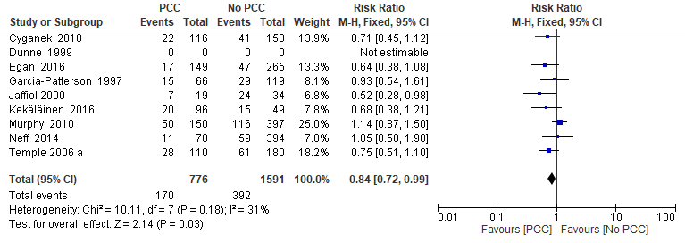
Supplementary Fig 4. Risk ratio for preterm delivery from eight studies of women with pre-existing diabetes mellitus who did or did not receive preconception care, one study with high risk of bias is not estimated.
The black diamond represents the pooled risk estimate. Heterogeneity is quantified by I² statistics, an I² value ≥ 50 indicates substantial heterogeneity. Estimated results are presented as risk ratio with 95% Confidence Interval. PCC= Preconception care; No PCC= No preconception care; CI= Confidence intervals.

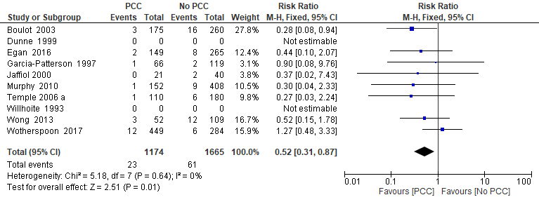
Supplementary Fig 5. Risk ratio for perinatal mortality from eight studies of women with pre-existing diabetes mellitus who did or did not receive preconception care, two studies with high risk of bias are not estimated.
The black diamond represents the pooled risk estimate. Heterogeneity is quantified by I² statistics, an I² value ≥ 50 indicates substantial heterogeneity. Estimated results are presented as risk ratio with 95% Confidence Interval. PCC= Preconception care; No PCC= No preconception care; CI= Confidence intervals.

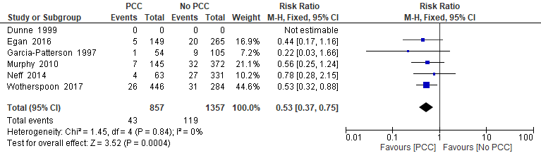
Supplementary Fig 6. Risk ratio for small for gestational age from five studies of women with pre-existing diabetes mellitus who did or did not receive preconception care, one study with high risk of bias is not estimated.
The black diamond represents the pooled risk estimate. Heterogeneity is quantified by I² statistics, an I² value ≥ 50 indicates substantial heterogeneity. Estimated results are presented as risk ratio with 95% Confidence Interval. PCC= Preconception care; No PCC= No preconception care; CI= Confidence intervals.

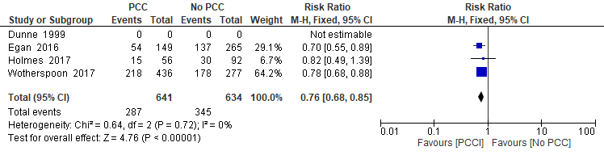
Supplementary Fig 7. Risk ratio for neonatal intensive care admission from three studies of women with pre-existing diabetes mellitus who did or did not receive preconception care, one study with high risk of bias is not estimated.
The black diamond represents the pooled risk estimate. Heterogeneity is quantified by I² statistics, an I² value ≥ 50 indicates substantial heterogeneity. Estimated results are presented as risk ratio with 95% Confidence Interval. PCC= Preconception care; No PCC= No preconception care; CI= Confidence intervals.

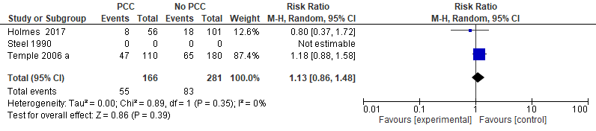
Supplementary Fig 8. Risk ratio for maternal hypoglycemia from three studies of women with pre-existing diabetes mellitus who did or did not receive preconception care.
Data of Steel 1990 were not estimated in the analysis. The large blue square represents the estimate effect of the study with he highest weight and very precise 95% CI. The black diamond represents the pooled risk estimate. Heterogeneity is quantified by I² statistics, an I² value ≥ 50 indicates substantial heterogeneity. Estimated results are presented as risk ratio with 95% Confidence Interval. PCC= Preconception care; No PCC= No preconception care; CI= Confidence intervals.

