S1 Fig. Histogram of the duration between ECG recordings in the same patient

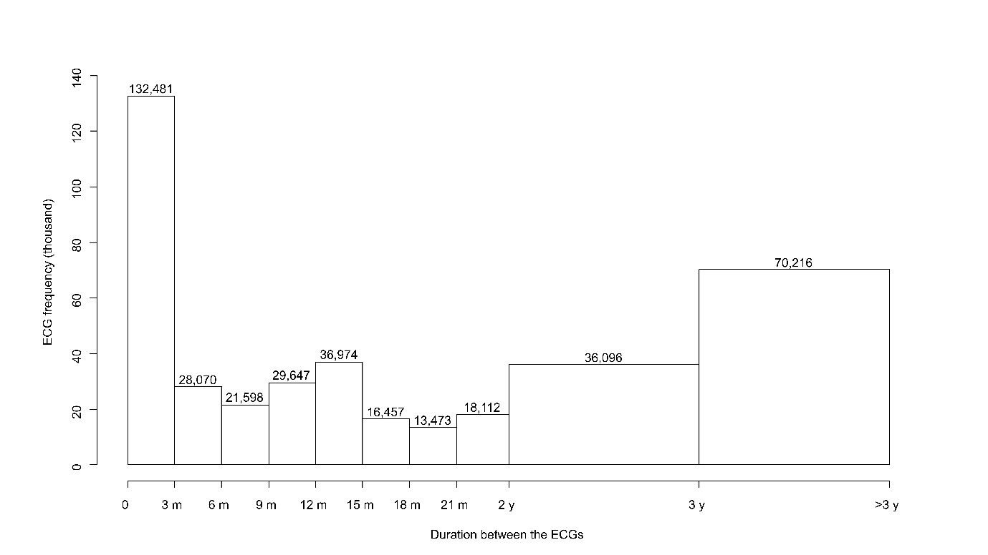
Abbreviations: m, months; y, years.

