Table S4. Tandem mass spectrometry analysis of ring-opened daptomycin by Paenibacillus lautus LC231. The observed ions are highlighted in bold.

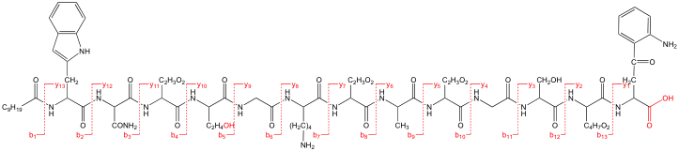
Ions | m/z | Ions | m/z
b13 | 1430.64 | y13 | 1484.59
b12 | 1287.59 | y12 | 1298.51
b11 | 1200.44 | y11 | 1184.47
b10 | 1143.53 | y10 | 1069.44
b9 | 1028.30 | y9 | 968.40
b8 | 957.17 | y8 | 911.37
b7 | 842.44 | y7 | 797.29
b6 | 728.24 | y6 | 682.27
b5 | 671.34 | y5 | 611.23
b4 | 570.29 | y4 | 496.25
b3 | 455.27 | y3 | 439.18
b2 | 341.22 | y2 | 352.15
b1 | 155.14 | y1 | 209.09

