Figure S3: PtdCho and GPCho are decreased in Chdh-/- sperm

A
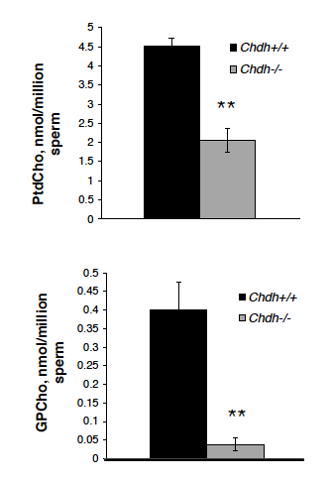
B

