S2 Fig. Bar plots of diagnostic category versus parameter estimates for precuneus/cuneus activation.

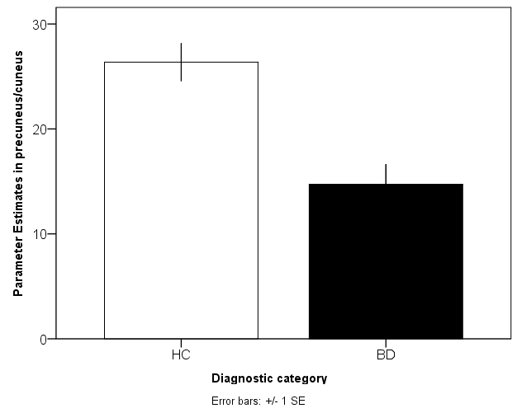

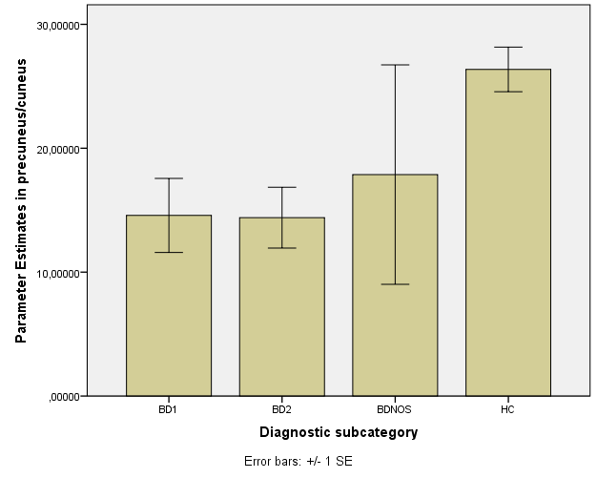

S2 Fig. Bipolar disorder cases (N = 85) show decreased BOLD activation in cuneus/precuneus (x = 10, y = -68, z = 22) compared to healthy controls (N = 121) at whole-brain level (z = 2.3) for the Negative Faces > Shapes contrast. Z max = 3.89, Cluster size = 818, P = 0.00012. Parameter estimates have been selected for cluster mean value.
Abbreviations: BD, bipolar disorder; NOS, not otherwise specified.

