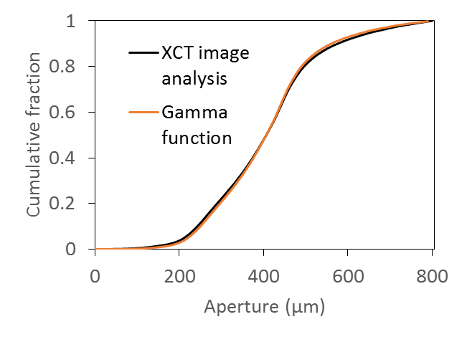
S3 Fig. Cumulative fraction of aperture size from computational segmented fracture and calculated gamma function, Eqn 14.

