Antimicrobial activity of methanolic extracts of Vernonia cinerea against Xanthomonas oryzae and identification of their compounds using in silico techniques

Tushar Joshi¹, Satish Chandra Pandey^{1,2}, Priyanka Maiti³, Manish Tripathi⁴, Ashutosh Paliwal¹, Mahesha Nand⁶, Priyanka Sharma⁵, Mukesh Samant², Veena Pande¹, Subhash Chandra⁴

- Department of Biotechnology, Bhimtal campus, Bhimtal 263136, Kumaun University Uttarakhand, India

- Cell in Molecular Biology laboratory, Department of Zoology, SSJ University, Almora-263601, Uttarakhand, India.

- Centre for Environmental Assessment & Climate Change, G. B. Pant National Institute of Himalayan Environment, Kosi-Katarmal, Almora-263 643, Uttarakhand, India, priyankamaiti.06@gmail.com (P. M.)

- Computational Biology & Biotechnology Laboratory, Department of Botany, SSJ Unversity, Almora 263601, Uttarakhand, India

- Department of Botany, Kumaun University, D.S.B Campus, Nainital 263001, Uttarakhand, India

- Environmental Information System on Himalayan Ecology, G.B. Pant National Institute of Himalayan Environment, Kosi‑Katarmal, Almora, Uttarakhand 263 643, India.

S1 Fig - The in vitro antibacterial activity of different concentrations of whole plant extract of V. cinerea against Xanthomonas oryzae pv oryzae (Xoo). (A) Plate (qualitative) assay using methanolic extract at the concentration of 25, 50, and 100 μg/mL (B) positive control tetracycling (1 μg/mL) (C) negative control DMSO (0.7%)
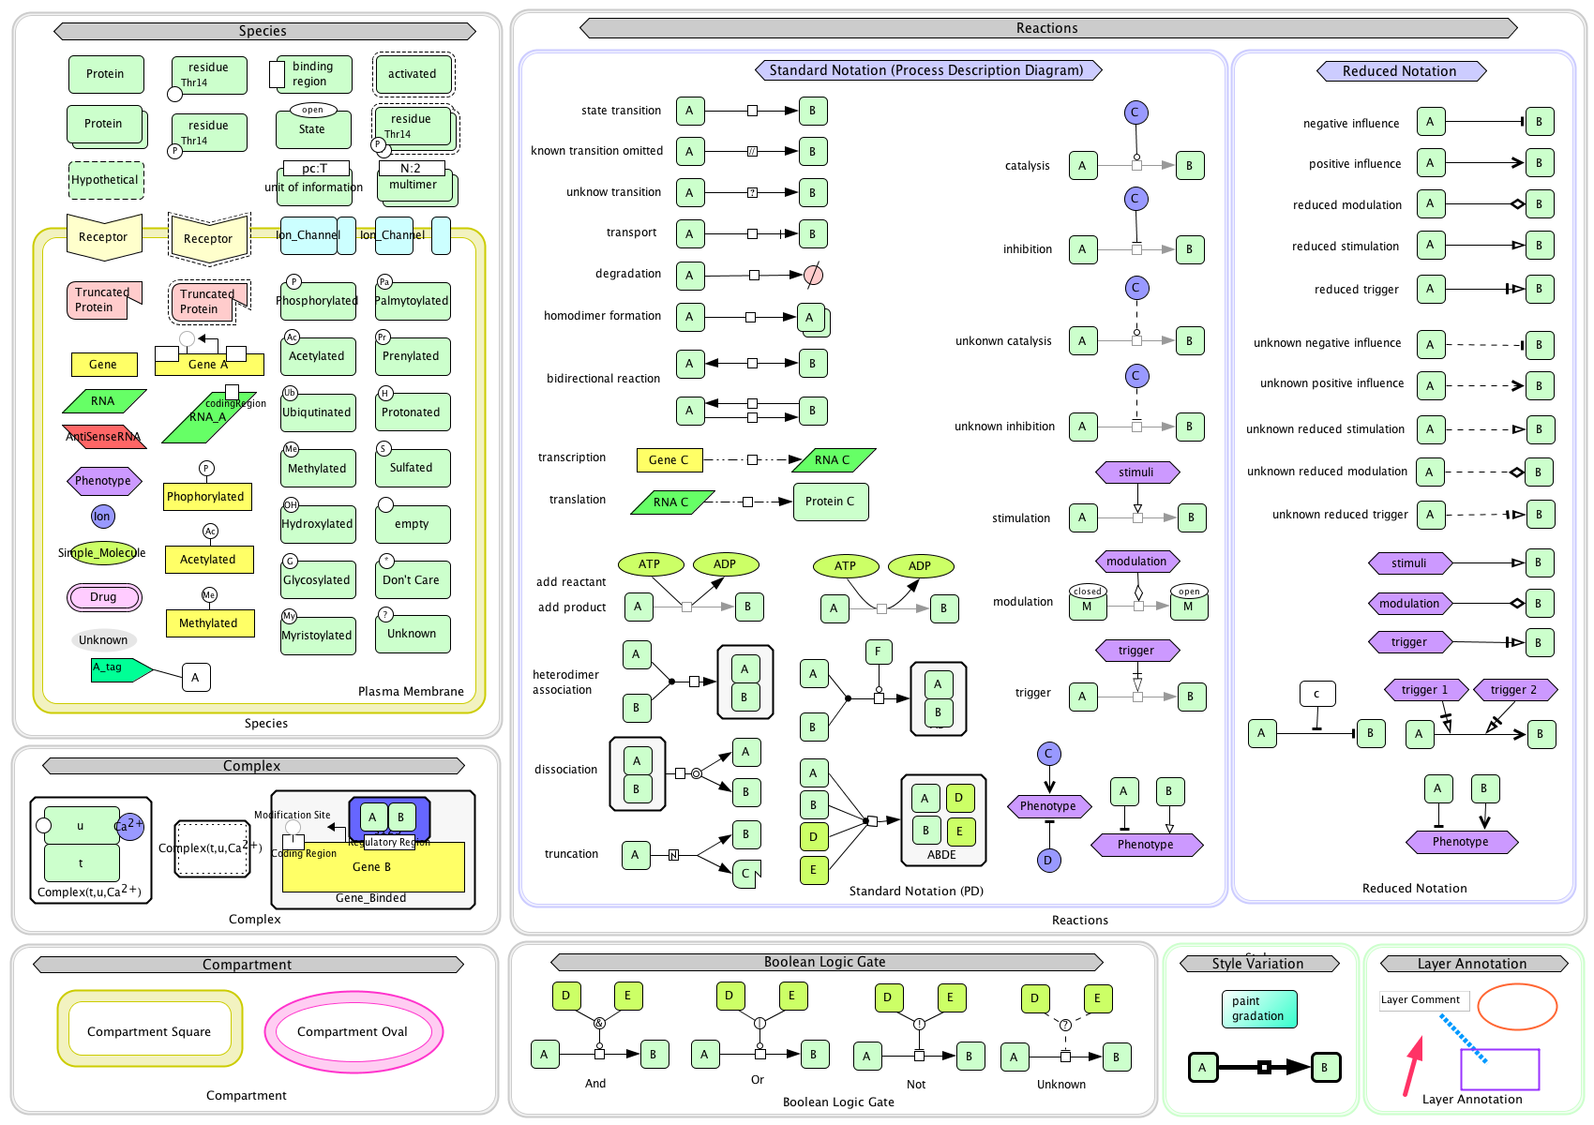

S2 Fig - System Biology Graphical Notation (SBGN) Symbols used in Cell designer 4.1 for modeling of drug inhibition activity on Ddl and PDF enzymes.

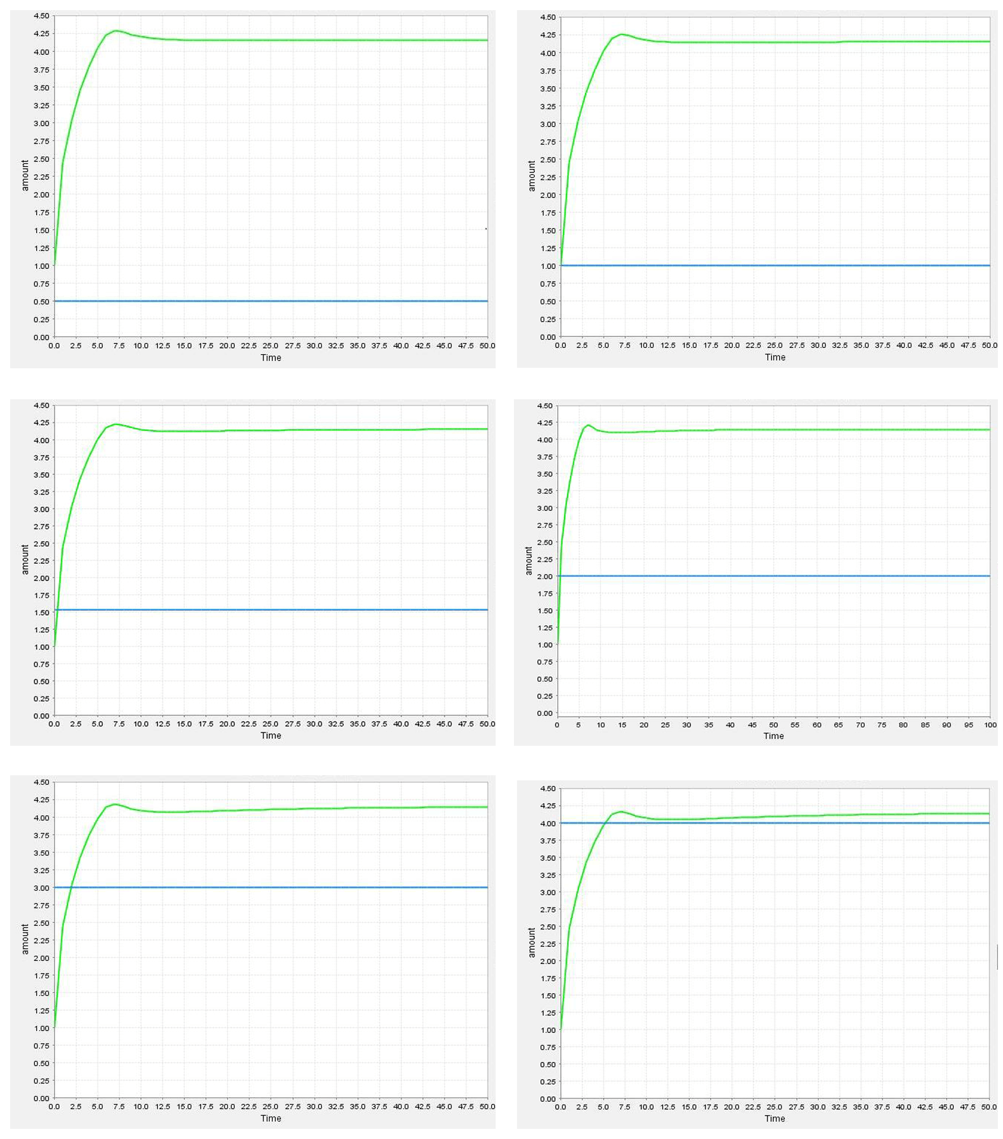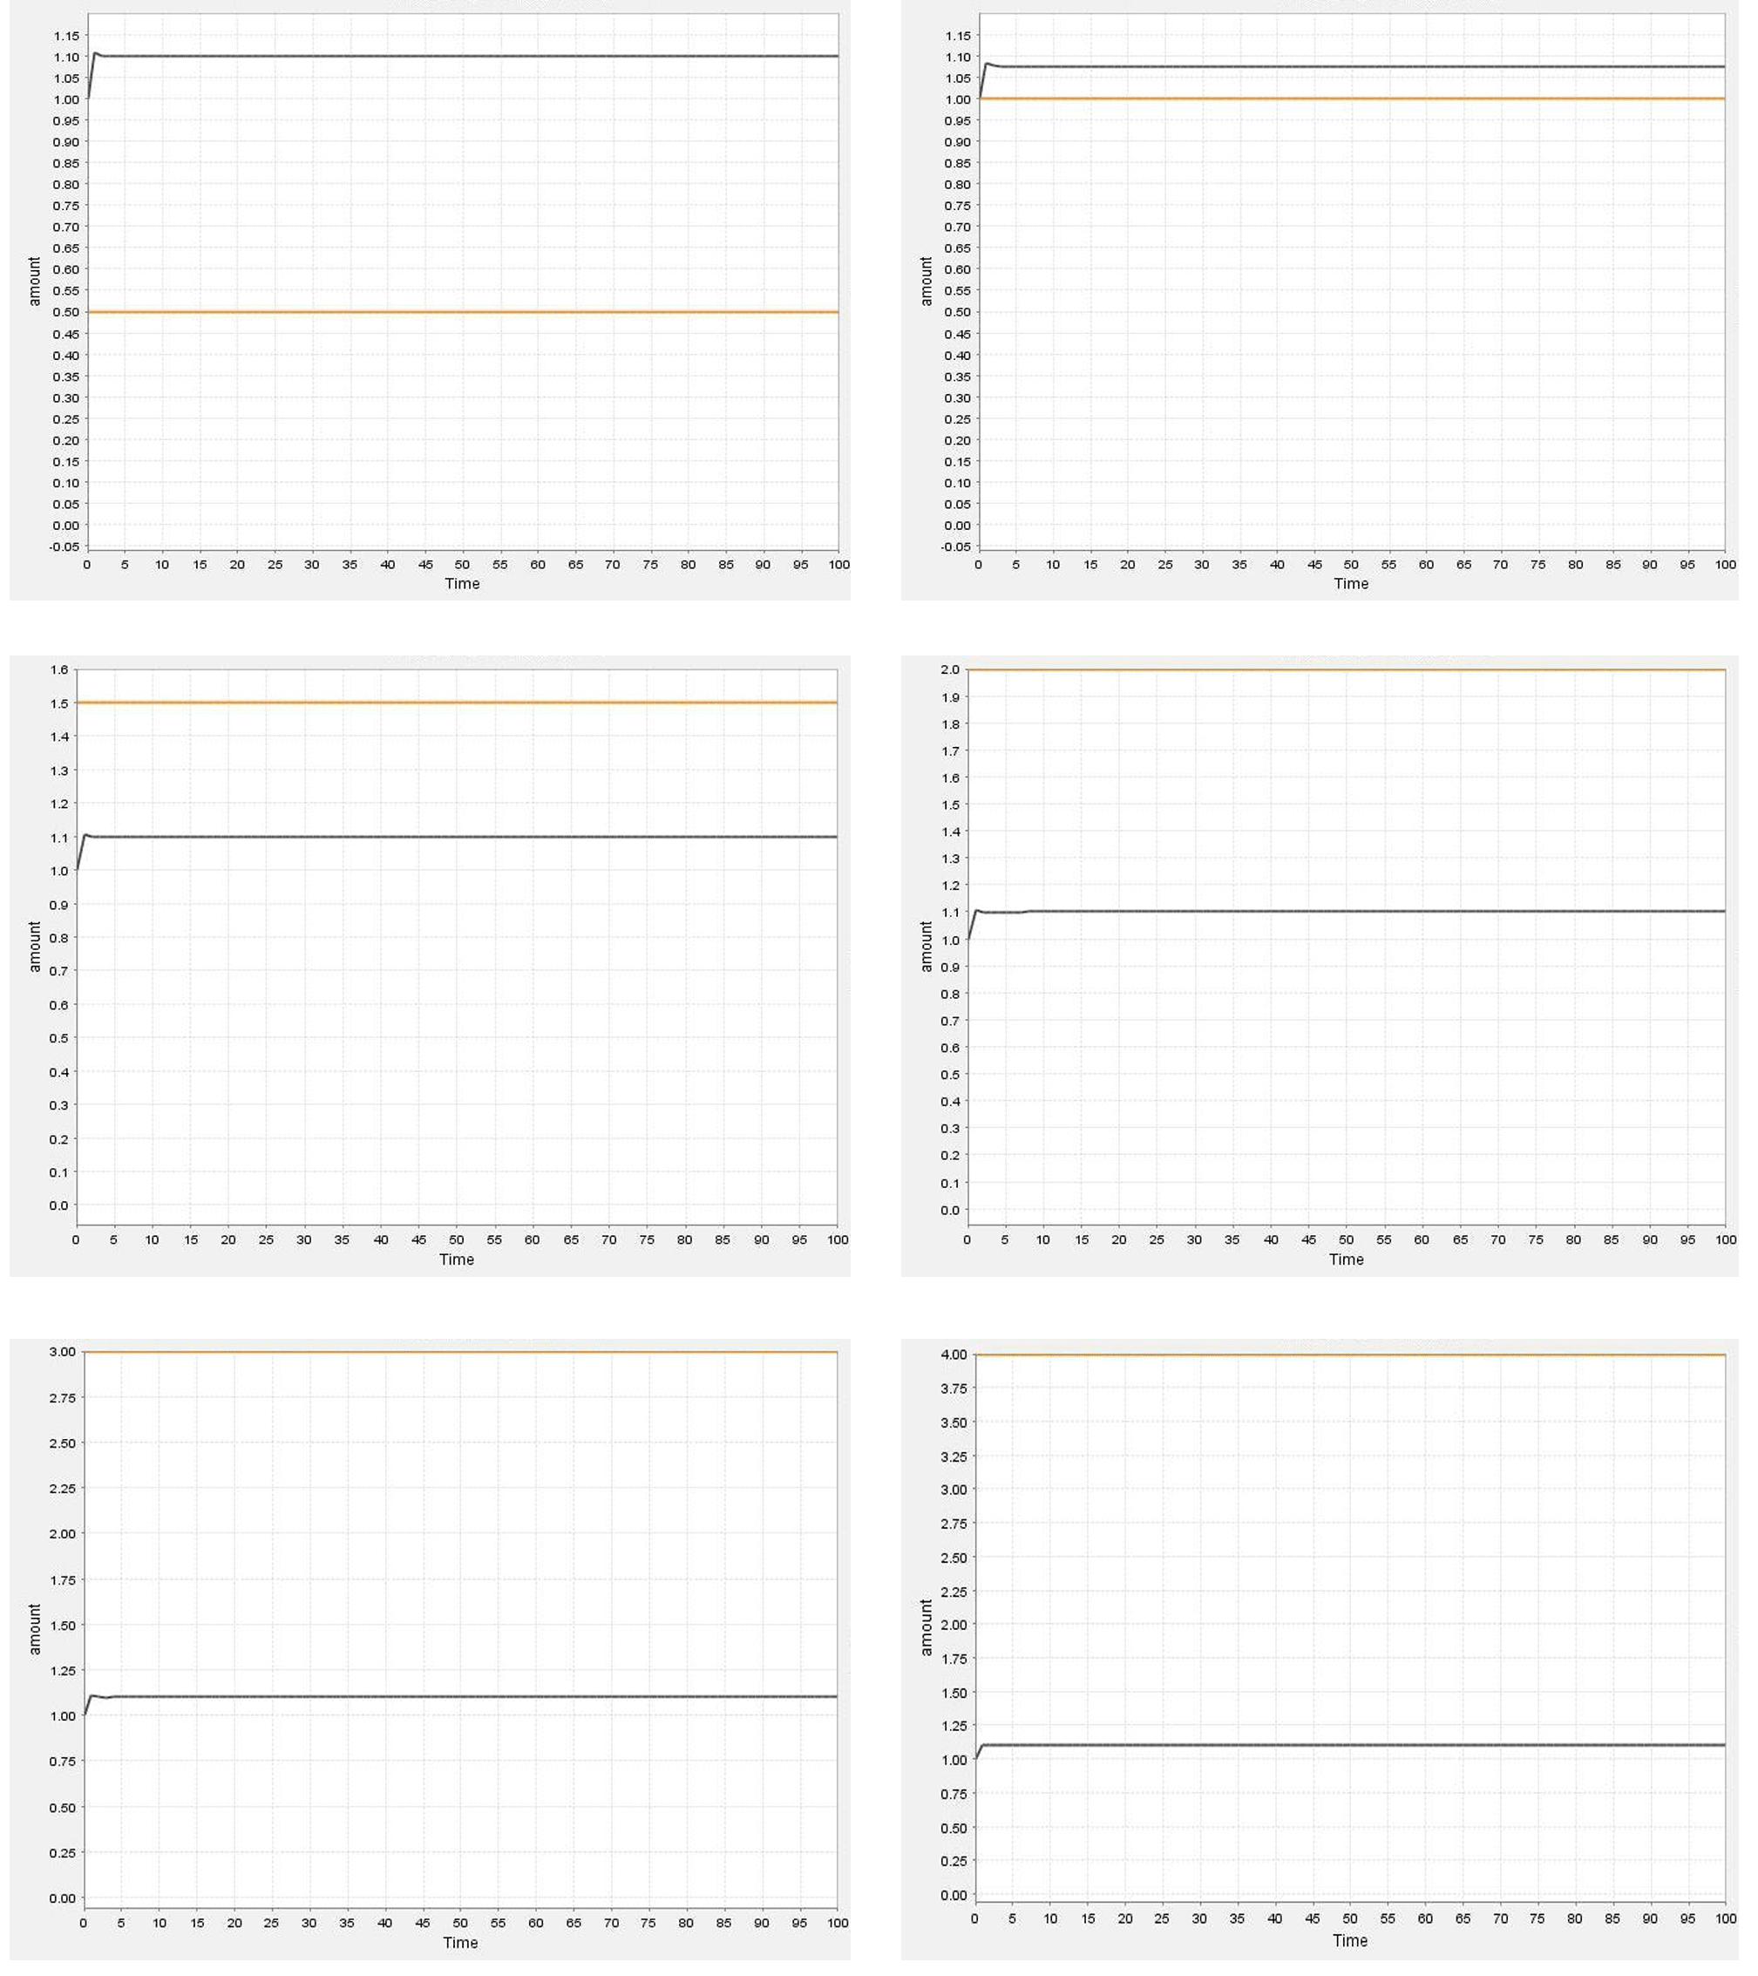
C
A
B
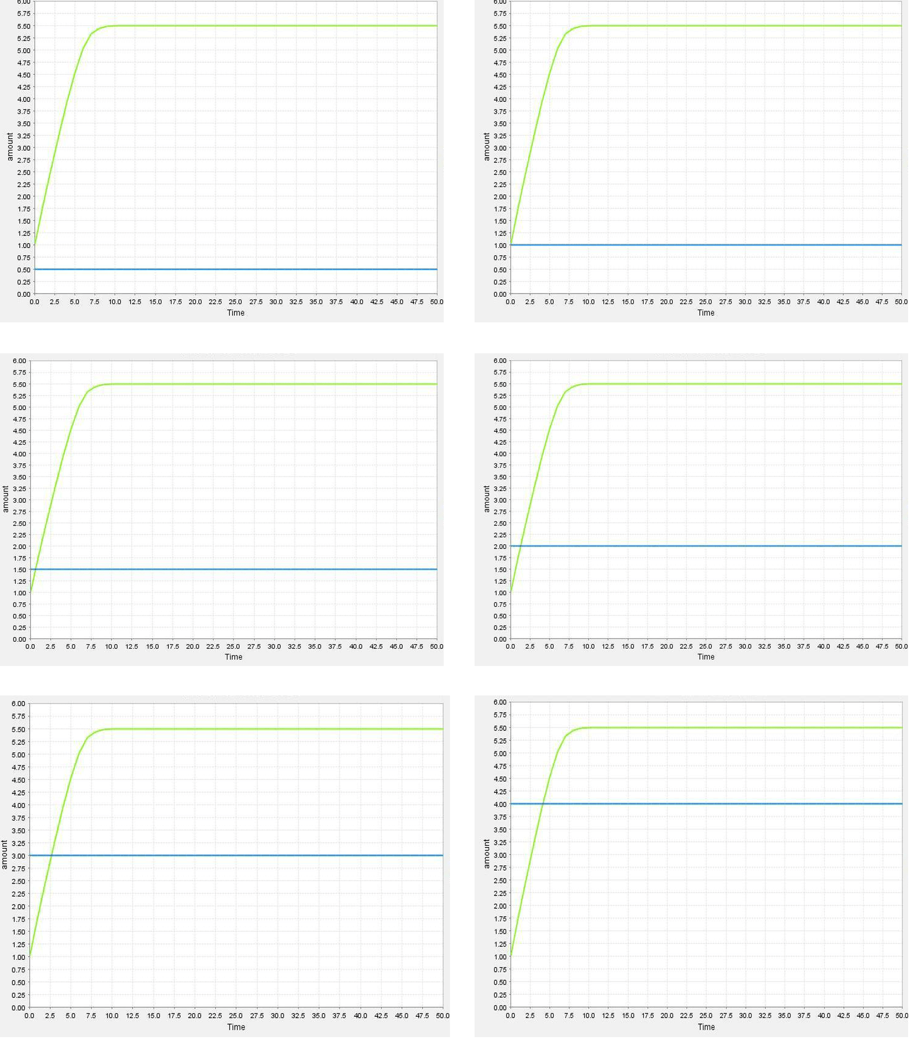

S3 Fig: Dynamic behavior analysis of drug inhibition activity on different amounts with (A) Ddl (B) D-alanyl-D-alanine and (C) PDF (amount 0.5 to 4.0).

S1 Table: Inhibition zones diameters (mm) and % inhibition of V.cinerea methanolic extracts against Xoo.

Concentration µg/ml | (Mean ± SD)
 | Zone of inhibition (mm) | % inhibition
25 | 16.0±1.0 | 31.14±0.54
50 | 18.1±1.0 | 50.50±0.89
100 | 22.6±2.08 | 74.94±0.78
Tetracycline (5) | 33.1 ± 3.7 | 92.61±0.80

S2 Table - Number of class, compartment and quantity of species during simulation on cell designer

S.No | Class | Name | Compartment | Position to compartment | Included | Quantity type | Initial quantity
1 | Gene | ddl | c1 | inside |  | Amount | 3
2 | Rna | RNA | c1 | inside |  | Amount | 3
3 | Protein | D-ala-D-ala-ligase | c1 | inside |  | Amount | 1
4 | Simple_molecule | ATP | c1 | inside |  | Amount | 1
5 | Simple_molecule | ADP | c1 | inside |  | Amount | 1
6 | Simple_molecule | Acyl Phosphate | c1 | inside |  | Amount | 1
7 | Simple_molecule | D-Ala-D-Ala | c1 | inside |  | Amount | 1
8 | Ion | Pi | c1 | inside |  | Amount | 1
9 | Simple_molecule | D-Ala-D-Ala | c1 | transmembrane |  | Amount | 1
10 | Complex | s51 | c1 | inside | s51(s50 s49) | Amount | 6
11 | Protein | aaRS | c1 | inside |  | Amount | 3
12 | Rna | tRNAi | c1 | inside |  | Amount | 2
13 | Protein | H2N-Met | c1 | inside |  | Amount | 3
14 | Complex | s69 | c1 | inside | s69(s67 s68) | Amount | 4
15 | Protein | FMT | c1 | inside |  | Amount | 3
16 | Protein | f-met-polypeptide | c1 | inside |  | Amount | 3
17 | Protein | Met-Ppd | c1 | inside |  | Amount | 3
18 | Protein | Polypeptide | c1 | inside |  | Amount | 3
19 | Protein | MAP | c1 | inside |  | Amount | 3
20 | Protein | PDF | c1 | inside |  | Amount | 1
21 | Gene | def | c1 | inside |  | Amount | 3
22 | Drug | Drug | c1 | inside |  | Amount | 4
23 | Simple_molecule | Tetrahedral intermediate | c1 | inside |  | Amount | 1
24 | Simple_molecule | First D-Ala | c1 | inside |  | Amount | 1
25 | Simple_molecule | Second D-Ala | c1 | inside |  | Amount | 1

S3 Table - Details of reactions and kinetics rate equations used in the model
S.No. | Reaction | Kinetics equations
1 | DNA→RNA | vmaf_re5 * (pow(s12 * c1, hic_re5_s12) / (pow(s12 * c1, hic_re5_s12) + pow(ksp_re5_s12, hic_re5_s12)))
2 | RNA→D-ala-ala-ligase | vmaf_re19 * ((s13 * c1)^hic_re19_s13 / ((s13 * c1)^hic_re19_s13 + ksp_re19_s13^hic_re19_s13))
3 | D-ala-ala-ligase → inhibition  First D-ala →Acyl phosphate | kic_re23_s81 / (kic_re23_s81 + s81 * c1) * ((kcrf_re23_s23 / (kic_re23_s40_s23 * kmc_re23_s33_s23) * s23 * c1 * s40 * c1 * s33 * c1 - kcrr_re23_s23 / (kic_re23_s34_s23 * kmc_re23_s35_s23) * s23 * c1 * s35 * c1 * s34 * c1) / (1 + s40 * c1 * s33 * c1 / (kic_re23_s40_s23 * kmc_re23_s33_s23) + s40 * c1 / kic_re23_s40_s23 + s35 * c1 * s34 * c1 / (kic_re23_s34_s23 * kmc_re23_s35_s23) + s33 * c1 / kic_re23_s33_s23 + s34 * c1 / kic_re23_s34_s23 + s35 * c1 / kic_re23_s35_s23))
4 | Acyl phosphatev→ Terahedral intermediate | kass_re24 * s35 * c1 * s41 * c1 - kdiss_re24 * s39 * c1
5 | Terahedral intermediate → D-Ala-D-Ala | kass_re25 * s39 * c1 - kdiss_re25 * s42 * c1 * s43 * c1
6 | D-Ala-D-Ala → D-Ala-D-Ala | kass_re26 * s42 * c1 - kdiss_re26 * s48 * c1
7 | H₂N-Met + tRNAi → (H₂N-Met tRNAi) | (kcrf_re31_s55 / (kic_re31_s52_s55 * kmc_re31_s54_s55) * s55 * c1 * s52 * c1 * s54 * c1 - kcrr_re31_s55 / kmc_re31_s51_s55 * s55 * c1 * s51 * c1) / (1 + s51 * c1 / kmc_re31_s51_s55 + s52 * c1 / kic_re31_s52_s55 + s52 * c1 * s54 * c1 / (kic_re31_s52_s55 * kmc_re31_s54_s55) + s54 * c1 / kic_re31_s54_s55)
8 | (H₂N-Met tRNAi) → (OHC-NH-Met f-tRNA) | s74 * c1 * ((kcrf_re38_s74 / kmc_re38_s51_s74 * s51 * c1 - kcrr_re38_s74 / kmc_re38_s69_s74 * s69 * c1) / (1 + s51 * c1 / kmc_re38_s51_s74 + s69 * c1 / kmc_re38_s69_s74))
9 | (OHC-NH-Met f-tRNA) → f-met-polypeptide | kass_re48 * s69 * c1 - kdiss_re48 * s75 * c1
10 | f-met-polypeptide → Met-Ppd | s79 * c1 * ((kcrf_re47_s79 / kmc_re47_s75_s79 * s75 * c1 - kcrr_re47_s79 / kmc_re47_s76_s79 * s76 * c1) / (1 + s81 * c1 / kic_1_re47_s81 + (s75 * c1 / kmc_re47_s75_s79 + s76 * c1 / kmc_re47_s76_s79) * (1 + s81 * c1 / kic_2_re47_s81)))
11 | Met-Ppd → Polypeptide | s78 * c1 * ((kcrf_re49_s78 / kmc_re49_s76_s78 * s76 * c1 - kcrr_re49_s78 / kmc_re49_s77_s78 * s77 * c1) / (1 + s76 * c1 / kmc_re49_s76_s78 + s77 * c1 / kmc_re49_s77_s78))
12 | Polypeptide → D-ala-ala-ligase | kass_re43 * s77 * c1 - kdiss_re43 * s23 * c1
13 | DNA→RNA | vmaf_re44 * ((s80 * c1)^hic_re44_s80 / ((s80 * c1)^hic_re44_s80 + ksp_re44_s80^hic_re44_s80))
14 | RNA → PDF | vmaf_re50 * ((s13 * c1)^hic_re50_s13 / ((s13 * c1)^hic_re50_s13 + ksp_re50_s13^hic_re50_s13))

S4 Table: Topological analysis of enzyme reaction network

Node | 40 | Edge | 40
Connected component | 1 | Average no. of neighbors | 1.95
Network diameter | 19 | Network density | 0.050
Network radius | 10 | Network heterogeneity | 0.537
Network centralization | 0.109 | Shortest Paths | 1560
Characteristic Path length | 7.721 | Multi edge node pairs | 1

