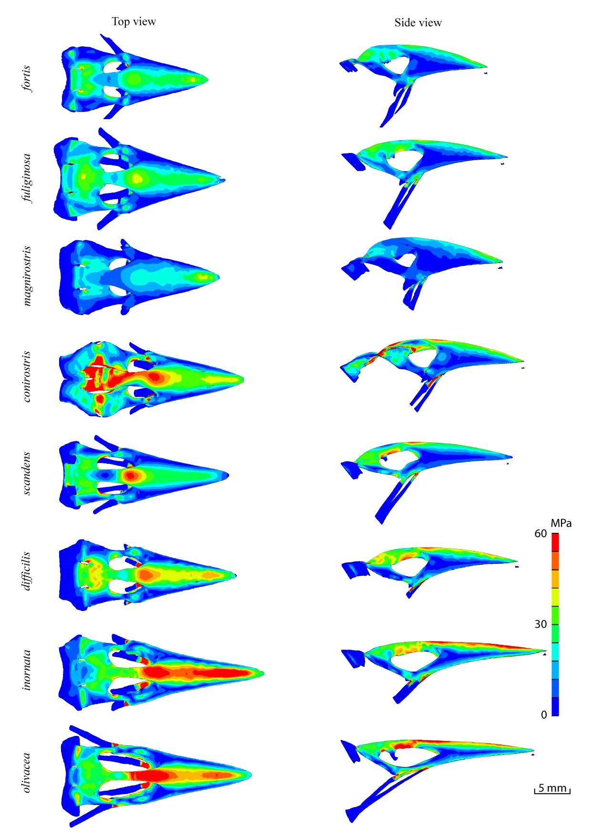
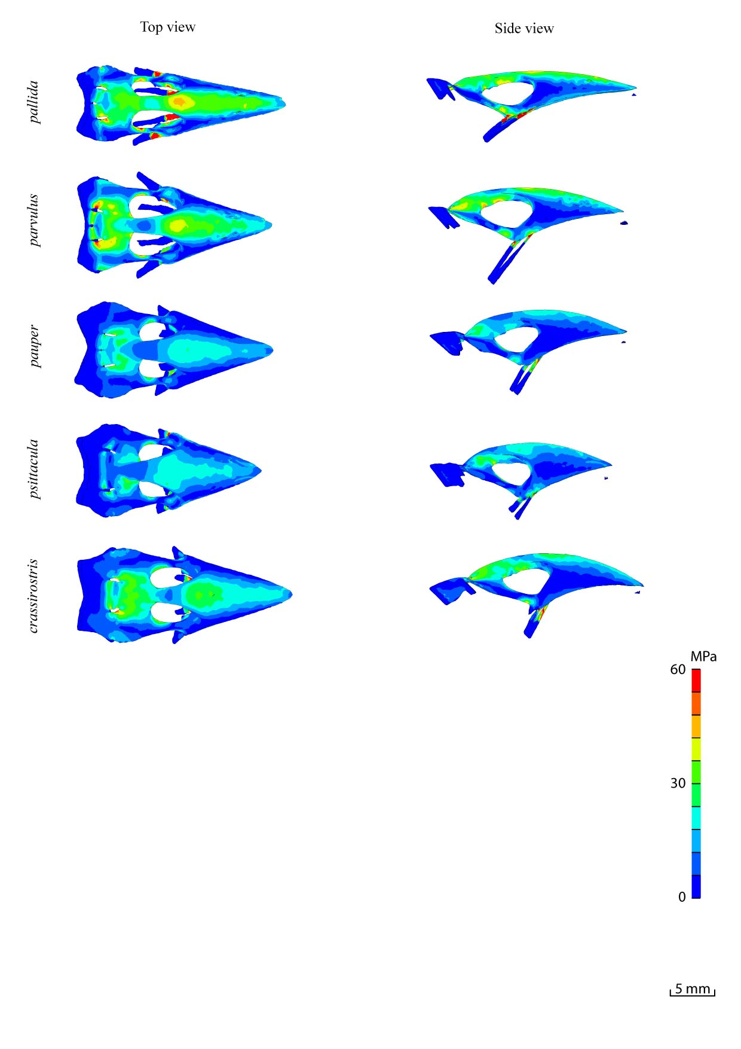
S5 Fig.: Top and side view for scaled FE models of upper beak during tip biting for 13 Darwin finches.

