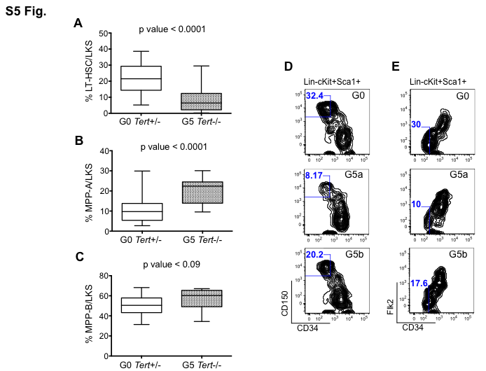

S5 Fig. HSC and MPP cell populations in G5 Tert-/- mice.
(A-C) Percentages of HSC, MPP-A and MPP-B cells within the Lin-c-Kit+Sca1+ population in the femurs from G0 Tert+/- (n=21) and G5 Tert-/- (n=14) mice aged 11-20 months. The ends of the whiskers represent minimum and maximum values while the bar indicates the median value (50th percentile). p values are based on a 2-tailed t test. (D-E) Representative FACS profile pre-gated on live, lineage-, c-Kit+ and Sca1+ cells, separated based on either (D) CD34 and CD150 or (E) CD34 and Flk-2 expression showing reduced HSC frequency in G0 Tert+/- and G5 Tert-/- BM. G5a and G5b represent two different G5 mice, in total 3 mice of each genotype were studied.

