Supplementary figure S1

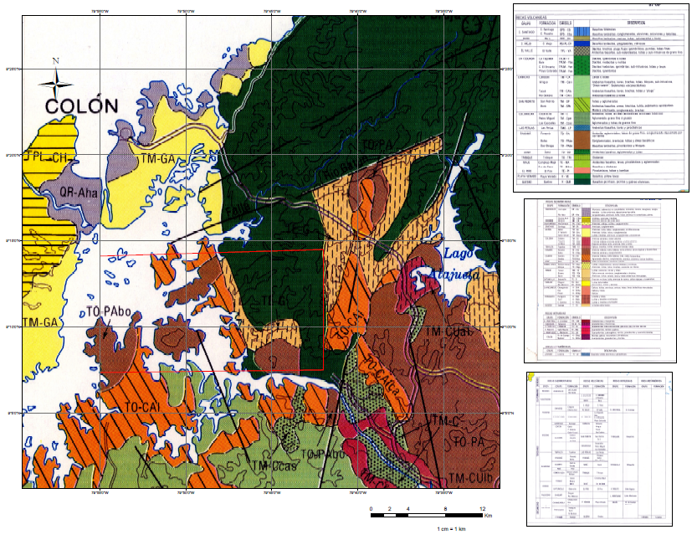
Figure S1. Geological map of Soberania National Park and surrounding areas. (original map and compilation from Woodring, 1957)

W. P. Woodring. 1957. Geology and Paleontology of Canal Zone and adjoining parts of Panama. United States Geological Survey Professional Paper 306(A).

