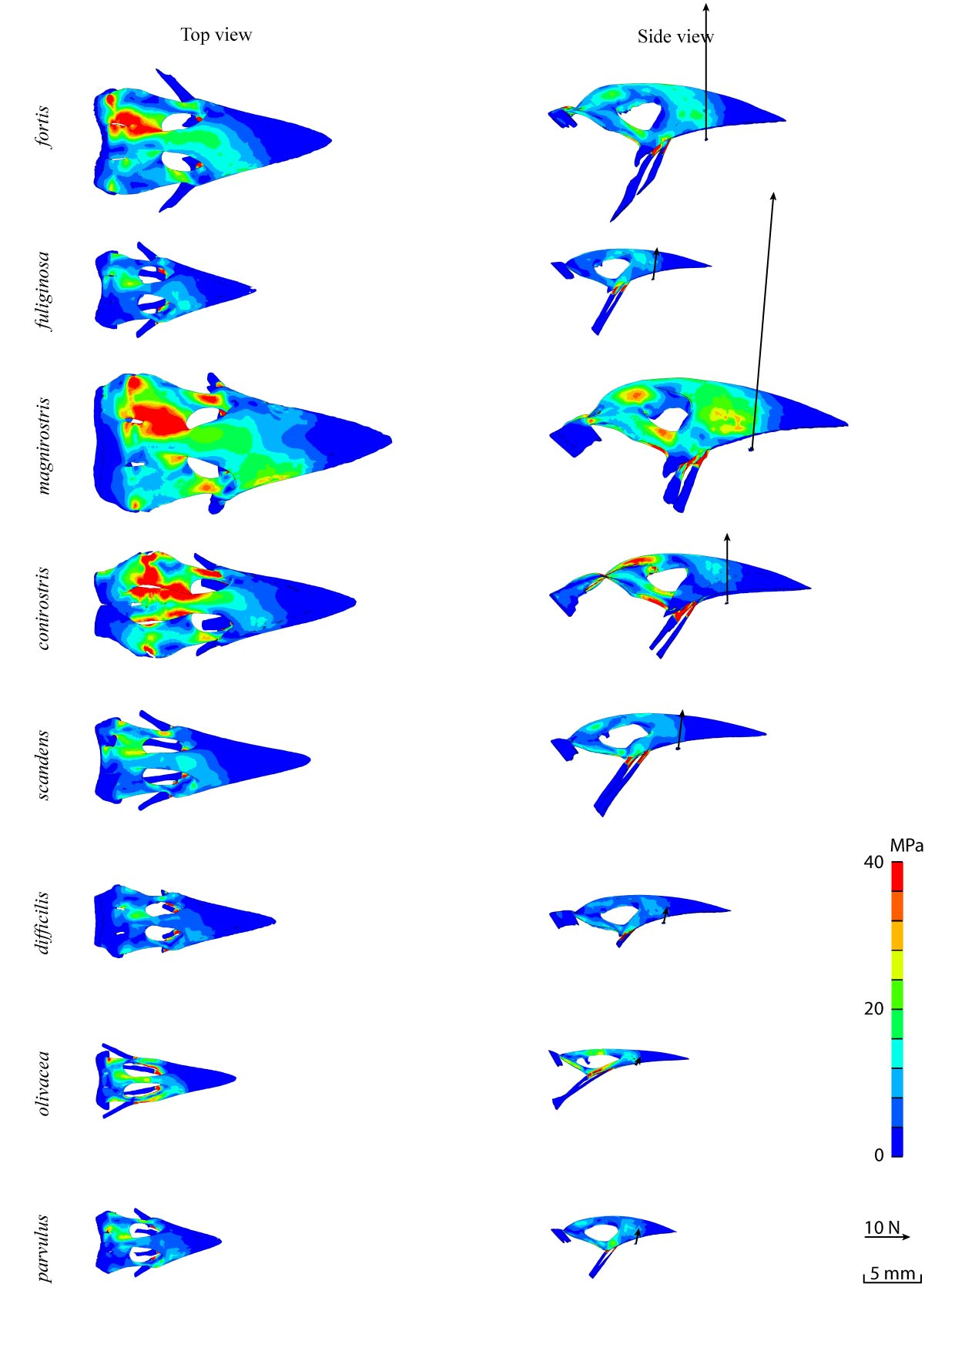
S2 Fig.: Top and side view for physiological FE models of upper beak during base biting for 8 Darwin finches.

