GUINEA

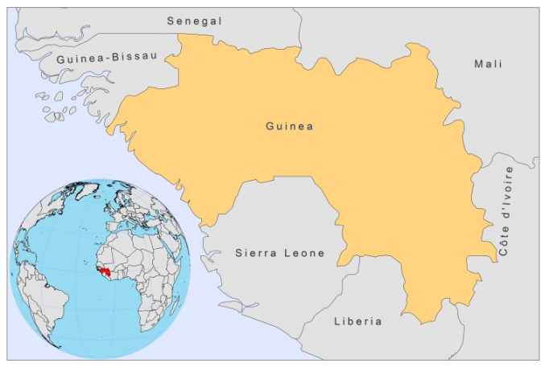

BASIC COUNTRY DATA

Total Population: 9,981,590
Population 0-14 years: 43%
Rural population: 65%
Population living under USD 1.25 a day: 43.3%
Population living under the national poverty line: 53%
Income status: Low income economy
Ranking: Low human development (ranking 178)
Per capita total expenditure on health at average exchange rate (US dollar): 19
Life expectancy at birth (years): 53
Healthy life expectancy at birth (years): 45

BACKGROUND INFORMATION

Very few data on prevalence or incidence are available. A case of CL has been reported in Conakry in 1977, and an earlier survey found 14.7% of positive response to LST in a population without any symptoms or history of CL [1]. No more recent cases have been documented, but as Guinea is part of a proposed CL endemicity belt, running across West Africa, cases may occur regularly but remain unreported [2].

PARASITOLOGICAL INFORMATION

Leishmania  Species | Clinical form | Vector species | Reservoirs
L. major | CL | P. duboscqi | Unknown

MAPS AND TRENDS, CONTROL, DIAGNOSIS & TREATMENT, ACCESS TO CARE, ACCESS TO DRUGS

No data available.

SOURCES OF INFORMATION

1. Pampiglione S, Marton K (1977). Cutaneous leishmaniasis in the Republic of Guinea. Bull Soc Pathol Exot Filiales 70(5):479-84.

2. Boakye DA, Wilson MD, Kweku M (2005). A review of leishmaniasis in West Africa. Ghana Medical J 39 (3):94-7.

