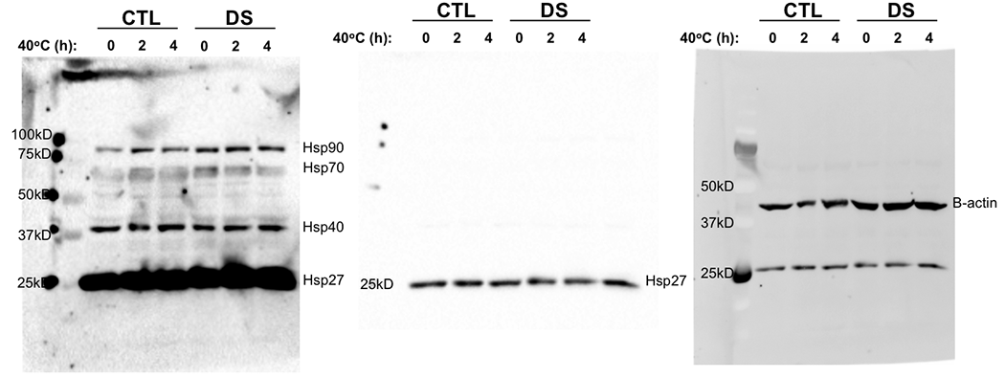

S11 Fig. Full blot images of Hsp proteins from 40ºC heat stress study presented in Fig 7.

