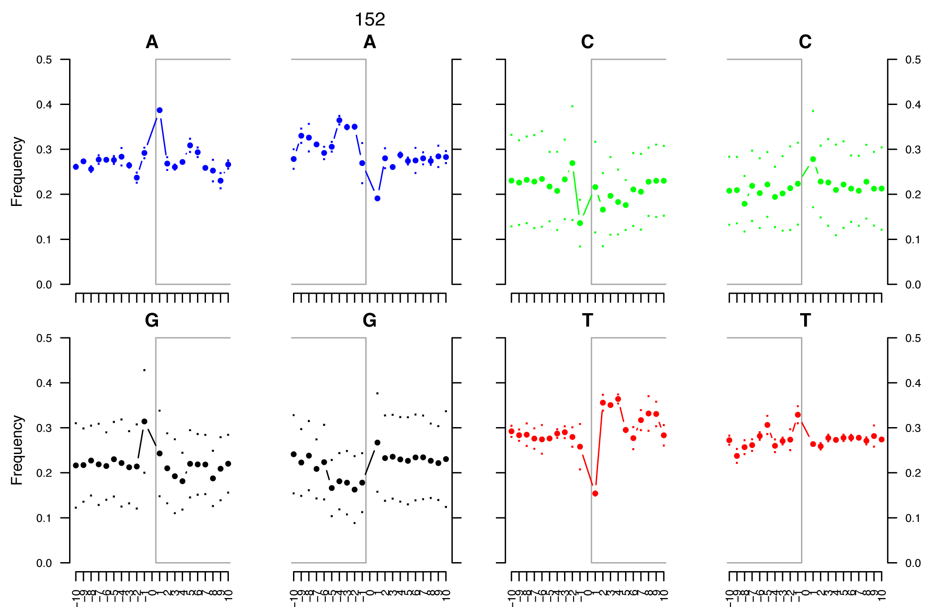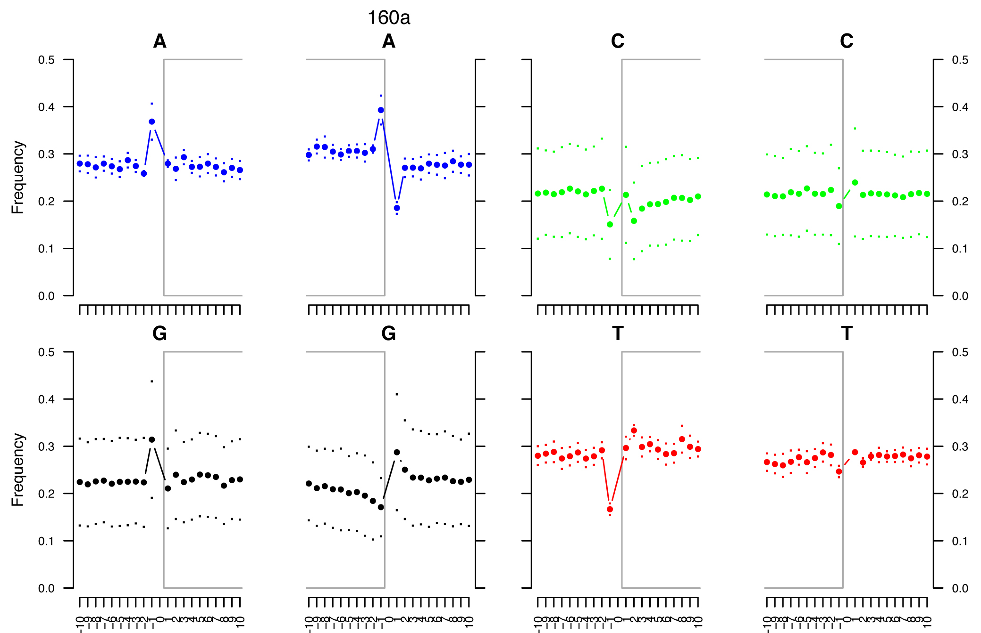
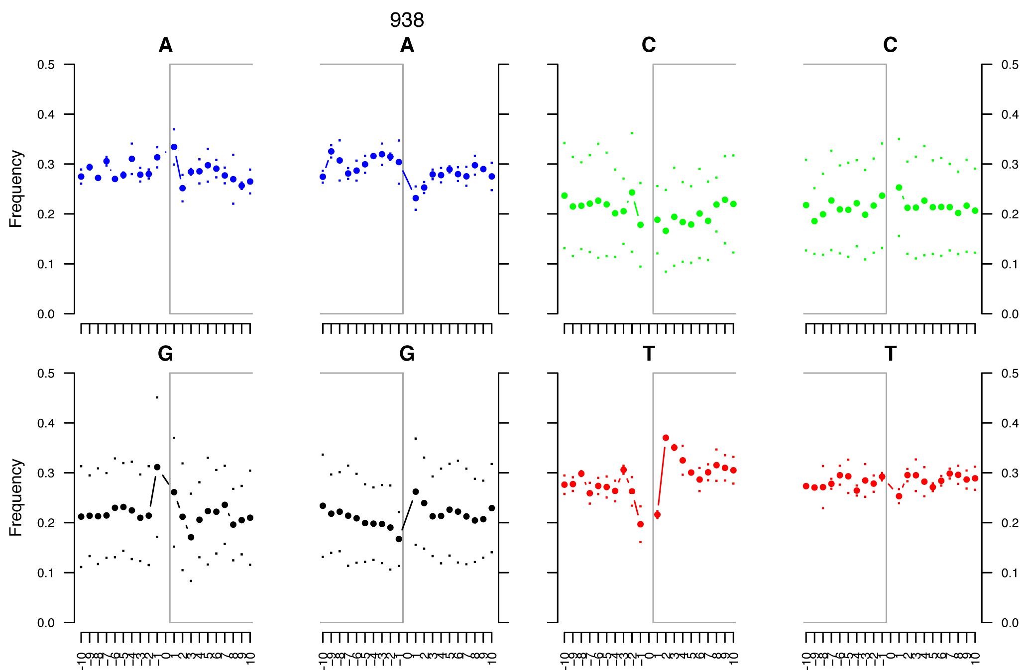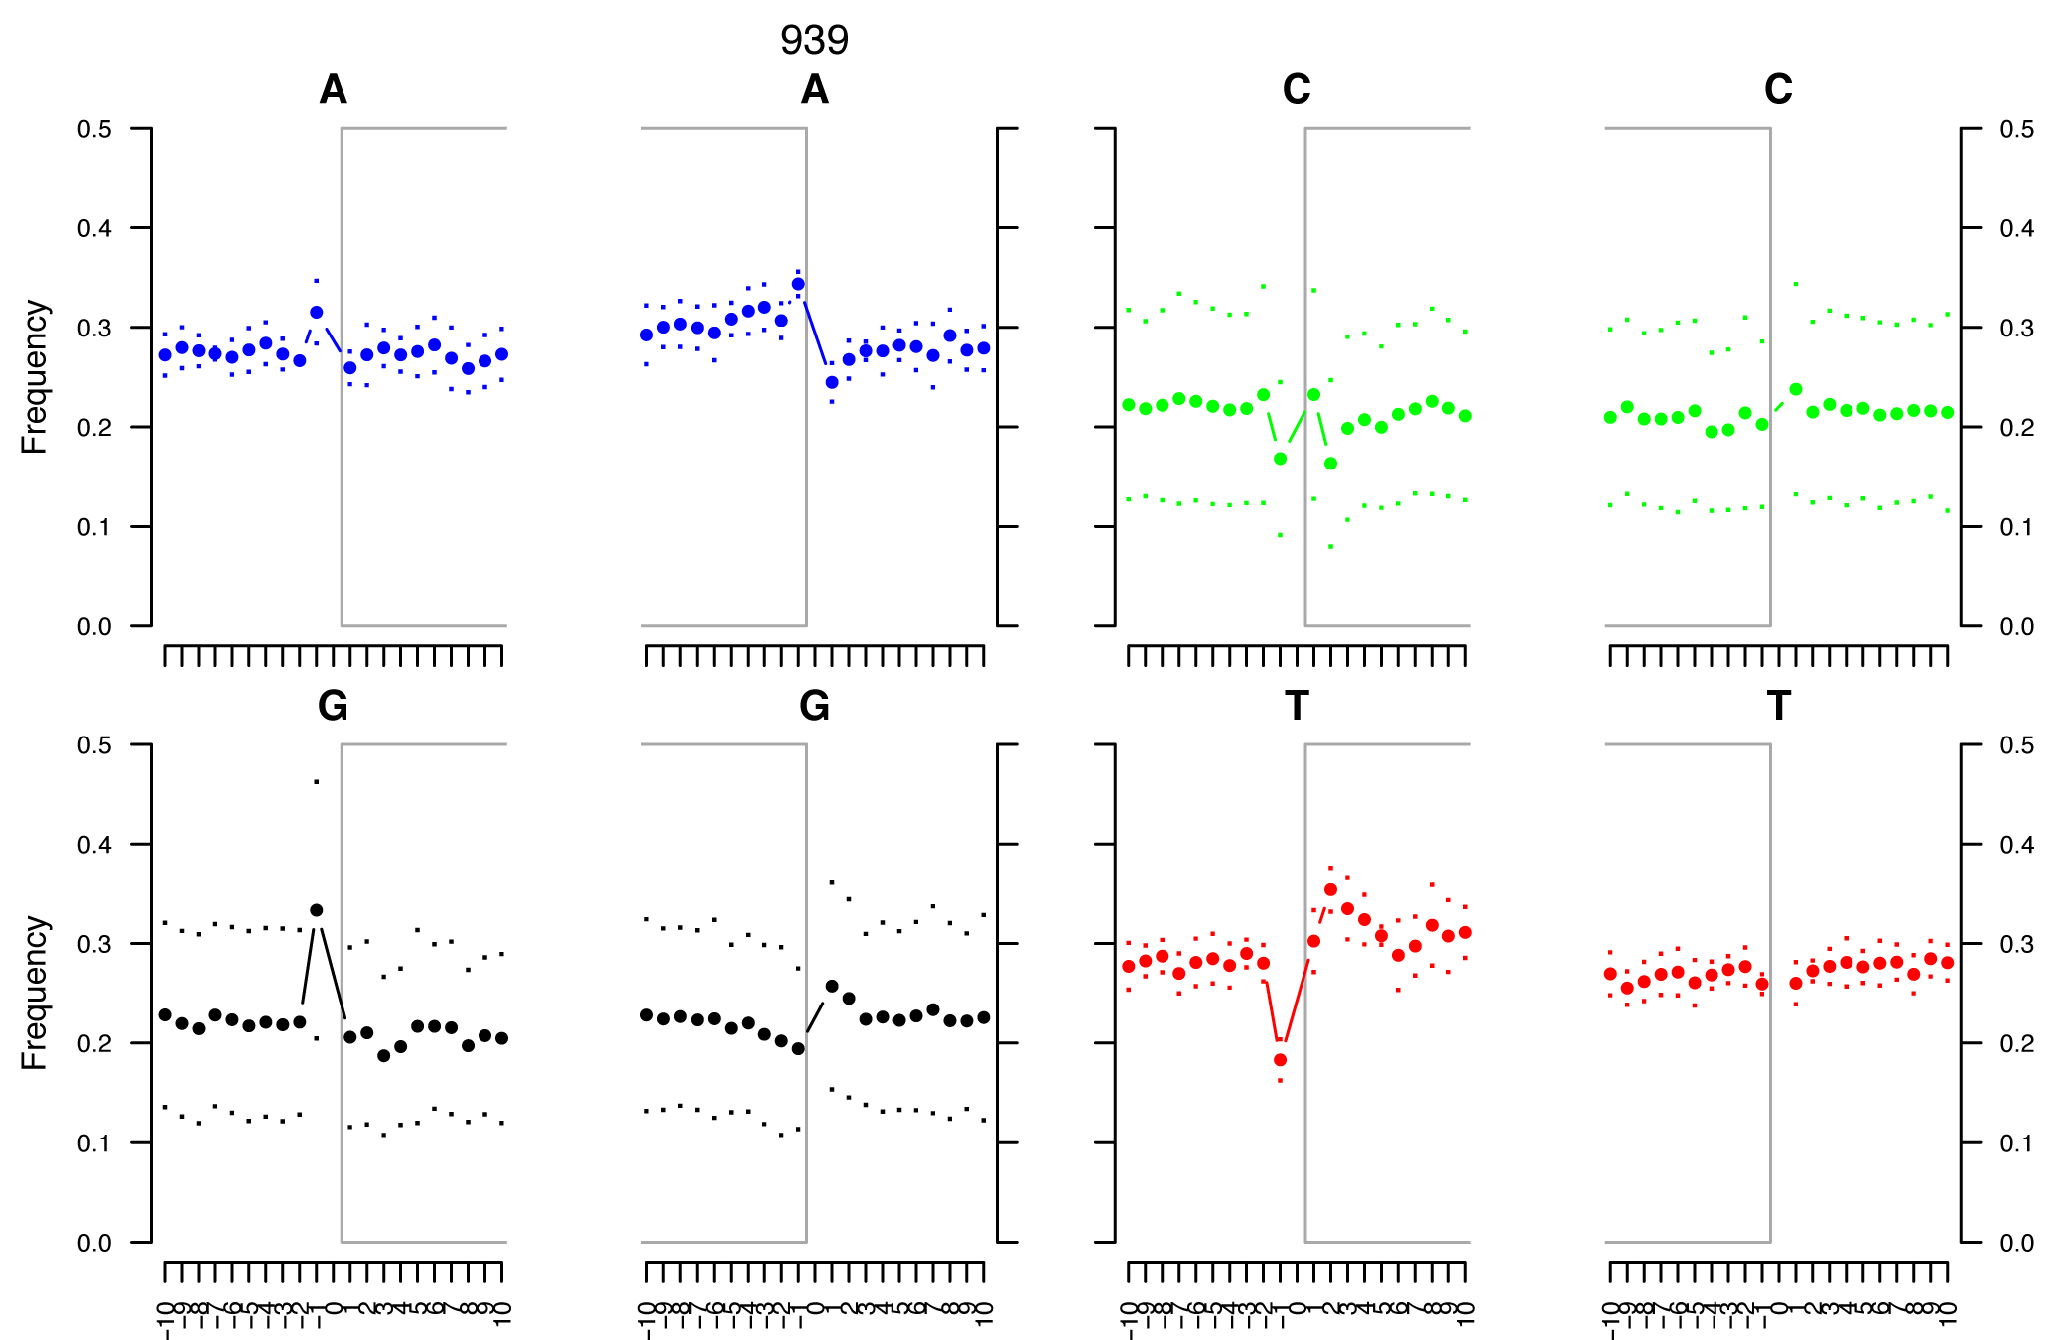
Supplemental Figure 1. DNA Damage Signatures. The above graphs demonstrate an excess of purines at the genomic coordinates located right before the sequence start. This pattern is indicative of ancient DNA, where post-mortem depurination occurs followed by a subsequent fragmentation (Briggs, Stenzel, Johnson, et al. 2007). The Perl script, mapDamage 0.36, measured this pattern globally across the aligned SAM file.

