Figure S1: Bland Altman plot showing concordance of methods when collecting birth weight data

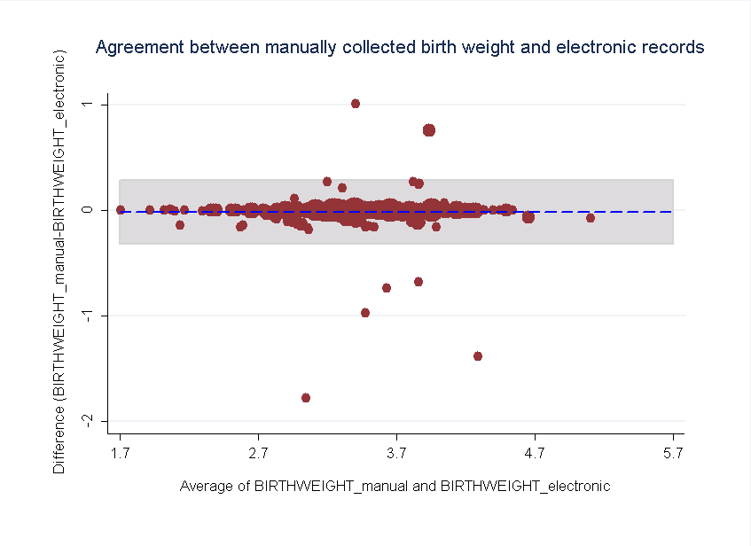
(kgs)
(kgs)

