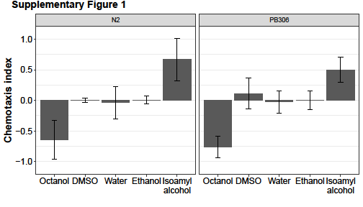

Supplemental Figure 1. Isoamyl alcohol (diluted to 1:1000 in ethanol) and 1-octanol serve as control attractant and control repellant, respectively, for both the N2 (left) and PB306 (right) C. elegans strains. Both strains respond neutrally to the three solvents used for the isopod washes (Supplemental Table 1, Supplemental Table 2).

