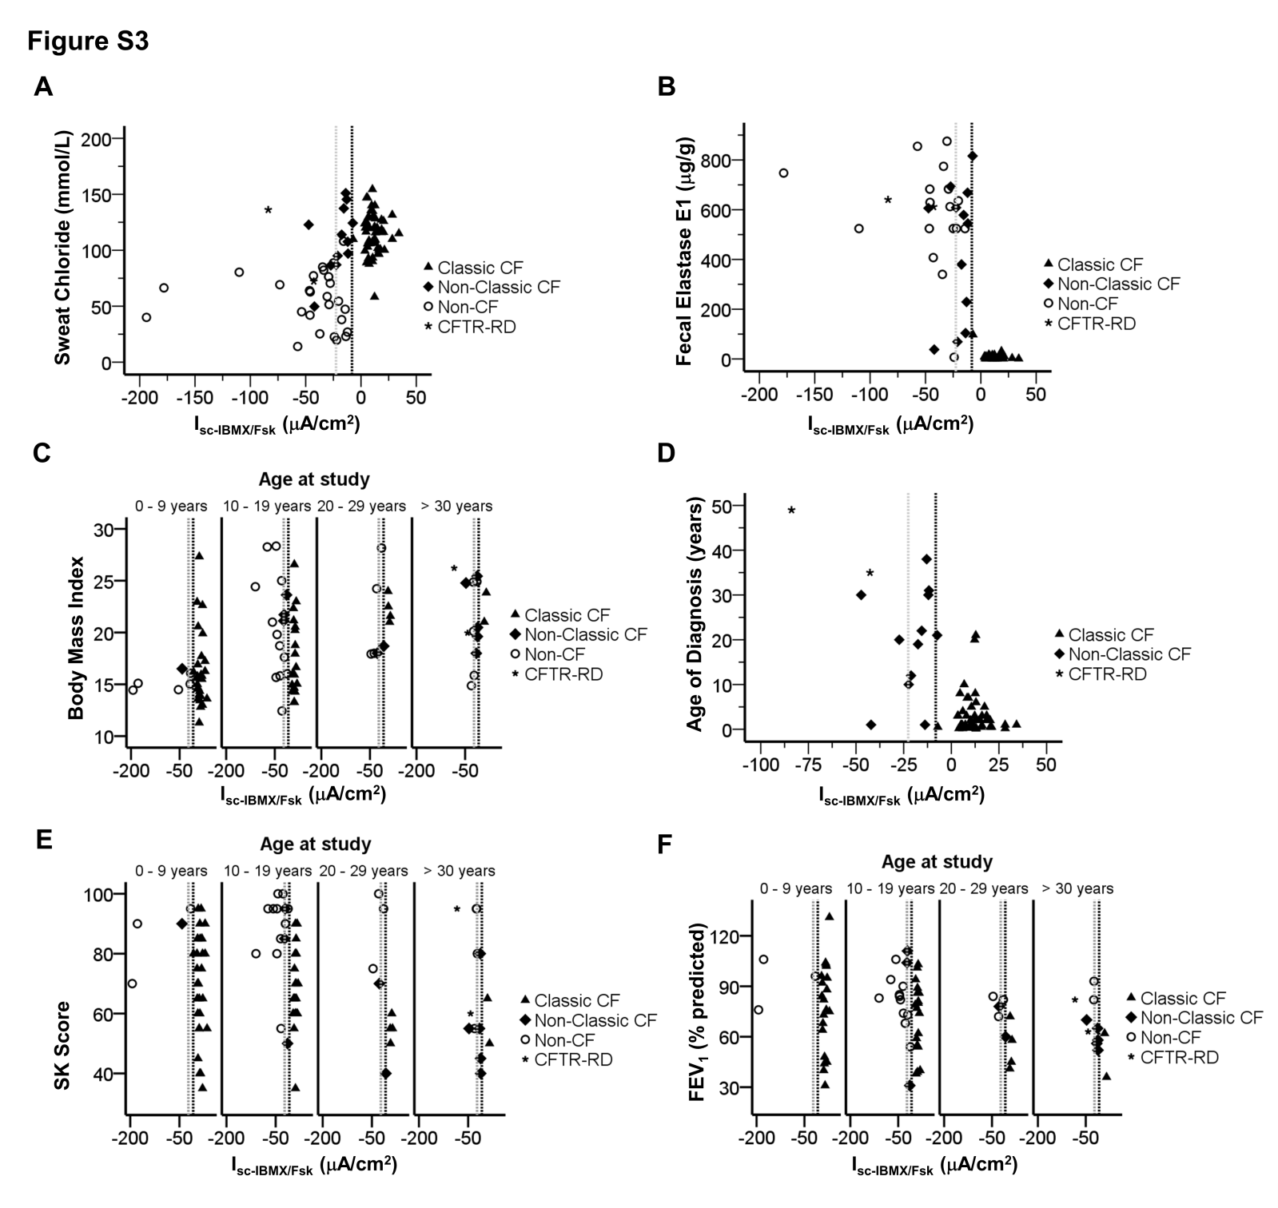

Figure S3: Correlations between CF clinical features and IBMX/Fsk-induced short circuit currents (I_{sc-IBMX/Fsk}). Scatter-plot summarizing the distribution I_{sc-IBMX/Fsk} against (A) sweat chloride concentrations (in mmol/l); (B) age at diagnosis (in years); (C) Body Mass Index distributed by groups of ages; (D) Fecal Elastase E1 concentrations (in µg/g of stools); (E) Shwachman–Kulczycki clinical scores distributed by groups of ages; and (F) FEV1 (% of predicted normal values for sex, age, and height) distributed by groups of ages. Vertical dashed black line represents subtraction of one standard deviation (STD) of the mean value calculated for I_{sc-IBMX/Fsk} in non-CF controls (ΔI_{sc} = -8.18 µA/cm²). Vertical dashed grey line represents addition of one STD of the mean value calculated for I_{sc-IBMX/Fsk} in reference sub-group of Non-Classic CF patients (ΔI_{sc} = -22.60 µA/cm²). Classic CF (filled triangles, n = 55); Non-Classic CF (filled diamonds, n = 12); CFTR-RD (star, n= 2) and Non-CF (open circles, n = 26) individuals.

