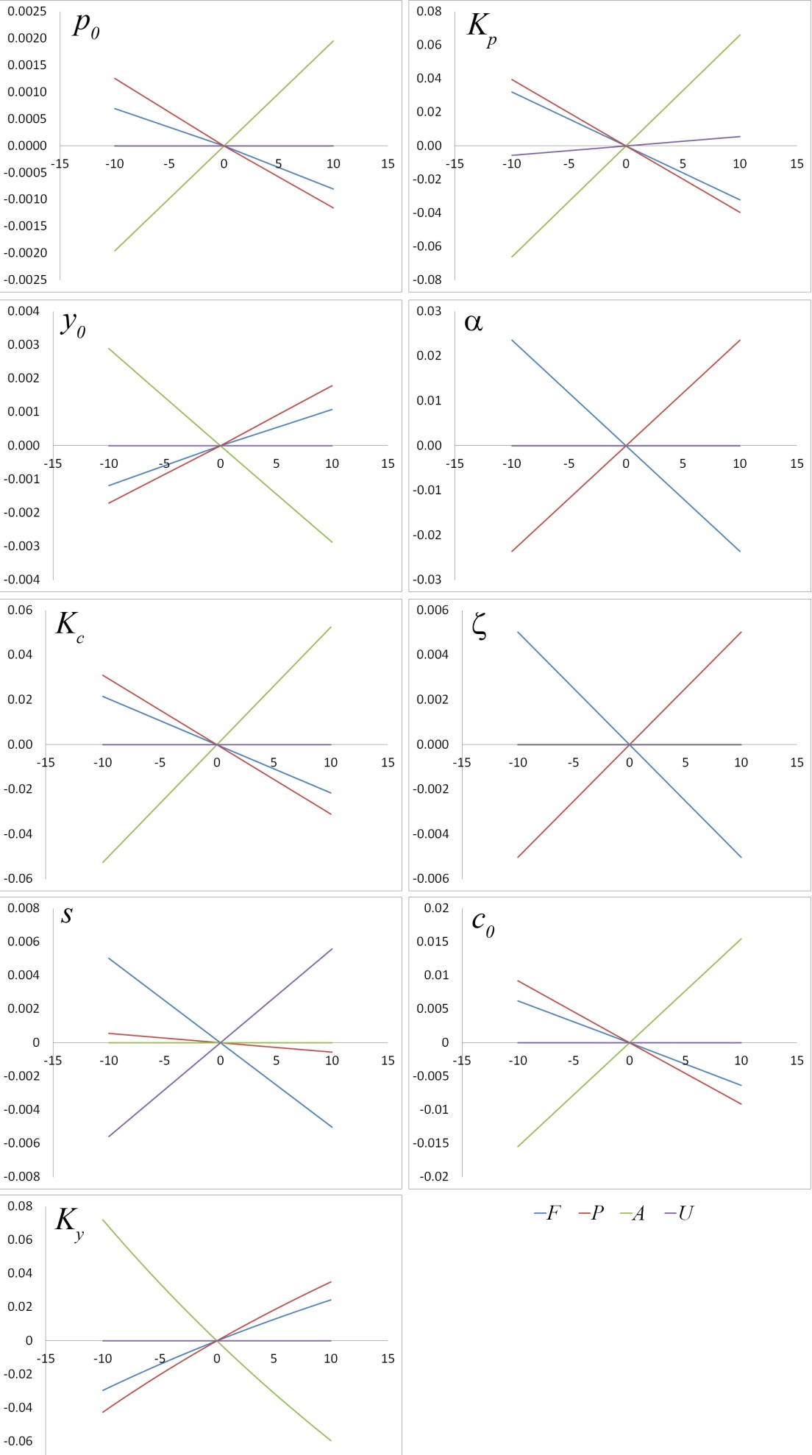

Supplementary Figure S1 – Sensitivity analysis. The horizontal axis is the percentage change of the corresponding parameter from its baseline value. The vertical axis is the absolute change in the fractional land cover. Varying the excluded parameters has a negligible effect.