S6. Selected experiments improve GBA-based function prediction – additional results from GO and MIPS
In the section (c) of the paper, we show that selected experiments improve the performance of GBA-based gene function prediction. We again framed it as a classification problem where a gene had to be classified into either of two classes. The performance of the classifier was measured by plotting average ROC curves over the ten-folds of the cross-validation and the average (1-AUC) was recorded. In Figure 6, for twelve GO Biological Process categories, the average (1-AUC) for the selected set (in green) is compared with the average (1-AUC) obtained by using all experiments (in red). To show that the (1-AUC) obtained for the selected experiments are significantly higher than for all experiments, we performed a t-test (p-values are shown in blue). Similarly, in Figure 7, results for twelve additional MIPS FunCat examples are shown. In both sets of examples, the Arabidopsis microarray collection was used.

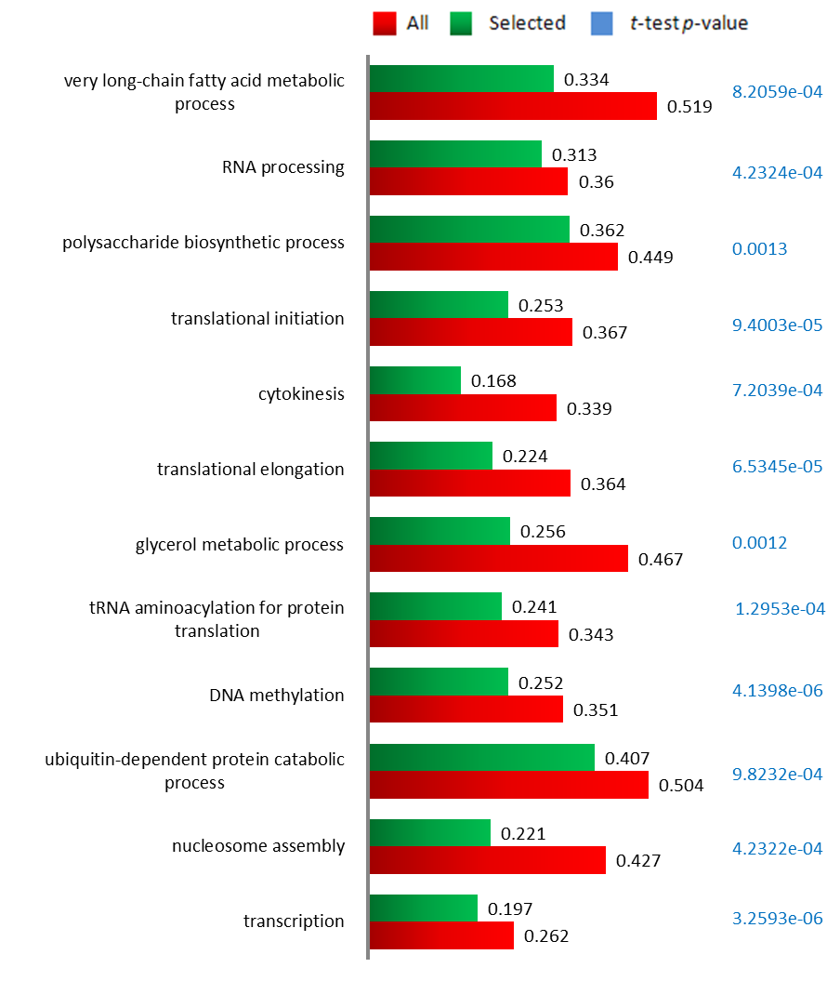
Figure S6

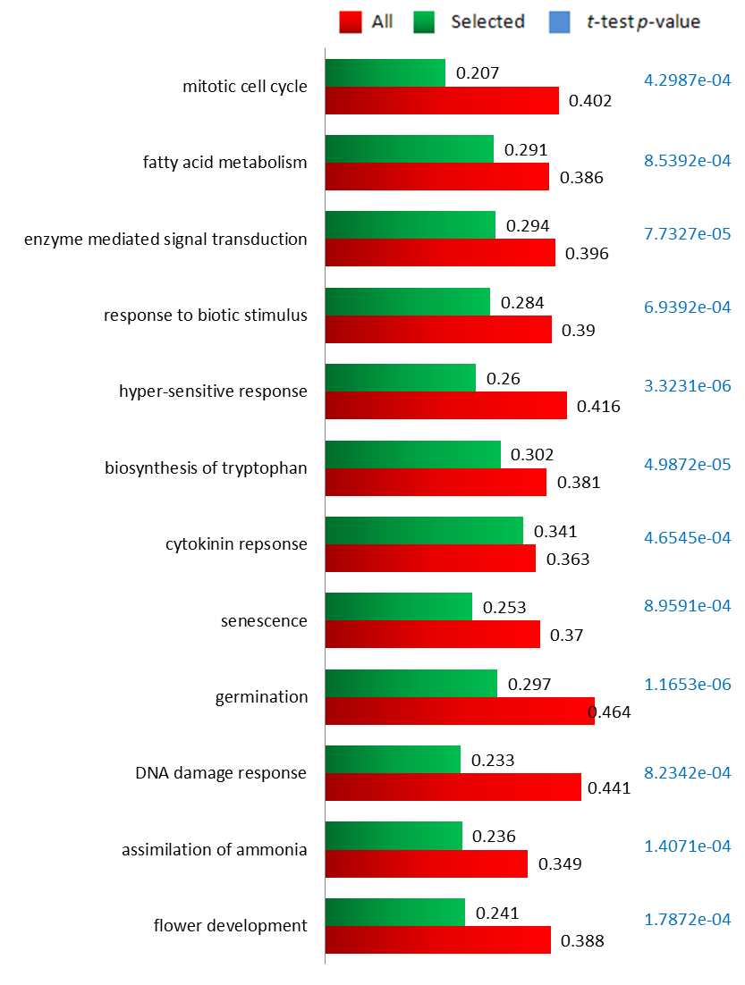
Figure S7

