Table S7: Compounds that were both active and annotated.
Compound name | Concentration [µM] | Source | Broad ID | Structure
(D,L)-TETRAHYDROBERBERINE | 2.95 | Prestwick Chemical Inc. | BRD-A69950438 | 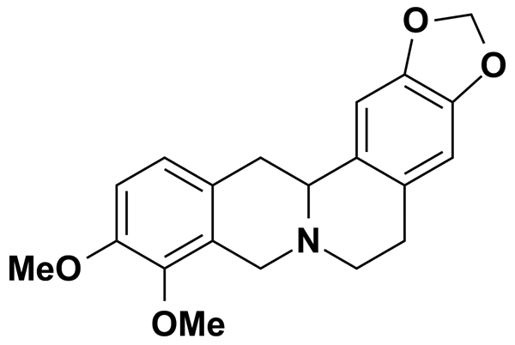
2,5-DITERTBUTYLHYDROQUINONE | 11.24 | Biomol International Inc. | BRD-K95603879 | 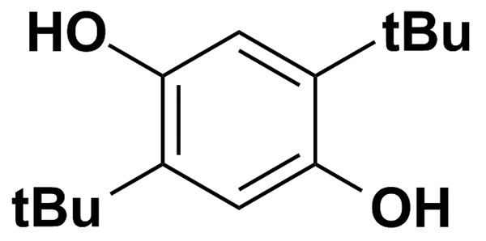
AG-879 | 7.90 | Biomol International Inc. | BRD-K59469039 | 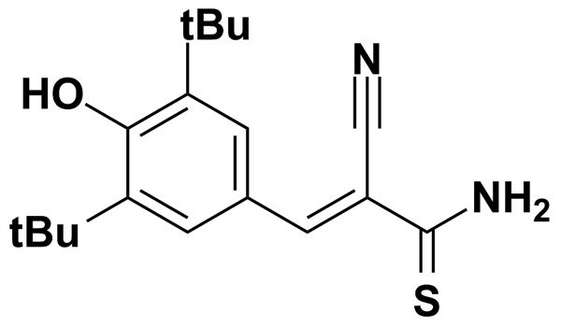
ANISOMYCIN | 9.42 | Biomol International Inc. | BRD-K91370081 | 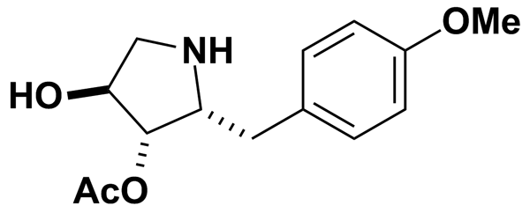
BAY 11-7082 | 12.06 | Biomol International Inc. | BRD-K15025317 | 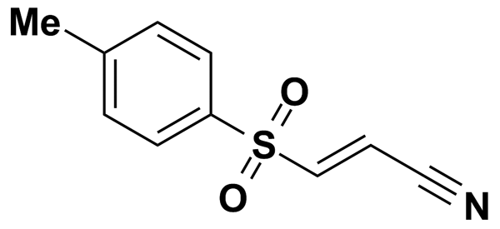
BW-B 70C | 7.90 | Biomol International Inc. | BRD-A55946879 | 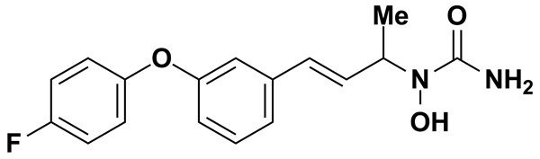
CA-074-ME | 6.29 | Biomol International Inc. | BRD-A56020723 | 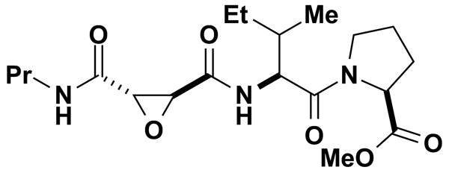
CELECOXIB | 5.00 | MicroSource Discovery Systems Inc. | BRD-K02637541 | 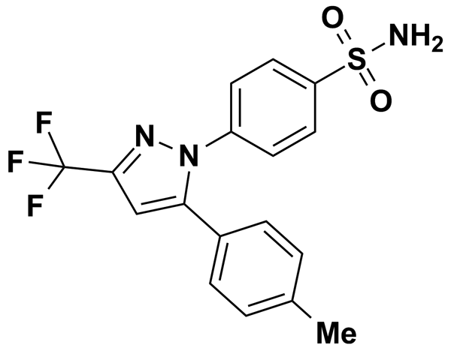
CERULENIN | 11.20 | Biomol International Inc. | BRD-K52075040 | 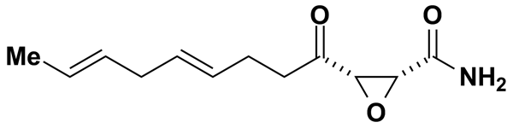
COLCHICINE | 2.50 | Prestwick Chemical Inc. | BRD-K00259736 | 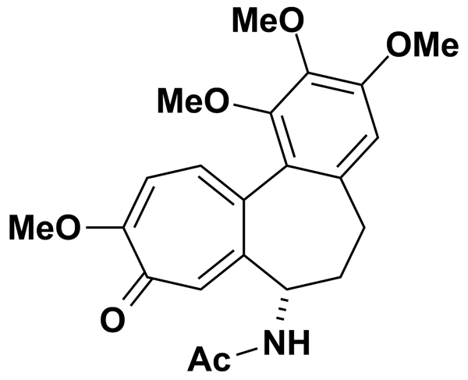
CYCLIZINE | 5.00 | MicroSource Discovery Systems Inc. | BRD-K79501723 | 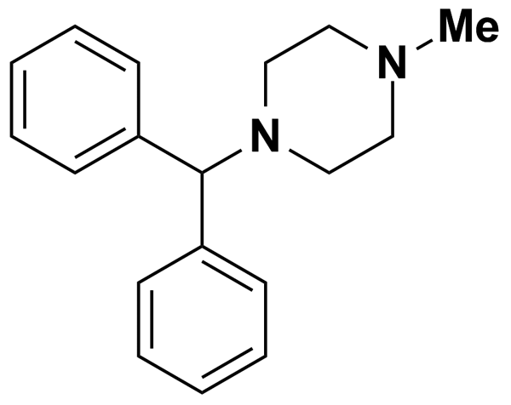
CYCLIZINE HYDROCHLORIDE | 3.30 | Prestwick Chemical Inc. | BRD-K79501723 | 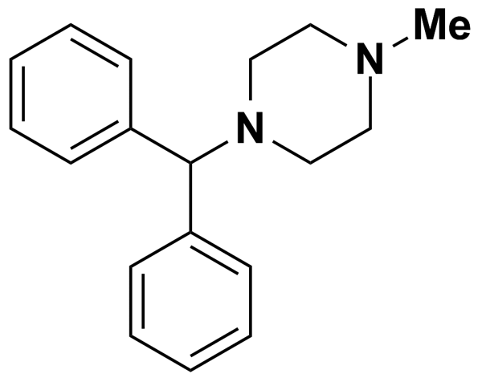
DAUNORUBICIN HYDROCHLORIDE | 1.77 | Prestwick Chemical Inc. | BRD-K43389675 | 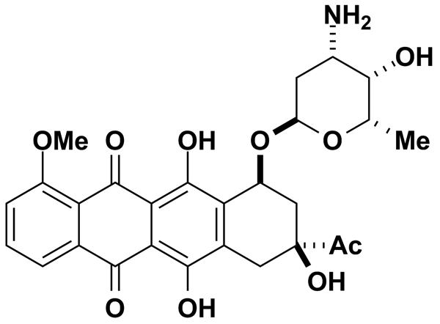
DIGITOXIN | 5.00 | MicroSource Discovery Systems Inc. | BRD-A93236127 | 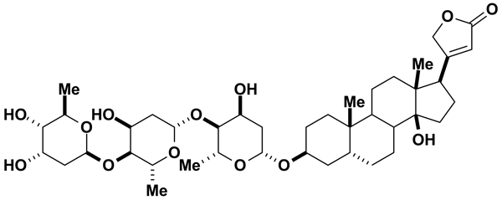
DIGOXIN | 5.00 | MicroSource Discovery Systems Inc. | BRD-A94756469 | 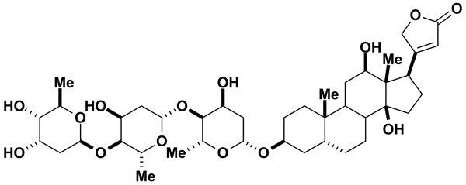
DISULFIRAM | 3.37 | Prestwick Chemical Inc. | BRD-K32744045 | 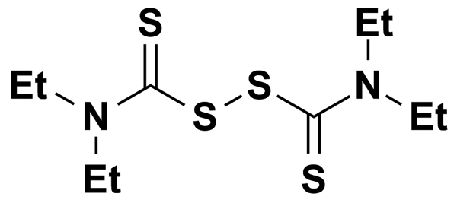
ELLIPTICINE | 4.06 | Prestwick Chemical Inc. | BRD-K85985071 | 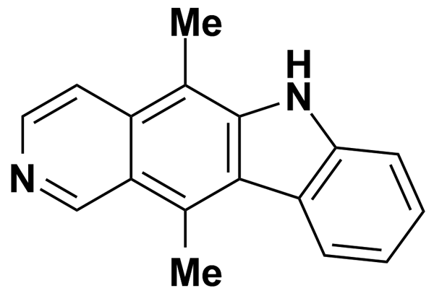
ESTRADIOL | 9.18 | Biomol International Inc. | BRD-K18910433 | 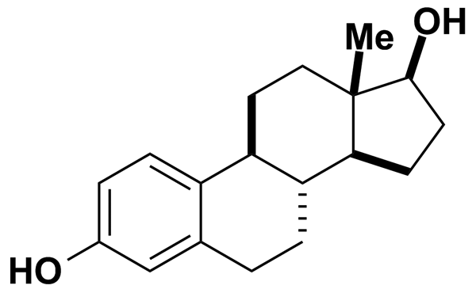
ETHINYL ESTRADIOL | 5.00 | MicroSource Discovery Systems Inc. | BRD-A02367930 | 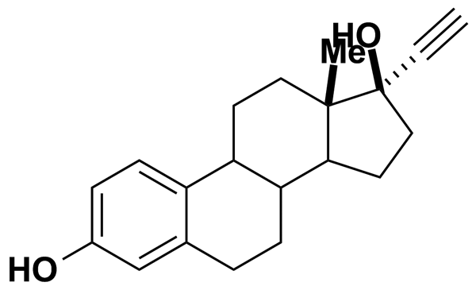
ETOPOSIDE | 1.70 | Prestwick Chemical Inc. | BRD-K37798499 | 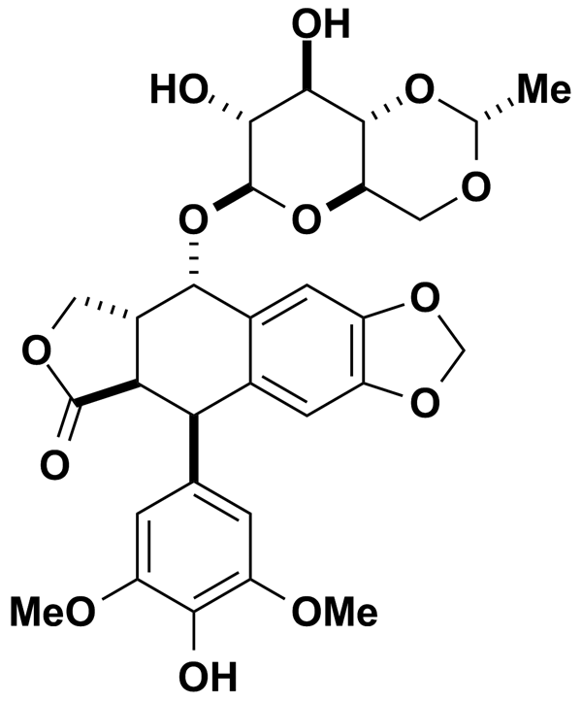
FCCP | 9.84 | Biomol International Inc. | BRD-K14821540 | 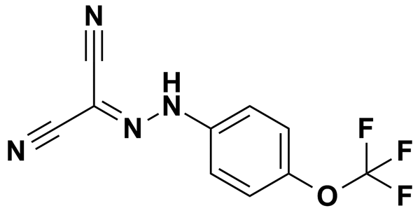
FENBENDAZOLE | 3.34 | Prestwick Chemical Inc. | BRD-K51318897 | 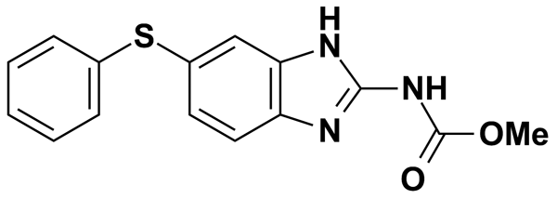
FENDILINE HYDROCHLORIDE | 2.84 | Prestwick Chemical Inc. | BRD-A71033472 | 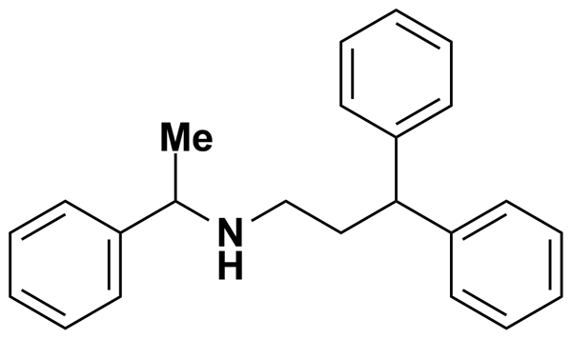
FLUPHENAZINE | 5.00 | Biomol International Inc. | BRD-K55127134 | 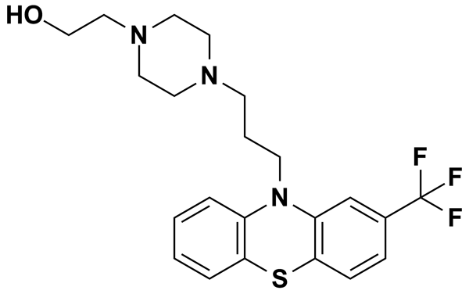
FLUPHENAZINE DIHYDROCHLORIDE | 1.96 | Prestwick Chemical Inc. | BRD-K55127134 | 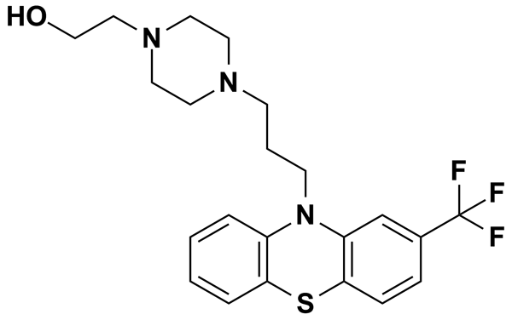
GBR 12935 | 5.00 | Biomol International Inc. | BRD-K50135270 | 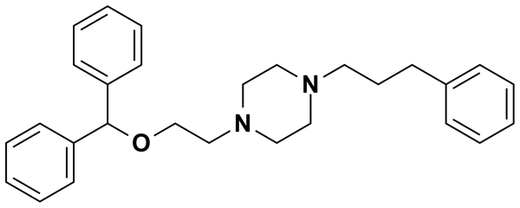
GENTIAN VIOLET | 5.00 | MicroSource Discovery Systems Inc. | BRD-K60025295 | 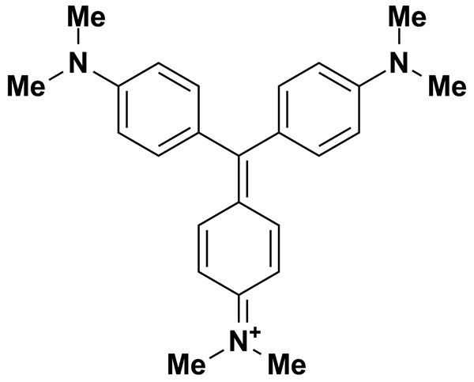
GF-109203X | 6.06 | Biomol International Inc. | BRD-K31342827 | 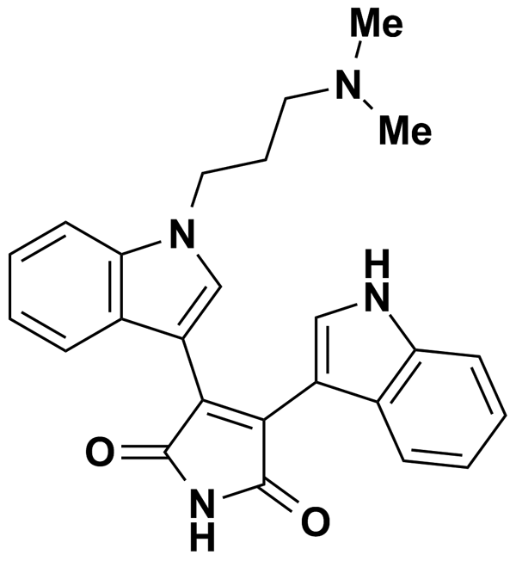
GO6976 | 6.61 | Biomol International Inc. | BRD-K59304176 | 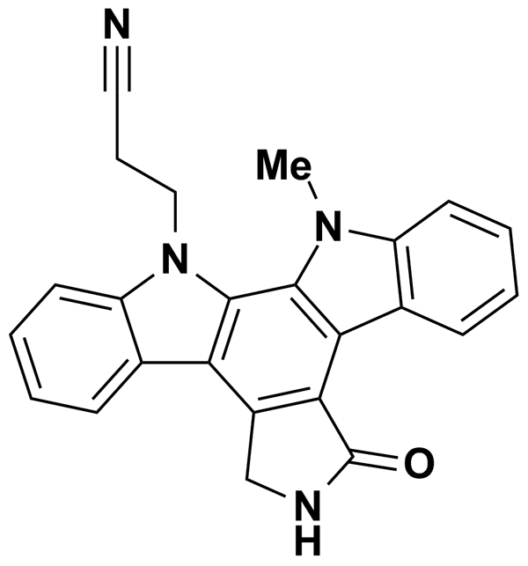
HYCANTHONE | 2.81 | Prestwick Chemical Inc. | BRD-K50406511 | 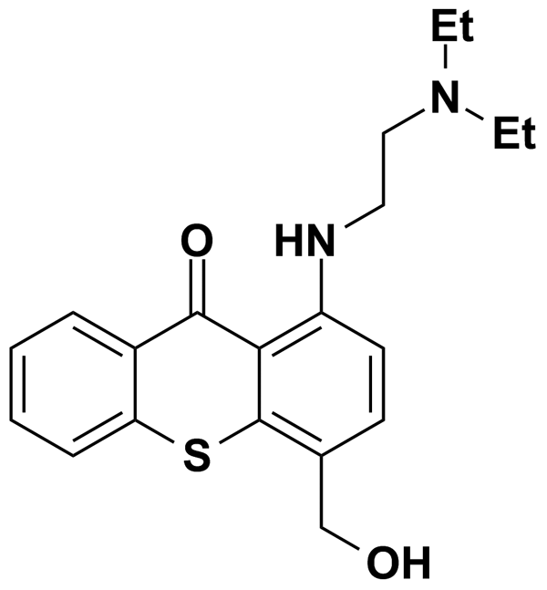
HYDROCHLOROTHIAZIDE | 3.36 | Prestwick Chemical Inc. | BRD-K13078532 | 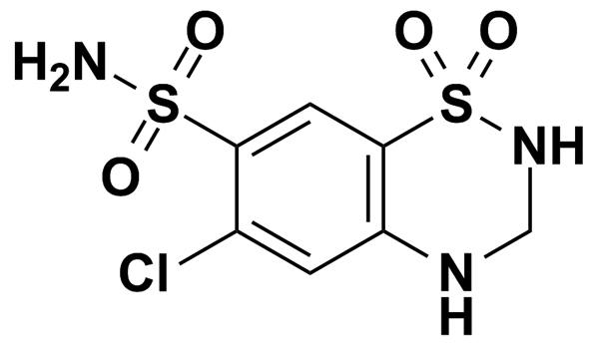
KINETIN RIBOSIDE | 5.00 | MicroSource Discovery Systems Inc. | BRD-K94325918 | 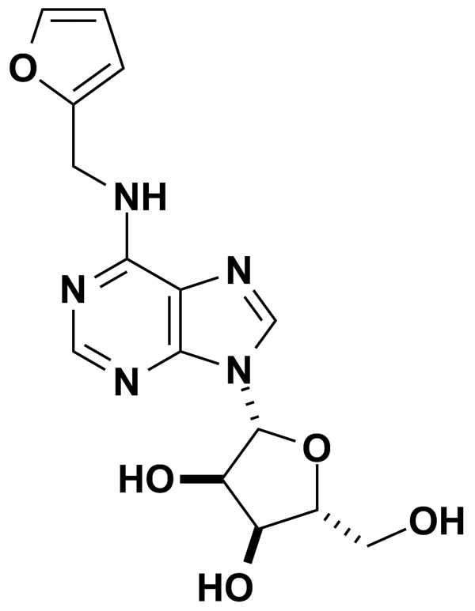
LANATOSIDE C | 5.00 | MicroSource Discovery Systems Inc. | BRD-A64242993 | 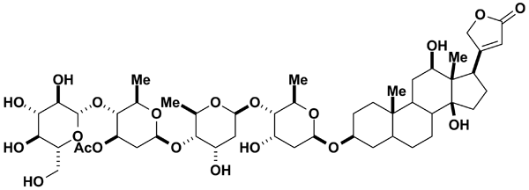
LAPACHOL | 5.00 | MicroSource Discovery Systems Inc. | BRD-A06912736 | 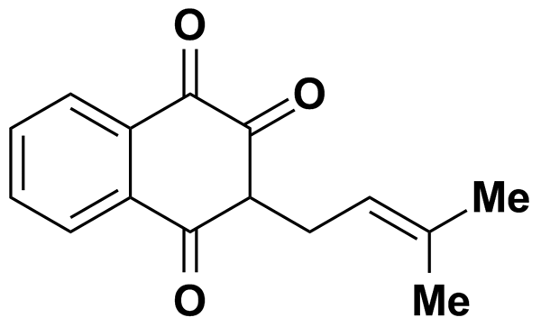
LEVAMISOLE HYDROCHLORIDE | 5.00 | MicroSource Discovery Systems Inc. | BRD-K73107279 | 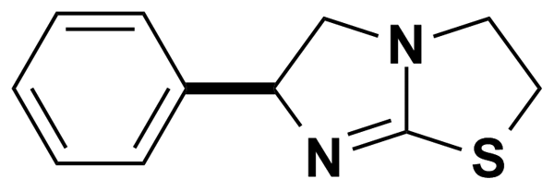
LY-294002 | 8.13 | Biomol International Inc. | BRD-K27305650 | 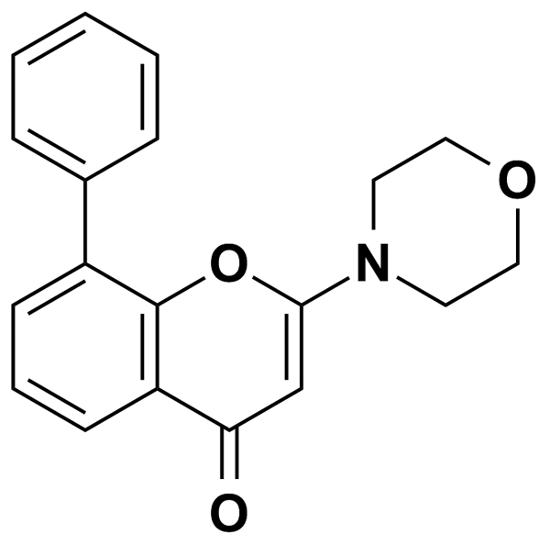
LY-83583 | 9.99 | Biomol International Inc. | BRD-K62792802 | 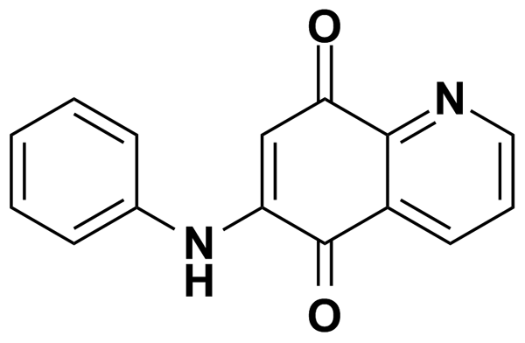
LYCORINE | 5.00 | MicroSource Discovery Systems Inc. | BRD-A10335634 | 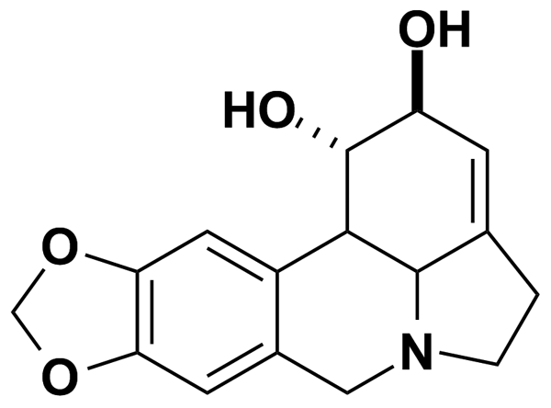
MCI-186 | 14.35 | Biomol International Inc. | BRD-K35458079 | 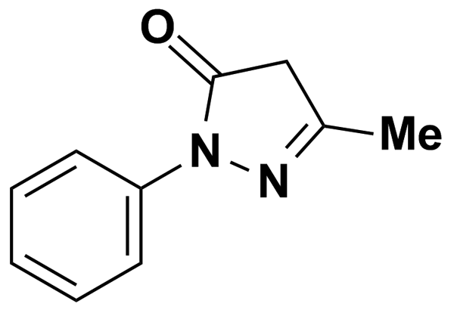
MELPHALAN | 5.00 | MicroSource Discovery Systems Inc. | BRD-K87827419 | 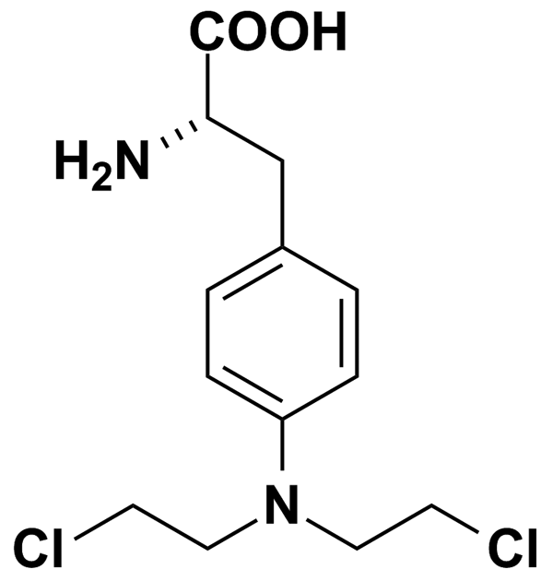
METOCLOPRAMIDE | 5.00 | Biomol International Inc. | BRD-K75641298 | 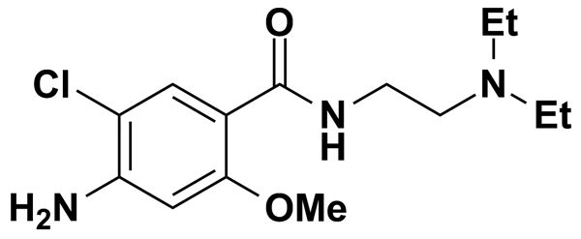
METOCLOPRAMIDE MONOHYDROCHLORIDE | 2.97 | Prestwick Chemical Inc. | BRD-K75641298 | 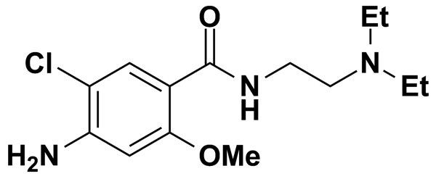
MITOXANTRONE DIHYDROCHLORIDE | 1.93 | Prestwick Chemical Inc. | BRD-K21680192 | 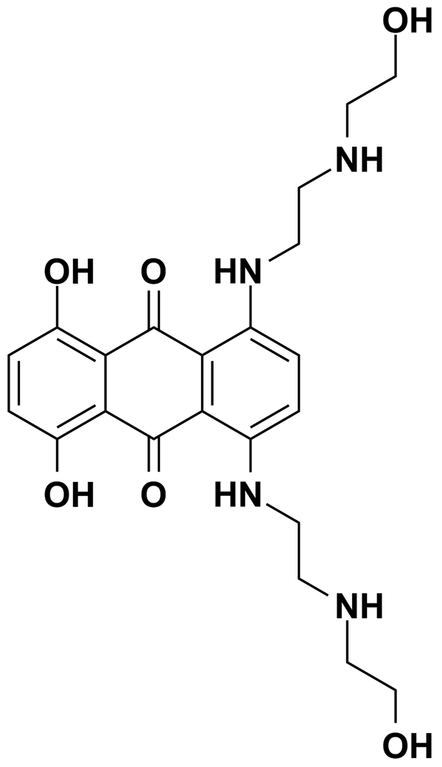
NERIIFOLIN | 5.00 | MicroSource Discovery Systems Inc. | BRD-A31385885 | 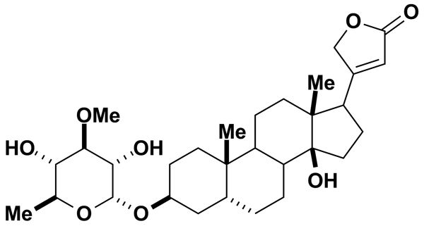
NIFLUMIC ACID | 8.86 | Biomol International Inc. | BRD-K98763141 | 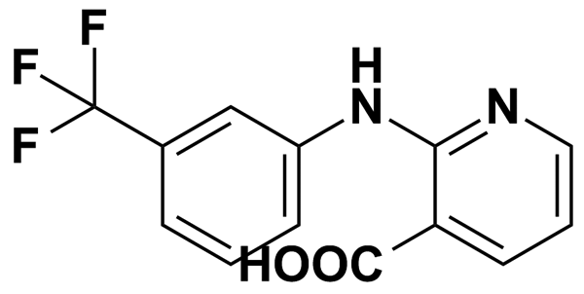
NITRENDIPINE | 6.94 | Biomol International Inc. | BRD-A02006392 | 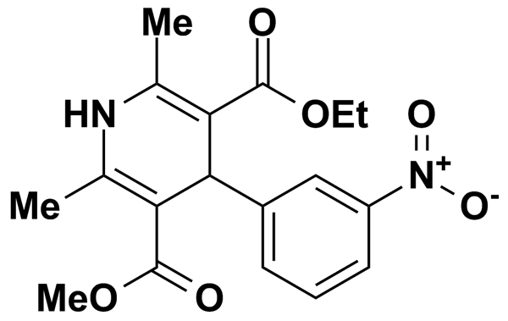
NOVOBIOCIN SODIUM | 5.00 | MicroSource Discovery Systems Inc. | BRD-K85307935 | 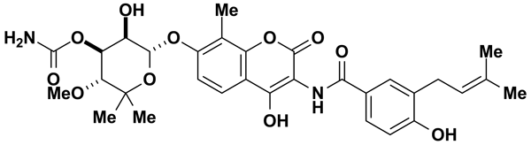
NSC-95397 | 8.05 | Biomol International Inc. | BRD-K68143200 | 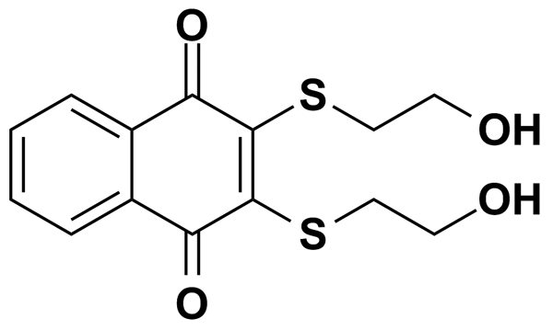
OXIBENDAZOLE | 5.00 | MicroSource Discovery Systems Inc. | BRD-K52075715 | 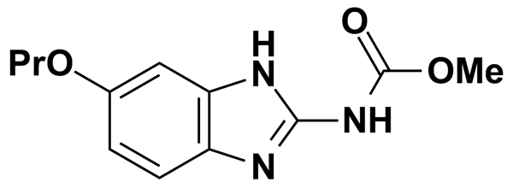
OXYPHENBUTAZONE | 3.08 | Prestwick Chemical Inc. | BRD-A33749298 | 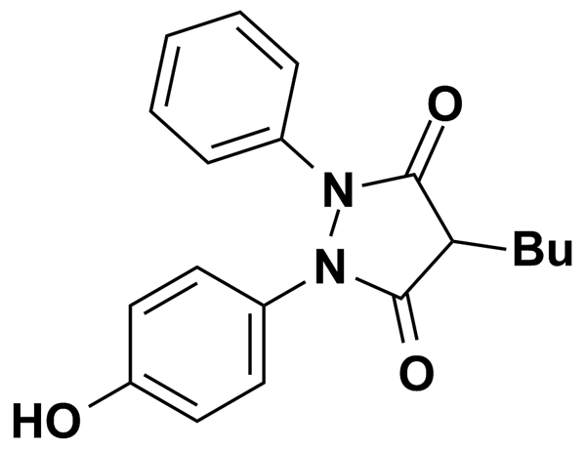
OXYQUINOLINE HEMISULFATE | 5.00 | MicroSource Discovery Systems Inc. | BRD-K66808046 | 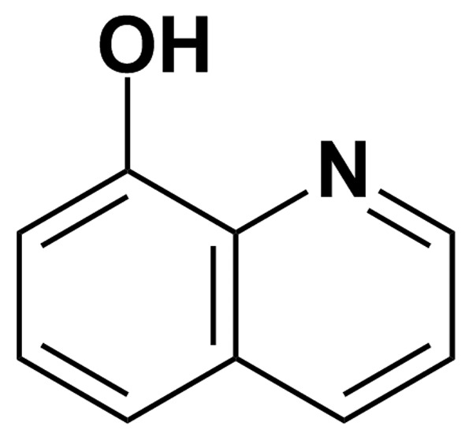
PACLITAXEL | 1.17 | Prestwick Chemical Inc. | BRD-K62008436 | 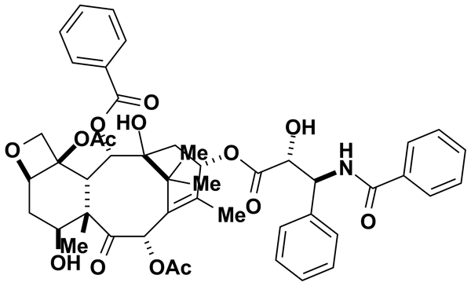
PCA 4248 | 6.92 | Biomol International Inc. | BRD-A29289453 | 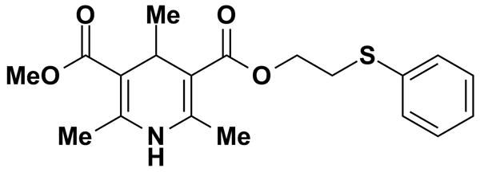
PENICILLIN V POTASSIUM | 5.00 | MicroSource Discovery Systems Inc. | BRD-K43966364 | 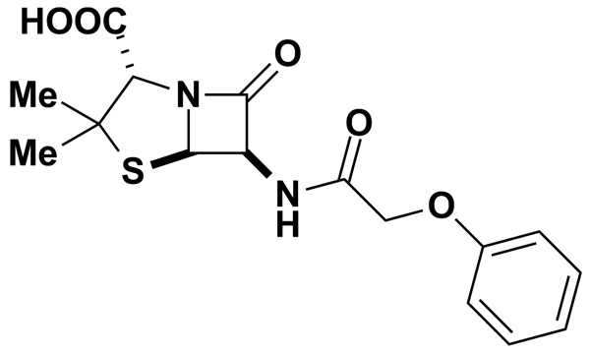
PENITREM A | 3.94 | Biomol International Inc. | BRD-K03842655 | 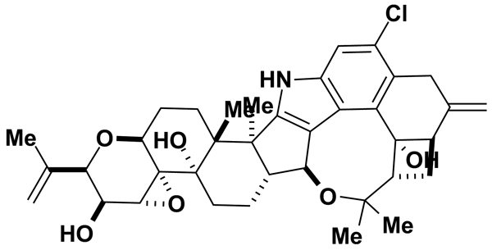
PERUVOSIDE | 5.00 | MicroSource Discovery Systems Inc. | BRD-A57089740 | 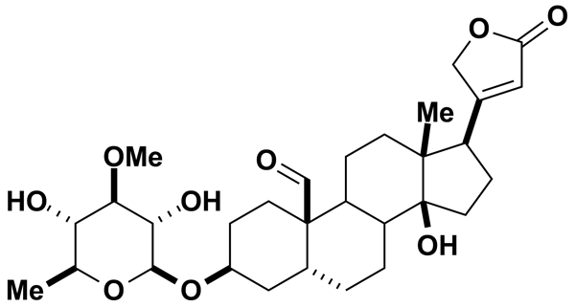
PHENACEMIDE | 5.00 | MicroSource Discovery Systems Inc. | BRD-K40905133 | 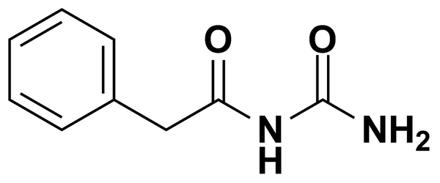
PIPERLONGUMINE | 3.15 | Prestwick Chemical Inc. | BRD-K24132293 | 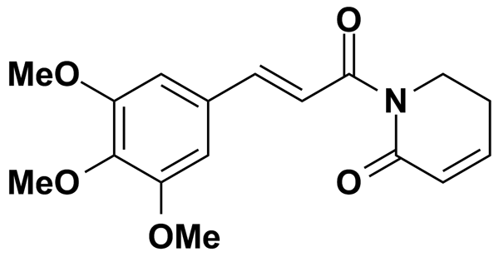
PROCAINE HYDROCHLORIDE | 3.67 | Prestwick Chemical Inc. | BRD-K24616672 | 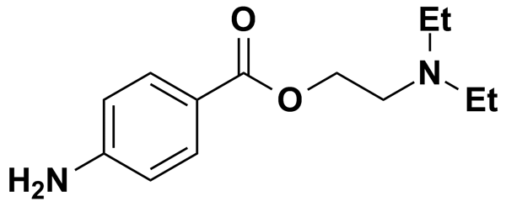
PROPAFENONE | 7.32 | Biomol International Inc. | BRD-A26334849 | 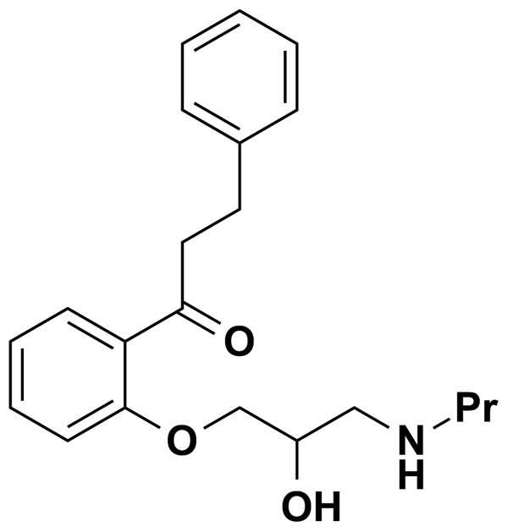
PROPAFENONE HYDROCHLORIDE | 2.65 | Prestwick Chemical Inc. | BRD-A26334849 | 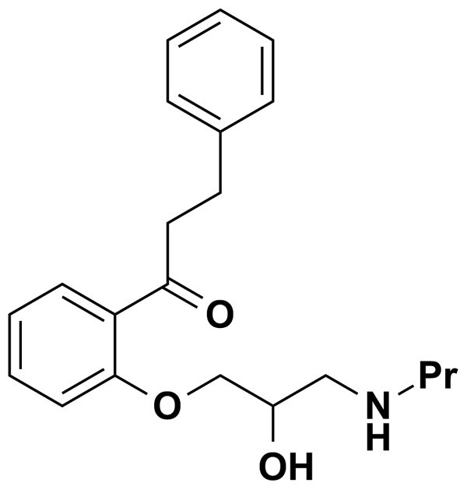
PROPIOMAZINE MALEATE | 5.00 | MicroSource Discovery Systems Inc. | BRD-A10471441 | 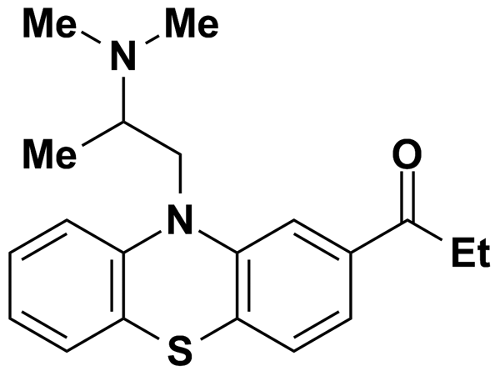
QUINACRINE DIHYDROCHLORIDE DIHYDRATE | 1.96 | Prestwick Chemical Inc. | BRD-A45889380 | 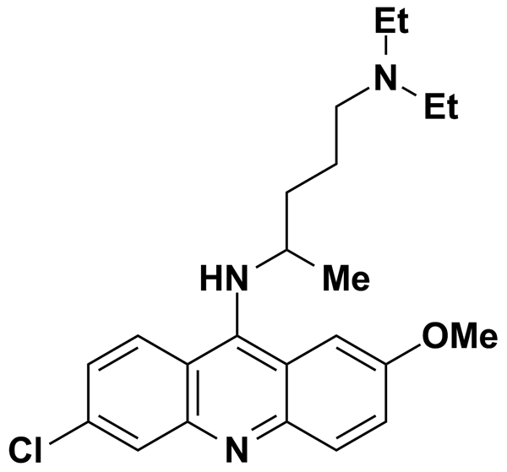
R(-)-APOMORPHINE | 5.00 | Biomol International Inc. | BRD-K76022557 | 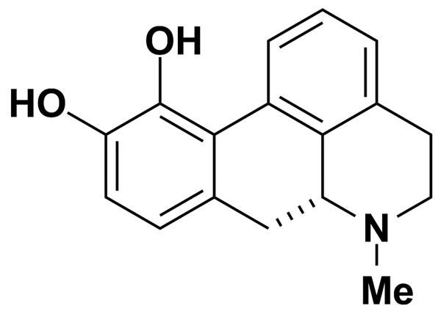
RESVERATROL | 10.95 | Biomol International Inc. | BRD-K80738081 | 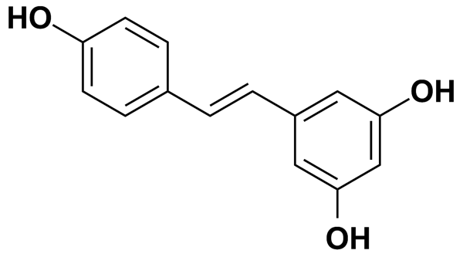
RO 31-8220 | 5.46 | Biomol International Inc. | BRD-K06543683 | 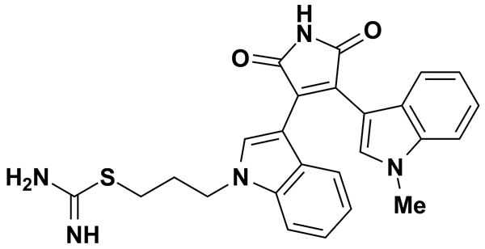
SDZ-201106 | 5.36 | Biomol International Inc. | BRD-A64553394 | 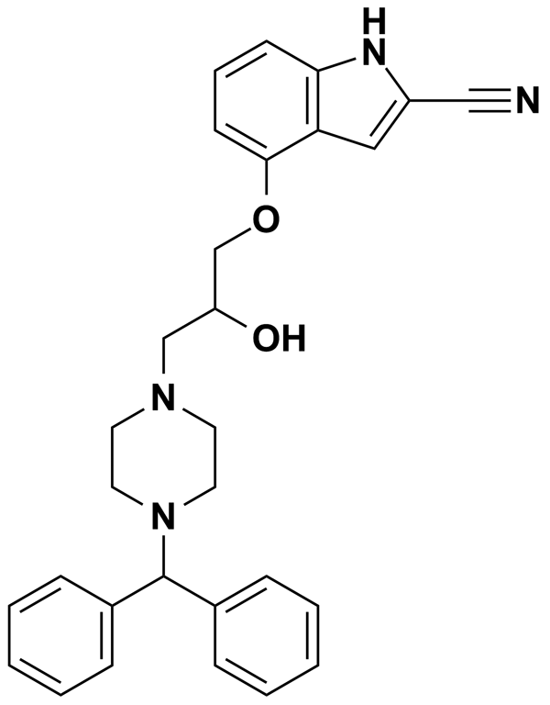
SKF-96365 | 6.82 | Biomol International Inc. | BRD-A72703248 | 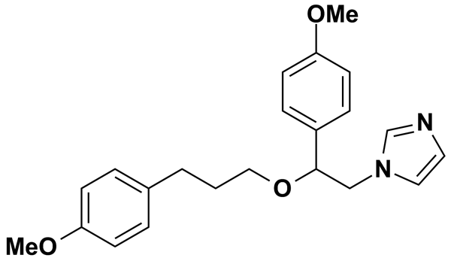
STAUROSPORINE | 5.36 | Biomol International Inc. | BRD-K17953061 | 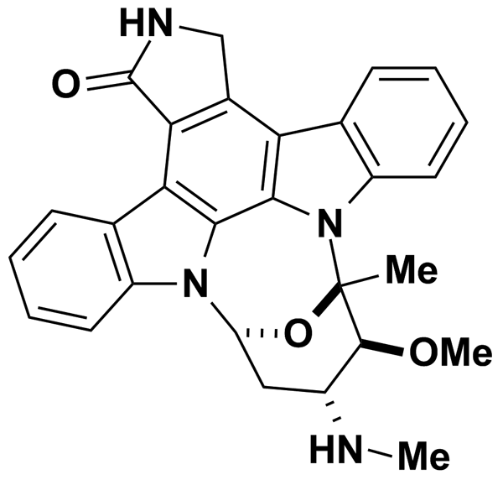
TACRINE HYDROCHLORIDE HYDRATE | 4.26 | Prestwick Chemical Inc. | BRD-K81473089 | 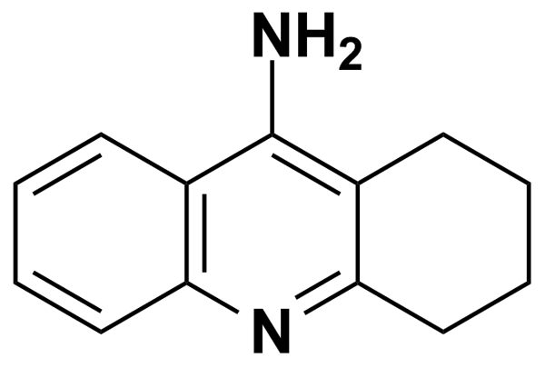
TENIPOSIDE | 5.00 | MicroSource Discovery Systems Inc. | BRD-A35588707 | 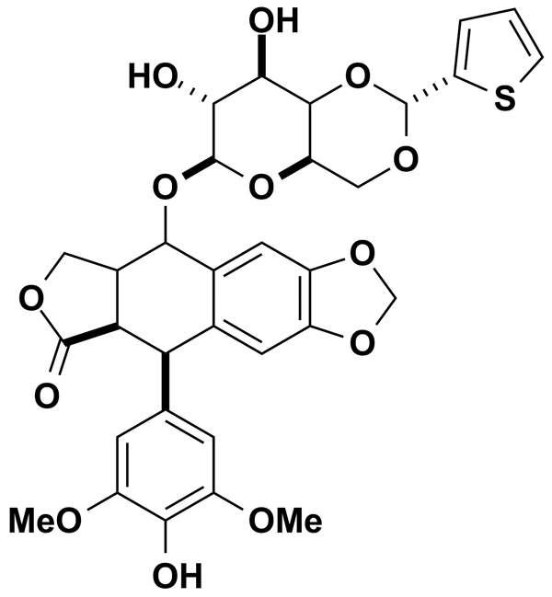
TERFENADINE | 2.12 | Prestwick Chemical Inc. | BRD-A06352418 | 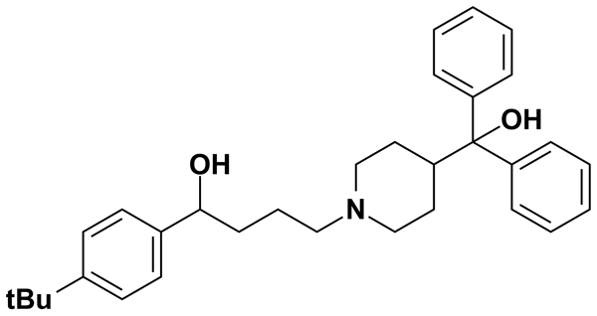
TETRAHYDROPALMATINE | 5.00 | MicroSource Discovery Systems Inc. | BRD-A43940795 | 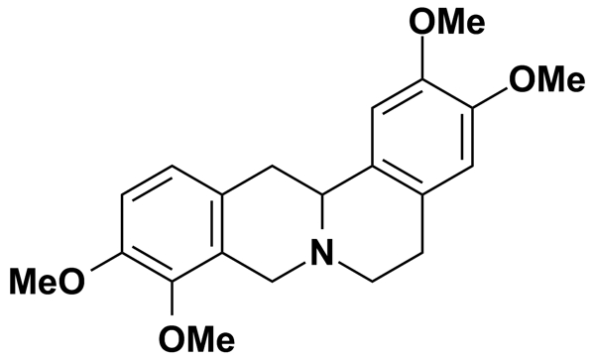
TETRANDRINE | 4.01 | Biomol International Inc. | BRD-K08078237 | 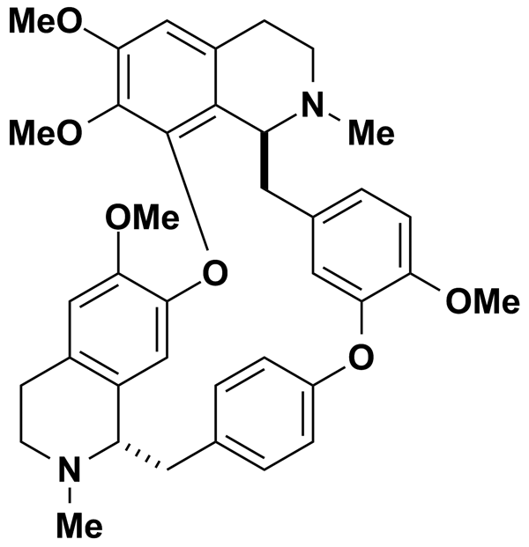
THIMEROSAL | 5.00 | MicroSource Discovery Systems Inc. | BRD-K61443650 | 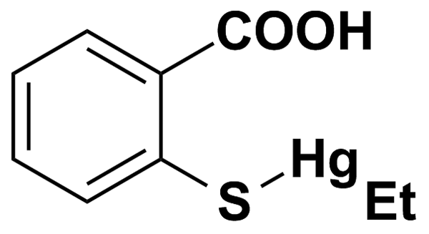
TICLOPIDINE HYDROCHLORIDE | 3.33 | Prestwick Chemical Inc. | BRD-K00603606 | 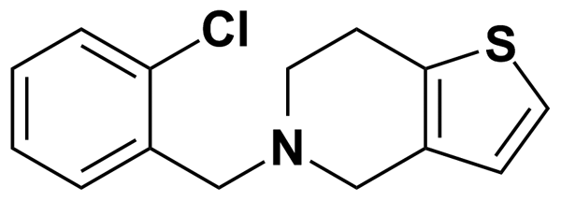
TRIFLUOPERAZINE | 5.00 | Biomol International Inc. | BRD-K89732114 | 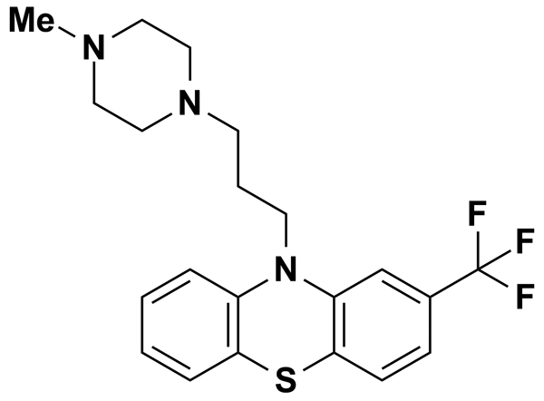
TRIFLUOPERAZINE DIHYDROCHLORIDE | 2.08 | Prestwick Chemical Inc. | BRD-K89732114 | 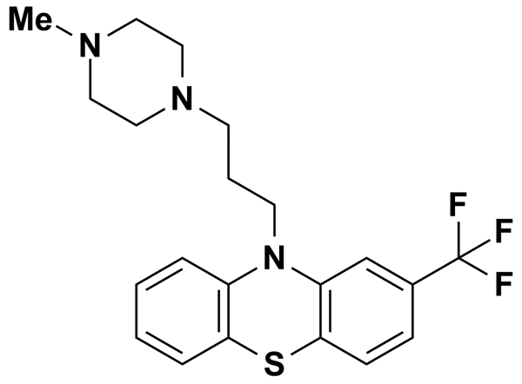
TRIPTOLIDE | 6.94 | Biomol International Inc. | BRD-K39484304 | 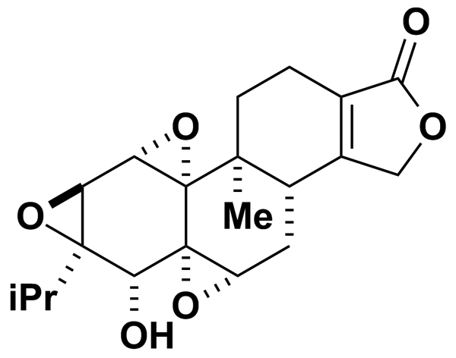
U-0126 | 5.00 | Biomol International Inc. | BRD-K18787491 | 