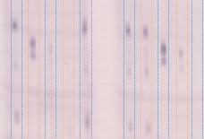

**Figure S2**. Example of microfluidic protein immunoblot generated using a 5-channel per lane microfluidic device.