62-day target

31-day target

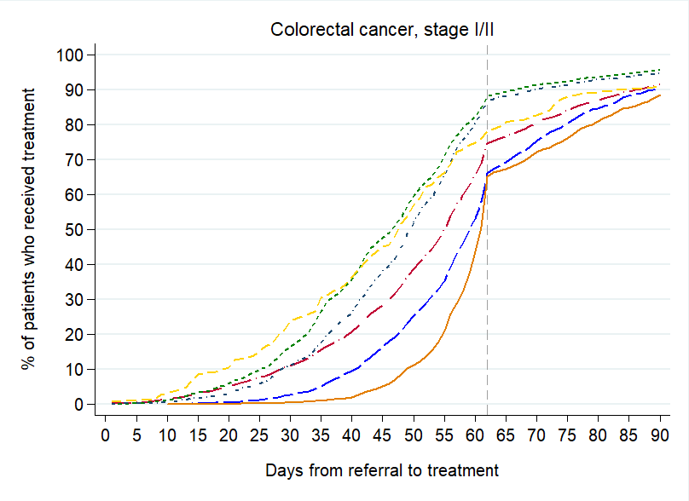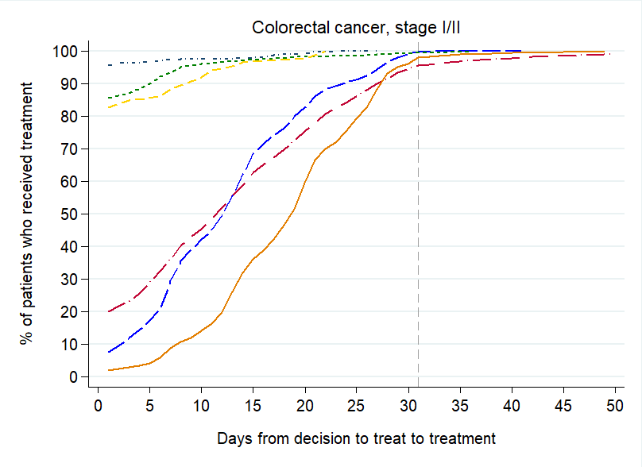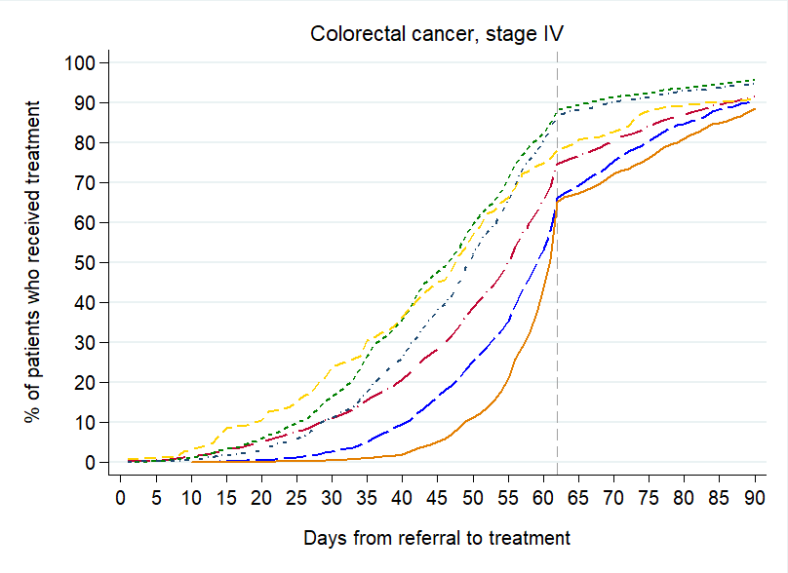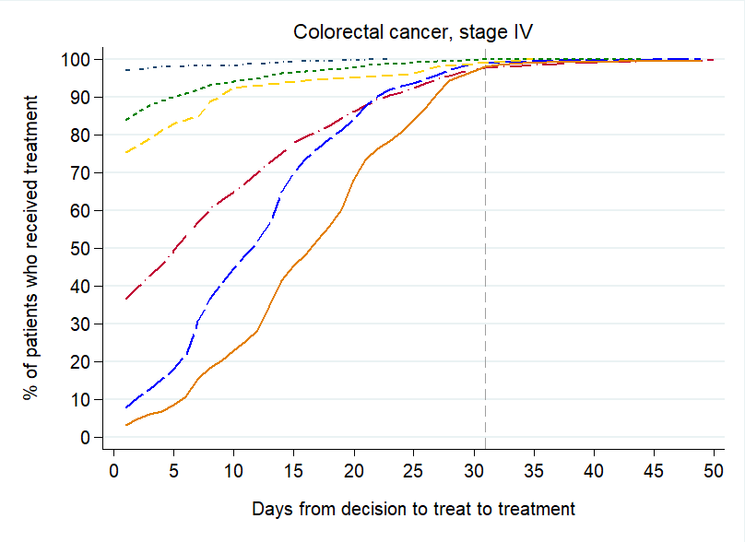



**S3 Fig: Stage-specific time-to-treatment graphs for colorectal cancer patients (stage I/II and stage IV for each target)**