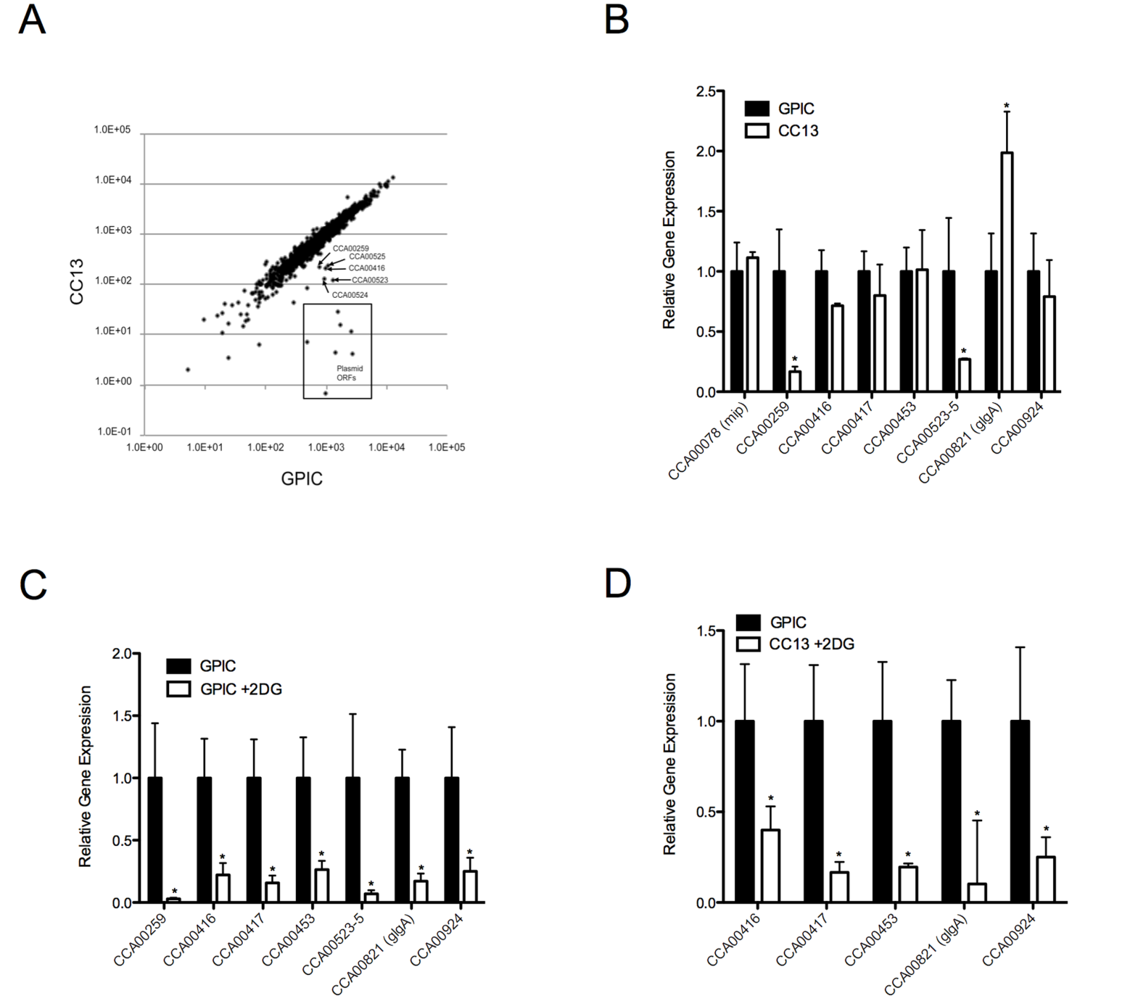

Scatter plot illustration of microarray comparison of the transcriptional profile of *C. caviae* GPIC and its plasmid-cured derivative CC13 30 hours after infection.

Supplemental Fig. 2.