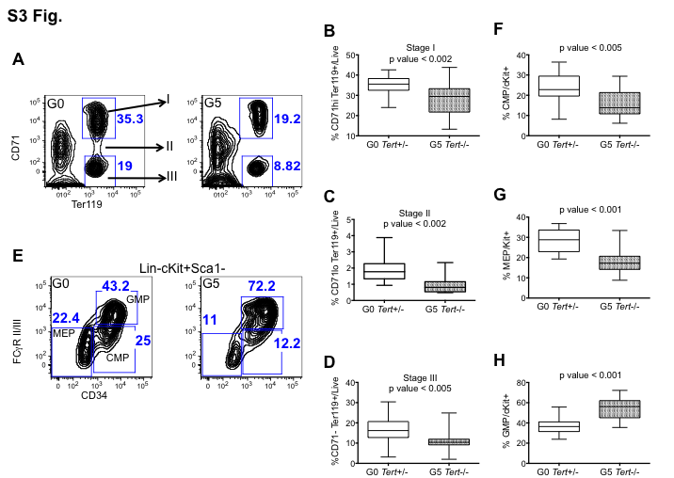

S3 Fig. Defective Erythropoiesis in G5 Tert-/- mice. (A) Representative flow cytometric (FACS) profiles of mouse BM pre-gated on live cells and separated based on levels of CD71 and Ter119 expression into three stages (I-III) of erythroid cell maturation. (B-D) Percentages of erythroblasts at stages I-III of erythroid maturation in G0 Tert+/- (n=21) and G5 Tert-/- (n=14) BM cells. (E) Representative FACS profiles of lineage-, c-Kit+ and Sca1- cells separated based on CD34 and FcγRII/III expression in G0 Tert+/- and G5 Tert-/- BM cells to define CMP (Lin-c-Kit+ Sca1- CD34+ FcγRII/IIIlo), MEP (Lin-c-Kit+ Sca1- CD34- FcγRII/III-) and GMP (Lin-c-Kit+ Sca1- CD34+ FcγRII/IIIhi) populations. (F-H) Percentages of CMP, MEP and GMP cells within the Lin-c-Kit+Sca1- population in G0 Tert+/- (n=21) and G5 Tert-/- (n=14) BM cells. The ends of the whiskers represent minimum and maximum values while the bar indicates the median value (50th percentile). p values are based on a 2-tailed t test.

