**TEXT S1.**

This document summarizes analysis that were carried out on the 46 AIMs by provinces, and main Bolivian regions.

**Figure S1. PCA analysis on the department of Beni**

D:\EUROTAST\Project Bolivia\20121112_Second_Paper_new\PCA\Departments\Analisis_13_Beni_2d.emf

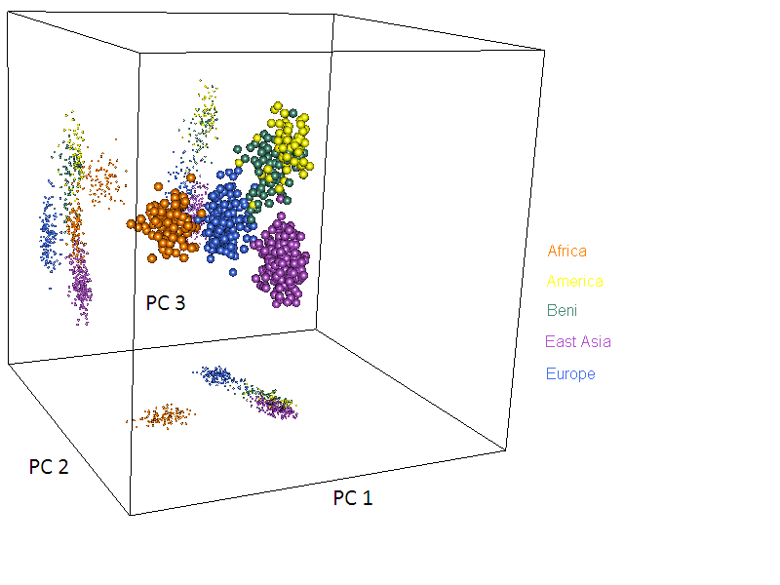

**Figure S2. PCA analysis on the department of Cochabamba**

D:\EUROTAST\Project Bolivia\20121112_Second_Paper_new\PCA\Departments\Analisis_13_CBBA_2d.emf

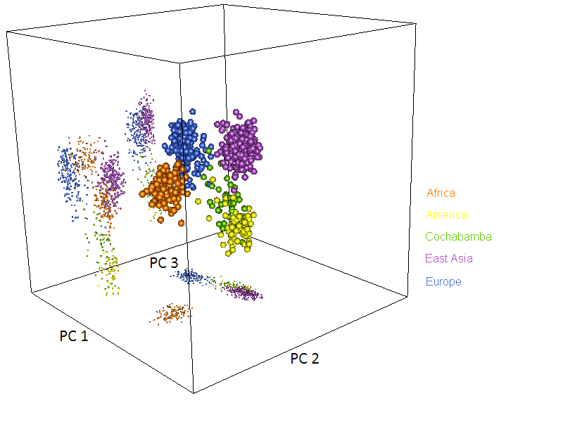

**Figure S3. PCA analysis on the department of Chuquisaca**

D:\EUROTAST\Project Bolivia\20121112_Second_Paper_new\PCA\Departments\Analisis_13_CH_2d.emf

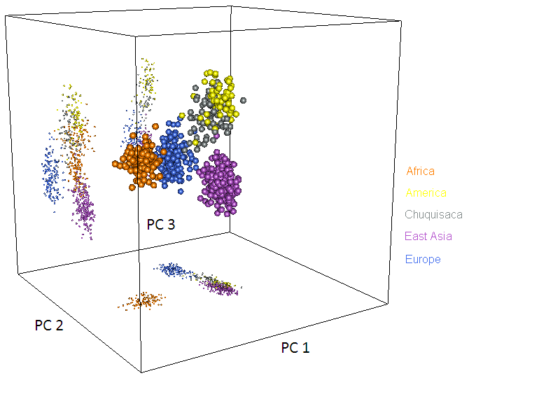

**Figure S4. PCA analysis on the department of La Paz**

D:\EUROTAST\Project Bolivia\20121112_Second_Paper_new\PCA\Departments\Analisis_13_LP_2d.emf

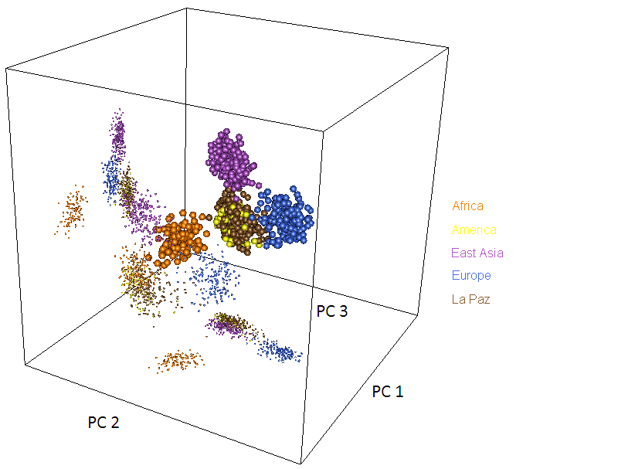

**Figure S5. PCA analysis on the department of Pando**

D:\EUROTAST\Project Bolivia\20121112_Second_Paper_new\PCA\Departments\Analisis_13_Pando_2d.emf

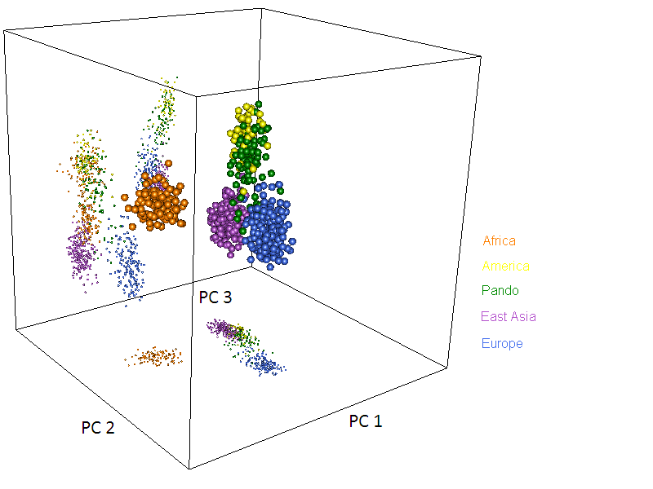

**Figure S6. PCA analysis on the department of Santa Cruz**

**D:\EUROTAST\Project Bolivia\20121112_Second_Paper_new\PCA\Departments\Analisis_13_Santa_Cruz_2d.emf**

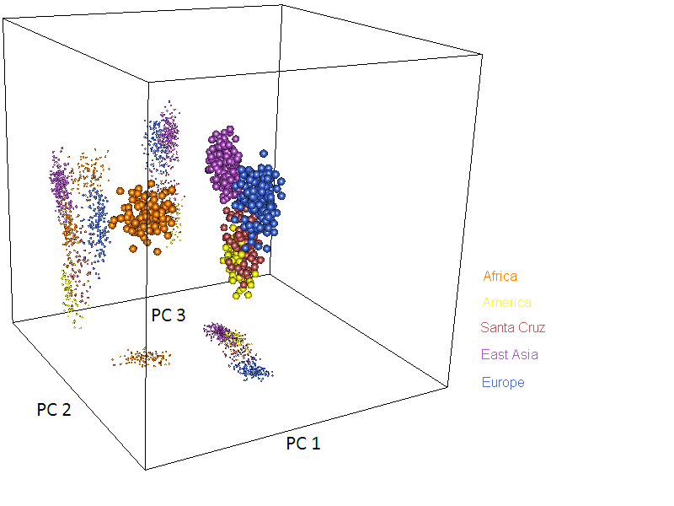

**Figure S7. Structure analysis carried out by departments**

**Figure S8. Structure analysis carried out by main regions**

**Figure S9. Structure analysis carried out in rural and urban locations**

**Figure S9. Structure analysis carried out in the whole Bolivian sample**