**Supplementary figure S3**

**Figure S3A**. Map of MCH and the drainage network in a part of the Agua Salud ecosystem services project. (See <http://www.ctfs.si.edu/aguasalud/>). Distances and heights are in meters.

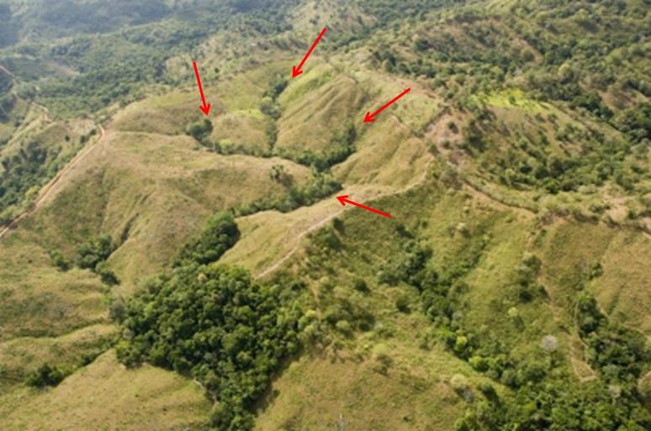

**Figure S3B**. Aerial photograph of part of the Agua Salud study area (source <http://www.ctfs.si.edu/aguasalud/>). The arrows indicate vegetation structure clearly associated with the drainage network.

Source: [http://www.ctfs.si.edu](http://www.ctfs.si.edu/)