**SUPPLEMENTARY MATERIAL**

**A MULTIPLEX ASSAY BASED ON CHIMERIC CITRULLINATED PEPTIDES FOR THE DIAGNOSIS OF RHEUMATOID ARTHRITIS**

Cristina García-Moreno, María José Gómara, María José Bleda, Raimon Sanmartí and Isabel Haro

**a**

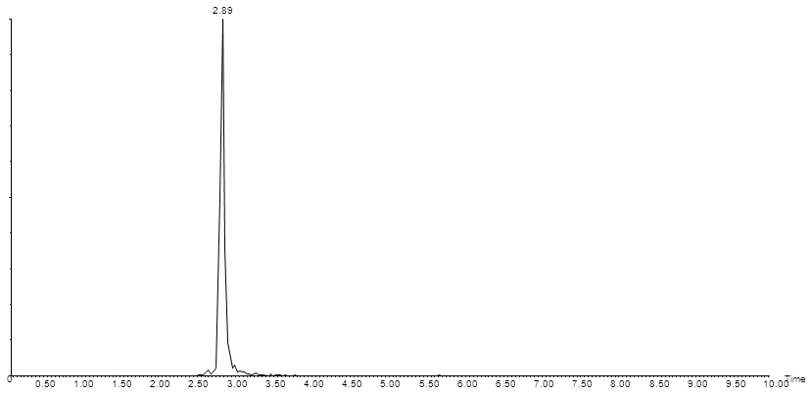

**b**

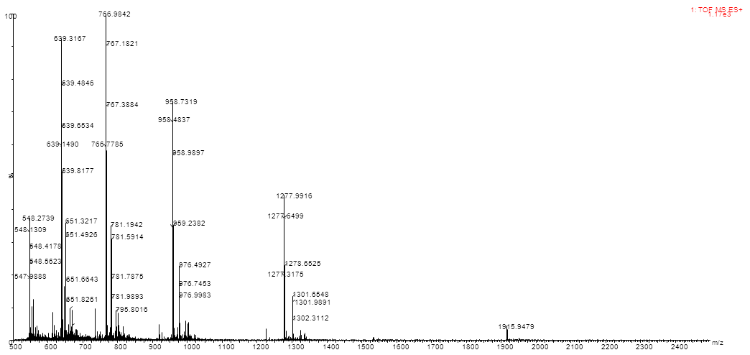

**Figure A**. UPLC-MS characterization of CFECP. (a) Peptide Elution was performed on an Acquity UPLC BEH C18 column (2.1×100 mm, 1.7 μm) with a linear gradient of 5%-100% solvent B (20mM formic acid in ACN) into solvent A (20mM formic acid in water) over 10min at 0.3mL/min. (b) The mass spectrum was recorded in positive ion mode in the m/z 500-2500 range. Calculated m/z: [M+2H]+2=1915.46, [M+3H]+3=1277.31, [M+4H]+4=958.24, [M+5H]+5=766.79, [M+6H]+6=639.16, [M+7H]+7=547.99; experimental m/z: [M+2H]+2=1915.95, [M+3H]+3=1277.31, [M+4H]+4=958.48, [M+5H]+5=766.77, [M+6H]+6=639.15, [M+7H]+7=547.99

**a**

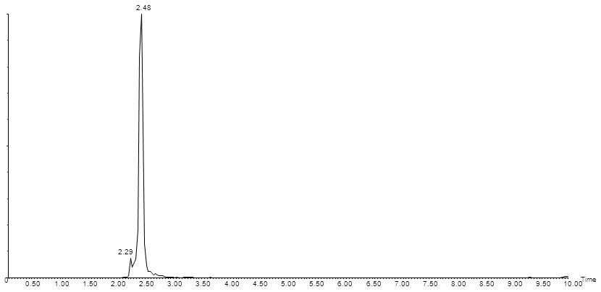

**b**

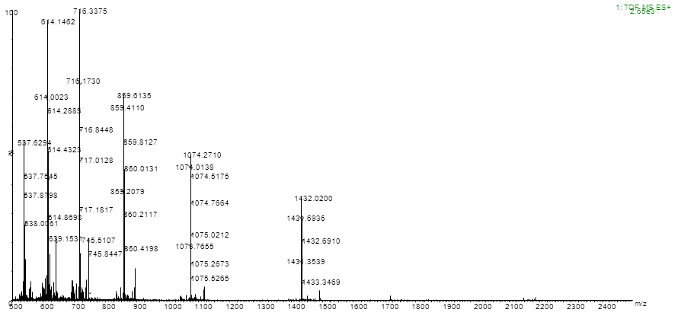

**Figure B**. UPLC-MS characterization of CEFCP. (a) Peptide Elution was performed on an Acquity UPLC BEH C18 column (2.1×100 mm, 1.7 μm) with a linear gradient of 5%-100% solvent B (20mM formic acid in ACN) into solvent A (20mM formic acid in water) over 10min at 0.3mL/min. (b) The mass spectrum was recorded in positive ion mode in the m/z 500-2500 range. Calculated m/z: [M+3H]+3=1431.02, [M+4H]+4=1073.51, [M+5H]+5=859.01; [M+6H]+6=716.01, [M+7H]+7=613.87, [M+8H]+8=537.26; experimental m/z: [M+3H]+3=1431.35, [M+4H]+4=1073.76, [M+5H]+5=859.20; [M+6H]+6=716.17, [M+7H]+7=614.00, [M+8H]+8=537.62

**a**

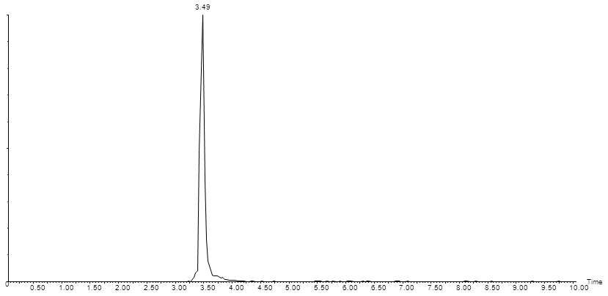

**b**

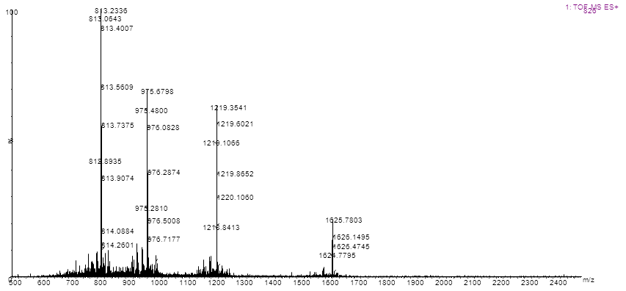

**Figure C**. UPLC-MS characterization of CVECP. (a) Peptide Elution was performed on an Acquity UPLC BEH C18 column (2.1×100 mm, 1.7 μm) with a linear gradient of 5%-100% solvent B (20mM formic acid in ACN) into solvent A (20mM formic acid in water) over 10min at 0.3mL/min. (b) The mass spectrum was recorded in positive ion mode in the m/z 500-2500 range. Calculated m/z: [M+3H]+3=1625.14, [M+4H]+4=1219.11, [M+5H]+5=975.49; [M+6H]+6=813.07; experimental m/z: [M+3H]+3=1624.78, [M+4H]+4=1218.84, [M+5H]+5=975.28; [M+6H]+6=812.89

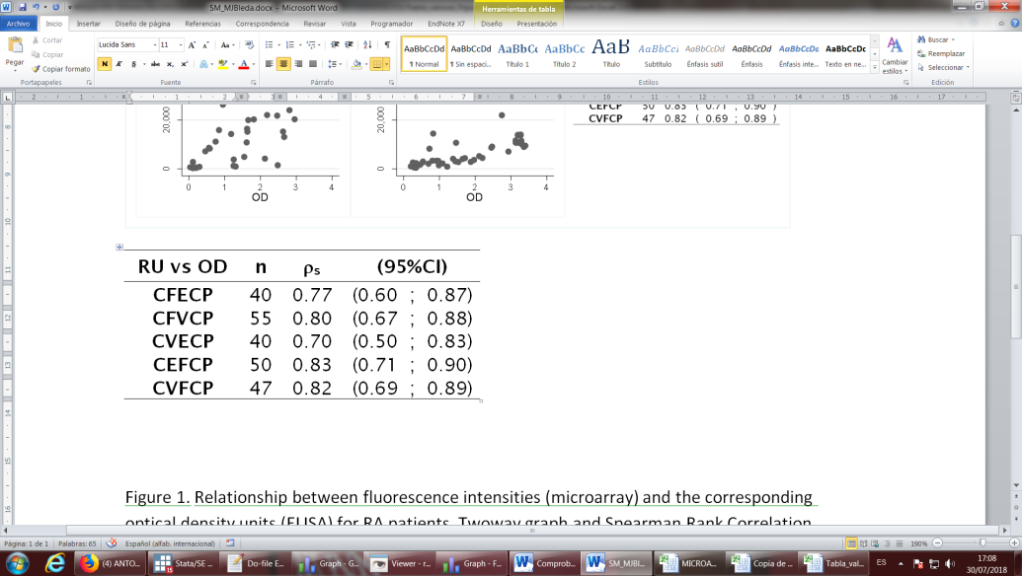 

**Figure D**. Relationship between fluorescence intensities (microarray) (RU) and the corresponding optical density units (ELISA) (OD) for RA patients (n). Two-way graphs and Spearman’s rank correlation coefficients (ρs) with their 95% confidence interval (95%CI).



**Figure E**. ROC curves analysis from microarray results with chimeric fibrin-filaggrin citrullinated peptides (CFFCP1, CFFCP2, CFFCP3), chimeric vimentin-filaggrin citrullinated peptide (CVFCP), chimeric fibrin-vimentin citrullinated peptide (CFVCP), chimeric enolase-filaggrin citrullinated peptide (CEFCP), chimeric vimentin-enolase citrullinated peptide (CVECP)and chimeric fibrin-enolase citrullinated peptide (CFECP) in the RA and BD cohorts of patients.

**Table A**. Number of discarded sera in RA, BD and PsA cohorts due to a high variability in the fluorescence intensity response units of corresponding triplicates spots for citrullinated and control peptides.

|  |  |  |  |  |  |  |  |  |
| --- | --- | --- | --- | --- | --- | --- | --- | --- |
| **RA (n = 70)** | | | | | | | | |
|  | **Discarded sera**  **CV > 25%** | | **Control peptide** | **Discarded sera**  **CV > 30%** | | **Discarded pairs**  **Peptide or Control CV > 25%,30%** | | **Final pairs** |
| **CFFCP1** | **20** | (28.57%) | **CFFCP-R** | **21** | (30.00%) | **36** | (51.43%) | **34** |
| **CFFCP2** | **21** | (30.00%) | **CFFCP-R** | **21** | (30.00%) | **36** | (51.43%) | **34** |
| **CFFCP3** | **10** | (14.29%) | **CFFCP-R** | **21** | (30.00%) | **26** | (37.14%) | **44** |
| **CFECP** | **16** | (22.86%) | **CFECP-R** | **21** | (30.00%) | **32** | (45.71%) | **38** |
| **CFVCP** | **0** | (0.00%) | **CFVCP-R** | **13** | (18.57%) | **13** | (18.57%) | **57** |
| **CVECP** | **15** | (21.43%) | **CVECP-R** | **13** | (18.57%) | **24** | (34.29%) | **46** |
| **CEFCP** | **6** | (8.57%) | **CEFCP-R** | **21** | (30.00%) | **25** | (35.71%) | **45** |
| **CVFCP** | **8** | (11.43%) | **CVFCP-R** | **13** | (18.57%) | **18** | (25.71%) | **52** |
| **BD (n = 70)** | | | | | | | | |
|  | **Discarded sera**  **CV > 30%** | | **Control peptide** | **Discarded sera**  **CV > 30%** | | **Discarded pairs**  **Peptide or Control CV > 30%** | | **Final pairs** |
| **CFFCP1** | **7** | (10.00%) | **CFFCP-R** | **14** | (20.00%) | **20** | (28.57%) | **50** |
| **CFFCP2** | **20** | (28.57%) | **CFFCP-R** | **14** | (20.00%) | **30** | (42.86%) | **40** |
| **CFFCP3** | **14** | (20.00%) | **CFFCP-R** | **14** | (20.00%) | **24** | (34.29%) | **46** |
| **CFECP** | **10** | (14.29%) | **CFECP-R** | **11** | (15.71%) | **18** | (25.71%) | **52** |
| **CFVCP** | **3** | (4.29%) | **CFVCP-R** | **7** | (10.00%) | **10** | (14.29%) | **60** |
| **CVECP** | **13** | (18.57%) | **CVECP-R** | **7** | (10.00%) | **17** | (24.29%) | **53** |
| **CEFCP** | **3** | (4.29%) | **CEFCP-R** | **11** | (15.71%) | **13** | (18.57%) | **57** |
| **CVFCP** | **8** | (11.43%) | **CVFCP-R** | **7** | (10.00%) | **14** | (20.00%) | **56** |
| **PsA (n = 70)** | | | | | | | | |
|  | **Discarded sera**  **CV > 30%** | | **Control peptide** | **Discarded sera**  **CV > 30%** | | **Discarded pairs**  **Peptide or Control CV > 30%** | | **Final pairs** |
| **CFFCP1** | **9** | (12.86%) | **CFFCP-R** | **3** | (4.29%) | **12** | (17.14%) | **58** |
| **CFFCP2** | **29** | (41.43%) | **CFFCP-R** | **3** | (4.29%) | **32** | (45.71%) | **38** |
| **CFFCP3** | **11** | (15.71%) | **CFFCP-R** | **3** | (4.29%) | **14** | (20.00%) | **56** |
| **CFECP** | **8** | (11.43%) | **CFECP-R** | **14** | (20.00%) | **18** | (25.71%) | **52** |
| **CFVCP** | **1** | (1.43%) | **CFVCP-R** | **6** | (8.57%) | **7** | (10.00%) | **63** |
| **CVECP** | **10** | (14.29%) | **CVECP-R** | **6** | (8.57%) | **15** | (21.43%) | **55** |
| **CEFCP** | **3** | (4.29%) | **CEFCP-R** | **14** | (20.00%) | **17** | (24.29%) | **53** |
| **CVFCP** | **7** | (10.00%) | **CVFCP-R** | **6** | (8.57%) | **13** | (18.57%) | **57** |

**Table B**. Reactivity of RA, BD and PsA cohorts to each citrullinated peptide.

|  |  |  |  |  |  |  |  |  |  |
| --- | --- | --- | --- | --- | --- | --- | --- | --- | --- |
|  | **RA** | | | **BD** | | | **PsA** | | |
| Number of sera reacting | **Number of positive** | (%) | Number of sera reacting | **Number of positive** | (%) | Number of sera reacting | **Number of positive** | (%) |
| **CFFCP1** | 34 | **20** | (58.8) | 50 | **1** | (2.0) | 58 | **0** | (0.0) |
| **CFFCP2** | 34 | **23** | (67.7) | 40 | **0** | (0.0) | 38 | **1** | (2.6) |
| **CFFCP3** | 44 | **35** | (79.6) | 46 | **0** | (0.0) | 56 | **0** | (0.0) |
| **CFECP** | 38 | **30** | (80.0) | 52 | **1** | (1.9) | 52 | **5** | (9.6) |
| **CFVCP** | 57 | **21** | (36.8) | 60 | **1** | (1.7) | 63 | **0** | (0.0) |
| **CVECP** | 46 | **39** | (84.8) | 53 | **1** | (1.9) | 55 | **3** | (5.5) |
| **CEFCP** | 45 | **38** | (84.4) | 57 | **1** | (1.8) | 53 | **0** | (0.0) |
| **CVFCP** | 52 | **42** | (80.8) | 56 | **1** | (1.8) | 57 | **0** | (0.0) |