**SIM Chromatograms with m/z values**

Fig A. Protocatechuic acid



Fig B. Pinocembrin



Fig C. Kaempferol



Fig D. Apigenin



Fig E. Chrysin



Fig F. Galangin



Fig G. Chlorogenic acid



Fig H. Daidzein



Fig I. Ellagic acid



Fig J. Ferrulic acid



Fig K. Gallic acid



Fig L. Hesperetin



Fig M. Hydroxytyrosol



Fig N. Luteolin



Fig O. p-Coumaric acid



Fig P. Pinobanksin



Fig Q. Pin-7-ME



Fig R. Quercetin



Fig S. Techtochrysin



Fig T. Caffeic acid



Fig U. Sakuranetin



Fig V. Rhamnetin



Fig W. Pinostrobin



Fig X. Syringic acid



Fig Y. Kaempferide



Fig Z. Acacetin



Fig A1. Rutin



Fig B1. Protocatechuic acid ethyl ester



Fig C1. Resveratrol



Fig D1. Phloridzin



Fig E1. Naringenin



Fig F1. Eriodictyol



Fig G1. Diosmetin



Fig H1. Rosmarinic acid



Fig I1. Myricetin



Fig J1. Isorhamnetin



Fig K1. Isosakuranetin



Fig L1. Catechin (in modified prolonged method)



Fig M1. Orientin

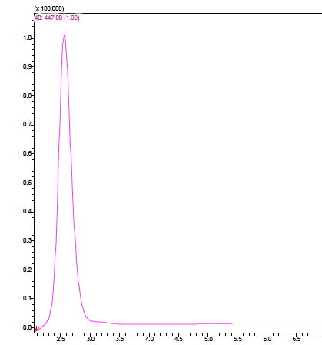

Fig N1. Vitexin



Fig O1. t-Cinnamic acid



Fig P1. Pinobanksin 3o-acetate



Fig Q1. Cinnamilidene acetic acid

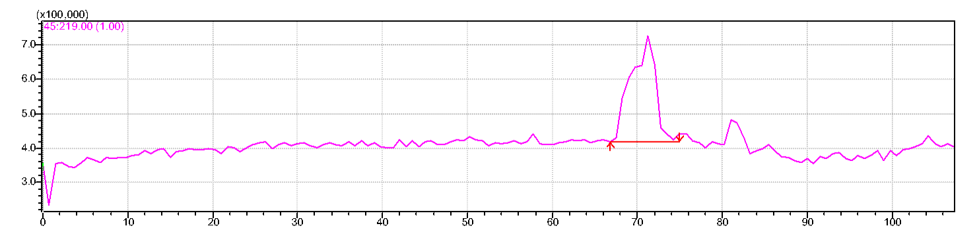

Fig R1. Artepillin c



Fig S1. Adipic acid



Fig T1. Ursolic acid



Fig U1. Suberic acid



Fig V1. Genistein



Fig W1. Hesperidin



Fig X1. Isoferulic acid



Fig Y1. Tangeretin



Fig Z1. Diosmin



Fig A2. Vanillin



Fig B2. Chrysoeriol



Fig C2. Naringin

