**Novel NAC transcription factor TaNAC67 confers enhanced multi-stress tolerances in *Arabidopsis***

Xinguo Mao, Shuangshuang Chen, Ang Li, Chaochao Zhai, Ruilian Jing*

The Key Laboratory for Crop Gene Resources and Germplasm Enhancement, Ministry of Agriculture; The National Key Facility for Crop Gene Resources and Genetic Improvement; Institute of Crop Science, Chinese Academy of Agricultural Sciences, Beijing 100081, China

*Corresponding author

Contact Information

Ruilian Jing

Institute of Crop Science

Chinese Academy of Agricultural Sciences

Beijing 100081

China

Tel/Fax: 86-10-82105829

Email: [jingrl@caas.net. cn](mailto:jingrl@caas.net.%20cn)

**Supplementary information**

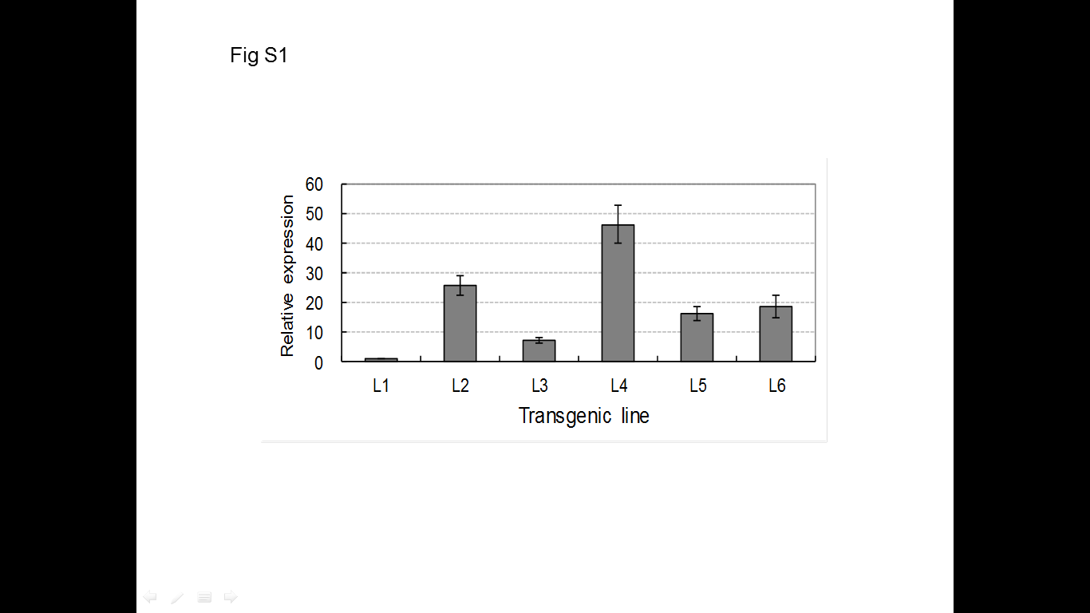

**Fig. S1 Expression levels of *TaNAC67* in different transgenic *Arabidopsis* lines**

Gene expression levels of *TaNAC67* differed significantlyin different transgenic *Arabidopsis* lines. L1 - 6, *TaNAC67* transgenic lines. The expression of *TaNAC67* in L1 was regarded as a standard for its lower expression level.

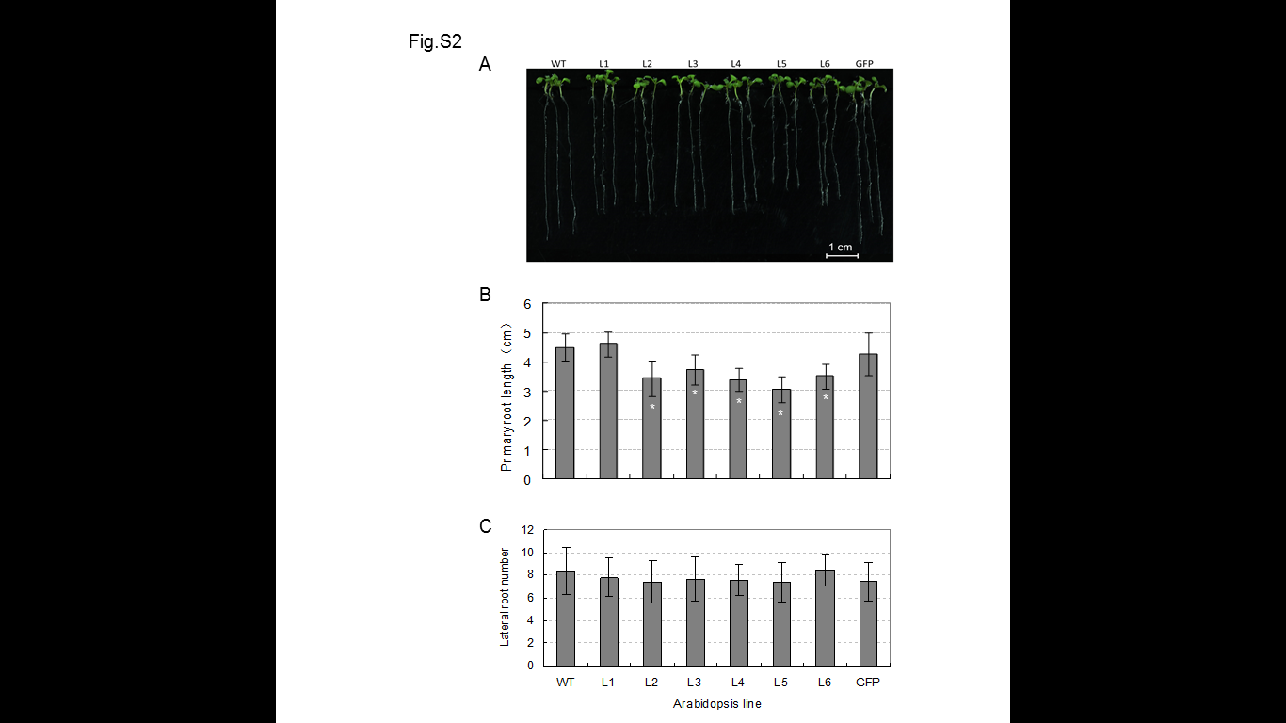

**Fig. S2 Comparison of primary root lengths and lateral root numbers for *TaNAC67* transgenics and two controls**

A. Phenotype of primary roots for *TaNAC67* transgenics. B. The primary root lengths of most transgenic plants were significantly shorter than the WT and GFP controls. C. Lateral root numbers of trangenics and controls were not significantly different.

*Arabidopsis* plants were sown on MS plates solidified with 1.0% agar and cultured vertically in a greenhouse. Primary root length and lateral root numbers were measured after 10 d and 14 d, respectively. *, significantly different at *P*=0.05. Values are means ± SE (n=20).



**Fig. S3 No differences were identified in biomass of *TaNAC67* transgenics and the two controls**

*Arabidopsis* plants were grown in sieve-like rectangular containers filled withmixed soil (vermiculite : humus = 1:1) and cultured under well-watered conditions as described in Materials and Methods. Six plants were collected per sample for biomass measurement; four replications were set for each *Arabidopsis* line and the plants were harvested at five weeks. Single plant biomasses were calculated before and after treatment in an 80 ℃ oven for 24 h. FW, fresh weight; DW, dry weight. Four replications were performed, and values are means ± SE.

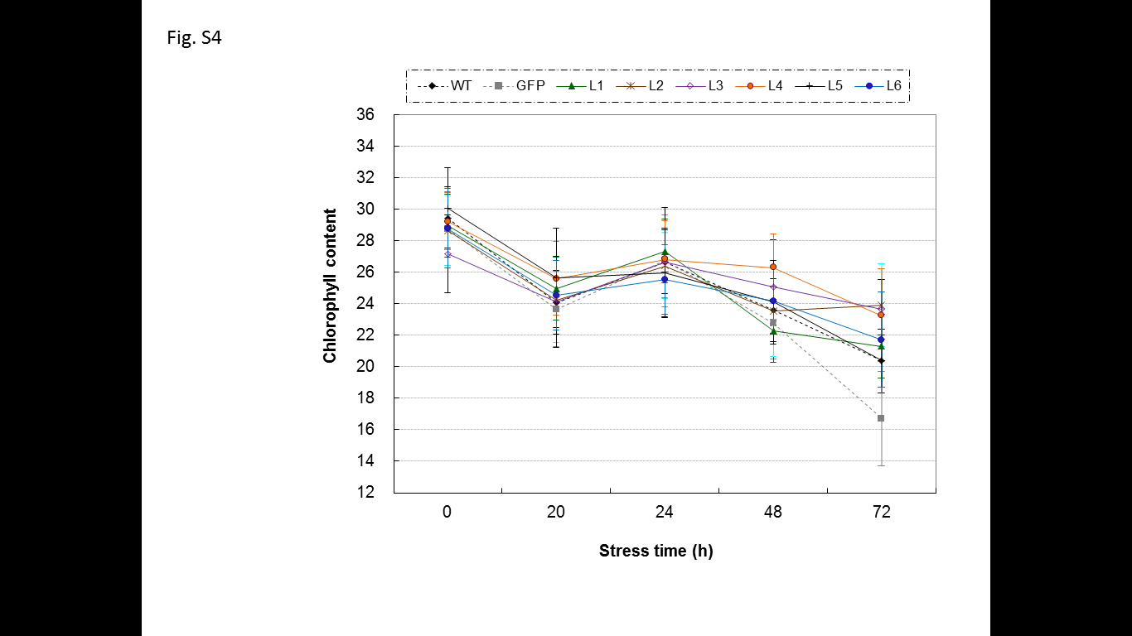

**Fig. S4 A rapid decrease, slow increase and slow decrease pattern in chlorophyll content was identified Arabidopsis after exposure to high salinity.**

The chlorophyll contents were measured at designated times after exposure to 300 mM NaCl solution. Twenty plants were measured for each line. Values are means ± SE (n=20).

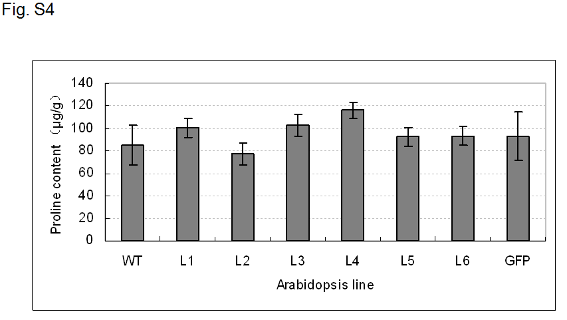

**Fig. S5 No differences were identified in free proline contents for *TaNAC67* transgenics and the two controls**

*Arabidopsis* plants were cultured as described in Materials and Methods. Five plants were collected as a single sample for measurement of free proline content. The experiment consisted of three replications. Values are means ± SE.

**Table S1 Plant materials used for identification of genomic origins**

Accession numbers are for the Chinese National Gene Bank, CAAS.

|  |  |  |  |  |  |  |  |
| --- | --- | --- | --- | --- | --- | --- | --- |
| **Species** | **Accession no. or variety** | **Genome** | **Origin** | **Species** | **Accession no. or variety** | **Genome** | **Origin** |
| *T*. *urartu* | UR 201 | AA | Lebanon | *Ae*. *tauschii* | Y 92 | DD | China |
| *T*. *urartu* | UR 204 | AA | Lebanon | *Ae*. *tauschii* | Y 215 | DD | Mexico |
| *T*. *urartu* | UR 206 | AA | Lebanon | *T. dicoccoides* | DS1 | AABB | France |
| *T*. *urartu* | UR 209 | AA | Syria | *T. dicoccoides* | DS6 | AABB | Germany |
| *Ae. speltoides* | Y 2003 | SS | Syria | *T. dicoccoides* | DS10 | AABB | Canada |
| *Ae. speltoides* | Y 2009 | SS | Syria | *T. dicoccum* | DM 51 | AABB | Canada |
| *Ae. speltoides* | Y 2017 | SS | Syria | *T. aestivum* | Hanxuan 10 | AABBDD | China |
| *Ae. speltoides* | Y 2021 | SS | Iran | *T. aestivum* | Chinese Spring | AABBDD | China |
| *Ae*. *tauschii* | AE 38 | DD | Iran | *T. aestivum* | Opata 85 | AABBDD | Mexico |
| *Ae*. *tauschii* | AE 46 | DD | China | *T. aestivum* | W7984 | AABBDD | Mexico |

**Table S2. Primer pairs used in quantitative real-time PCR in *Arabidopsis***

|  |  |  |  |
| --- | --- | --- | --- |
| **Gene** | **Accession no.** | **Forward primer** | **Reverse primer** |
| *ABA1* | AT5G67030 | GCTATGAAGGTGATCTGCTTGTGG | TTCATACCATTTGGAGCATCAGC |
| *ABI1* | AT4G26080 | AGCTGCTGATATAGTCGTCGTTGATA | GAGGATCAAACCGACCATCTAACA |
| *ABI2* | AT5G57050 | GTTCTTGTTCTGGCGACGGAGC | CCATTAGTGACTCGACCATCAAG |
| *ABI5* | AT2G36270 | AGAGGGATAGCGAACGAGTCTAGTC | GTTCGGGTTTGGATTAGGTTTAGG |
| *CBF1* | AT4G25490 | GTTTGGGATGCCGACTTTGTT | ACCATCTCCTTCGCCGTCAT |
| *CBF2* | AT4G25470 | GGGACTTTCCAAACCGCTGAG | GGATTTCCTTGGCACAGGTTGA |
| *COR15A* | AT2G42540 | GTGACGGATAAAACAAAAGAGG | GACCCTACTTTGTGGCATCCTT |
| *COR47* | AT1G20440 | ATGGCTGAGGAGTACAAGAACAACGTT | TCTTCTTCTTCTTCTCCTTCTTTTCCT |
| *DREB1A* | AT4G25480 | TGCGTTGGCGTTTCAGGATG | CAAACTCGGCATCTCAAACATCG |
| *DREB2A* | AT5G05410 | CTGGAGAATGGTGCGGAAGA | CAGATAGCGAATCCTGCTGTTGT |
| *RAB18* | AT5G66400 | GCAGTATGACGAGTACGGAAATCC | CCTTGTCCATCATCCGAGCTAGA |
| *RD22* | AT5G25610 | ACTTGGTAAATATCACGTCAGGGCT | CTGAGGTGTTCTTGTGGCATACC |
| *RD29A* | AT5G52310 | GATAACGTTGGAGGAAGAGTCGG | TCCTGATTCACCTGGAAATTTCG |
| *RD29B* | AT5G52300 | CCGACAAGAGGTGATGTGAAAGTAG | GTGTAACCTAGCTTTGAGGCAACG |
| *Actin* | AT3G18780 | TATCGCTGACCGTATGAGCAAAG | TGGACCTGCCTCATCATACTCG |