Supporting Information
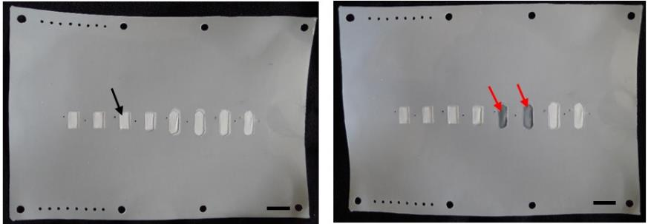
(A)
(B)
S4 Fig. Porous Teflon membrane modified with a layer of cured thiol-ene mixture. Black arrow indicating the region on porous membrane that was protected by a plastic mask during UV-exposure. When dry, the region appeared white and opaque. (b) Two chambers were wetted with DI water, as indicated by red arrows. Teflon membrane becomes transparent in visible light. (Scale bar = 5 mm).

