**Figure S1**

**Figure S1A.**

Bin correlation

Library size

Library size

Bin correlation

**Figure S1B.**

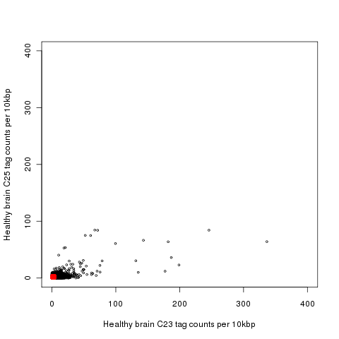



**Figure S1C.**

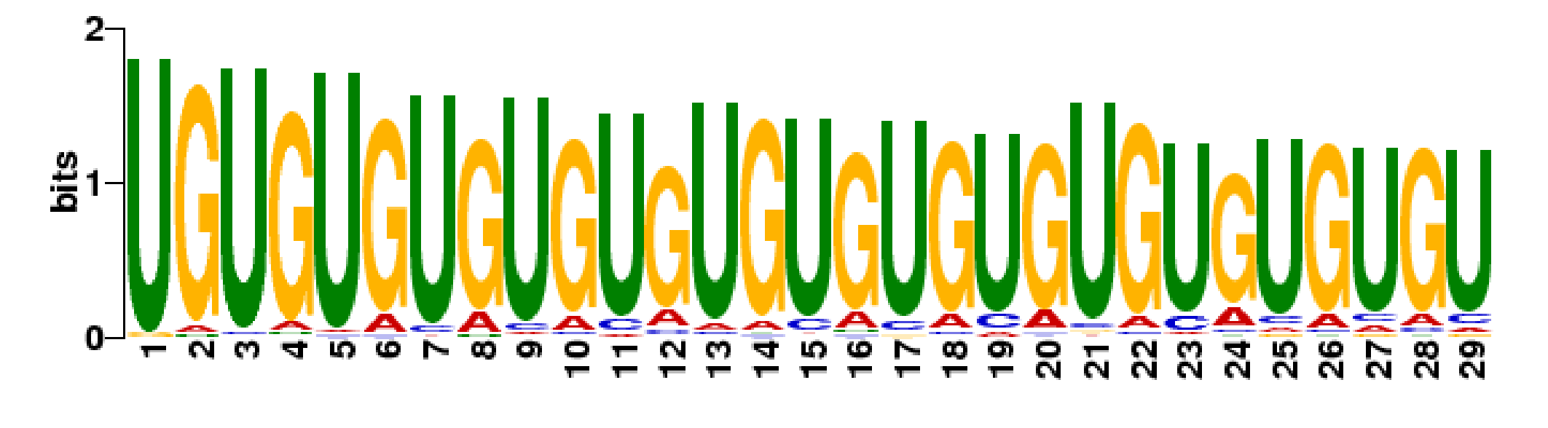

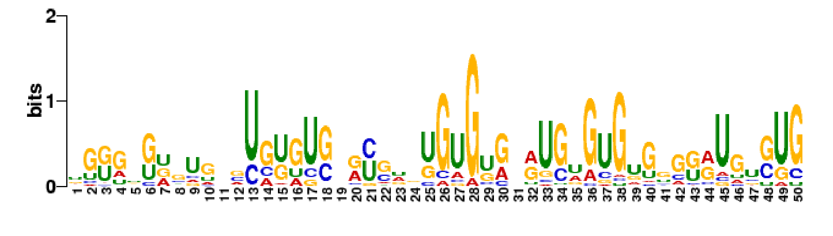

**Figure S1D.**

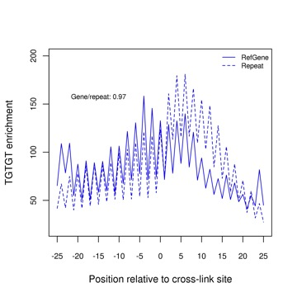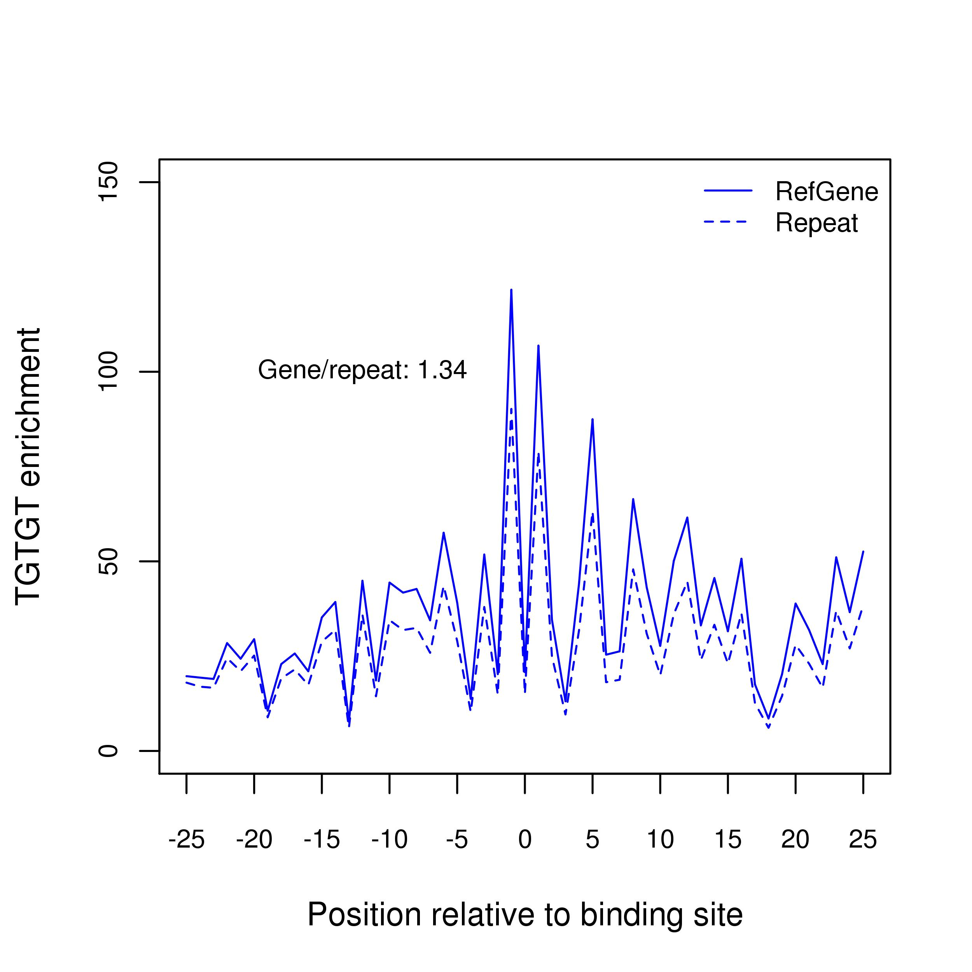

**Figure S1E.**

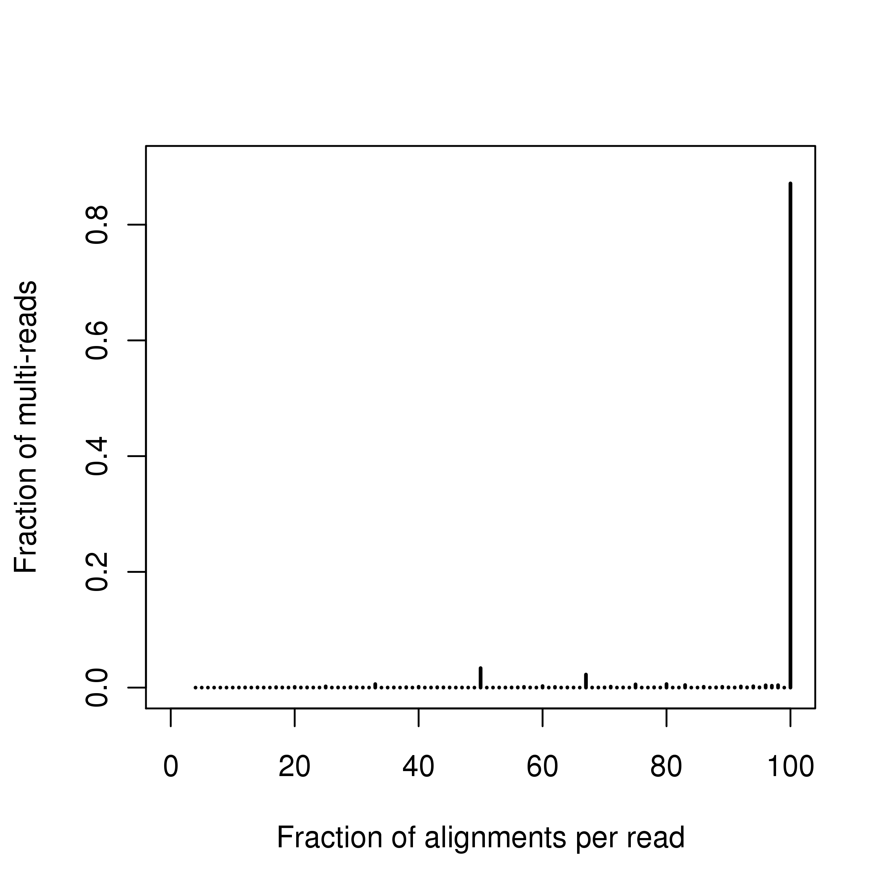

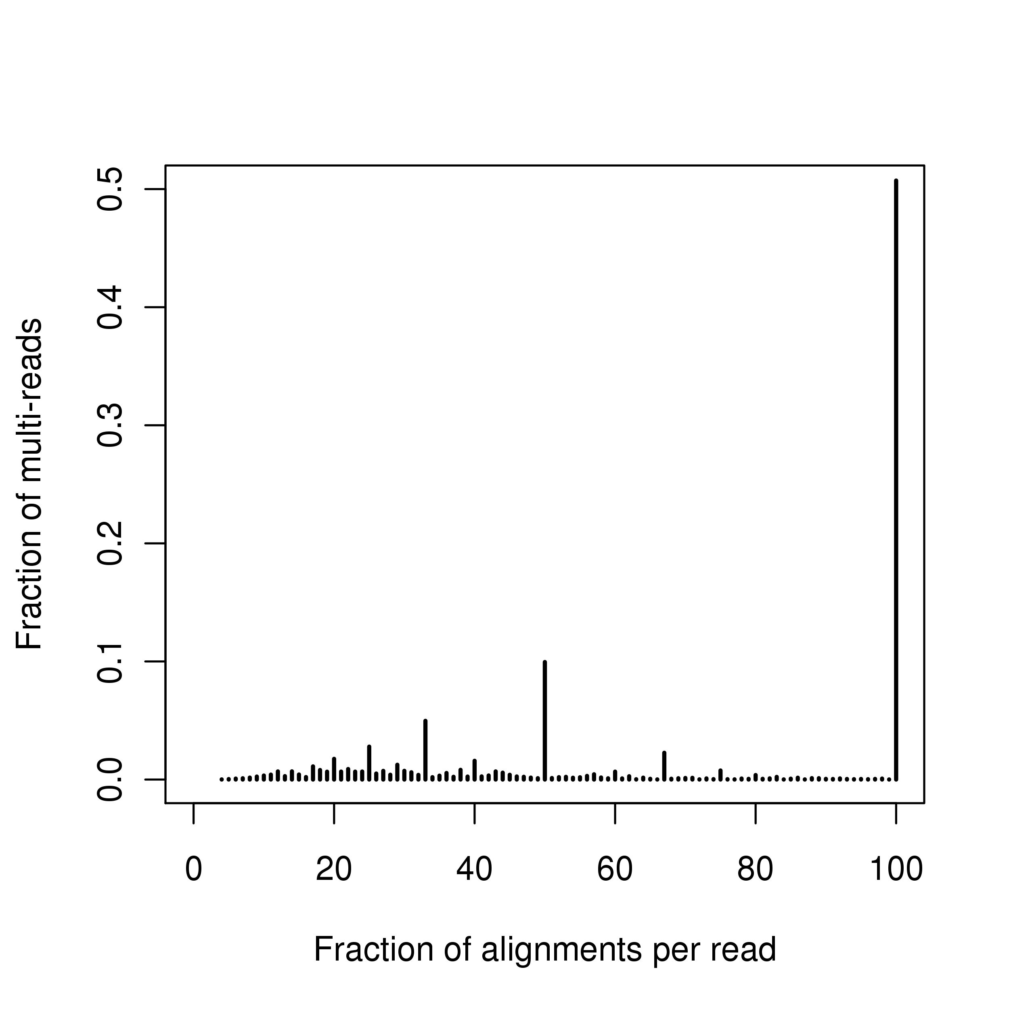

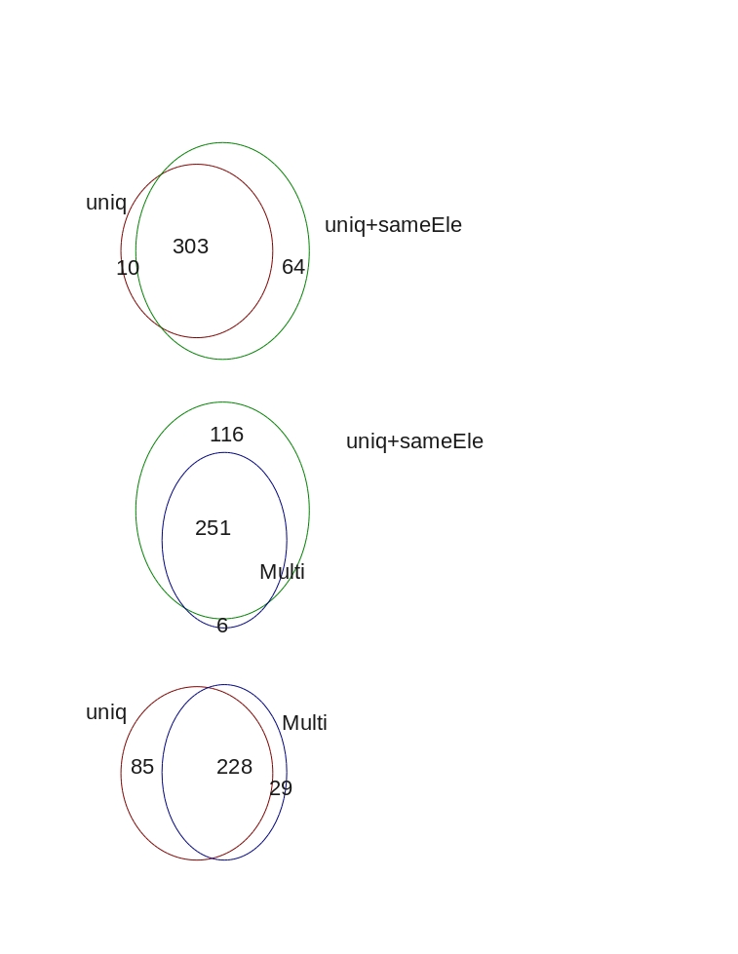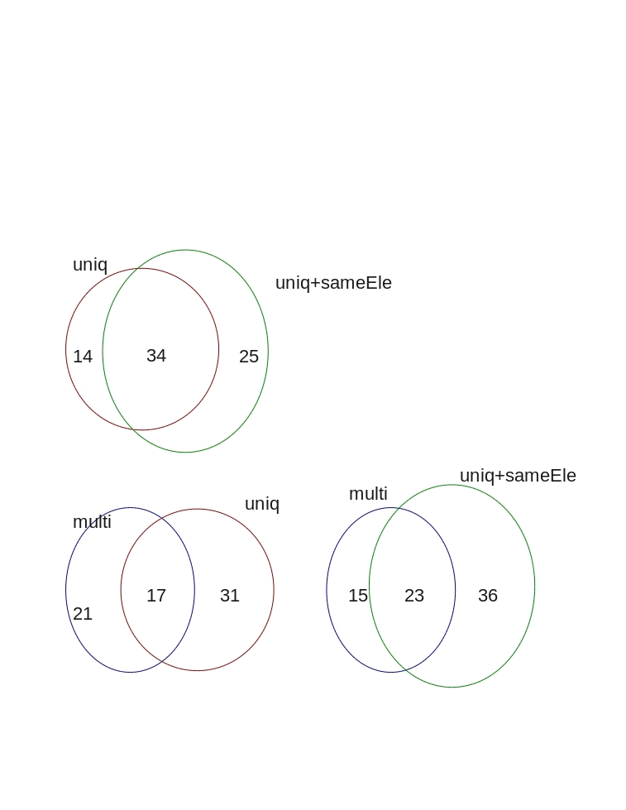**Figure S1F.**

**Figure S1G.**

Over-expression (mRNA-seq)

197

Binding sites (CLIP-seq)

175

48

Overlap of binding sites vs. over-expression on **TE transcripts** in mouse dataset GSE27394.

1201

167

17

Binding sites (CLIP-seq)

Over expression (mRNA-seq)

Overlap of binding sites vs. over-expression on **RefGene transcripts** in mouse dataset GSE27394

**Figure S1H.**

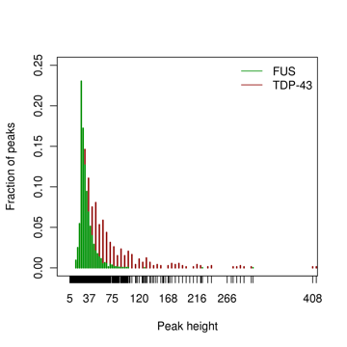

**Figure S1I**

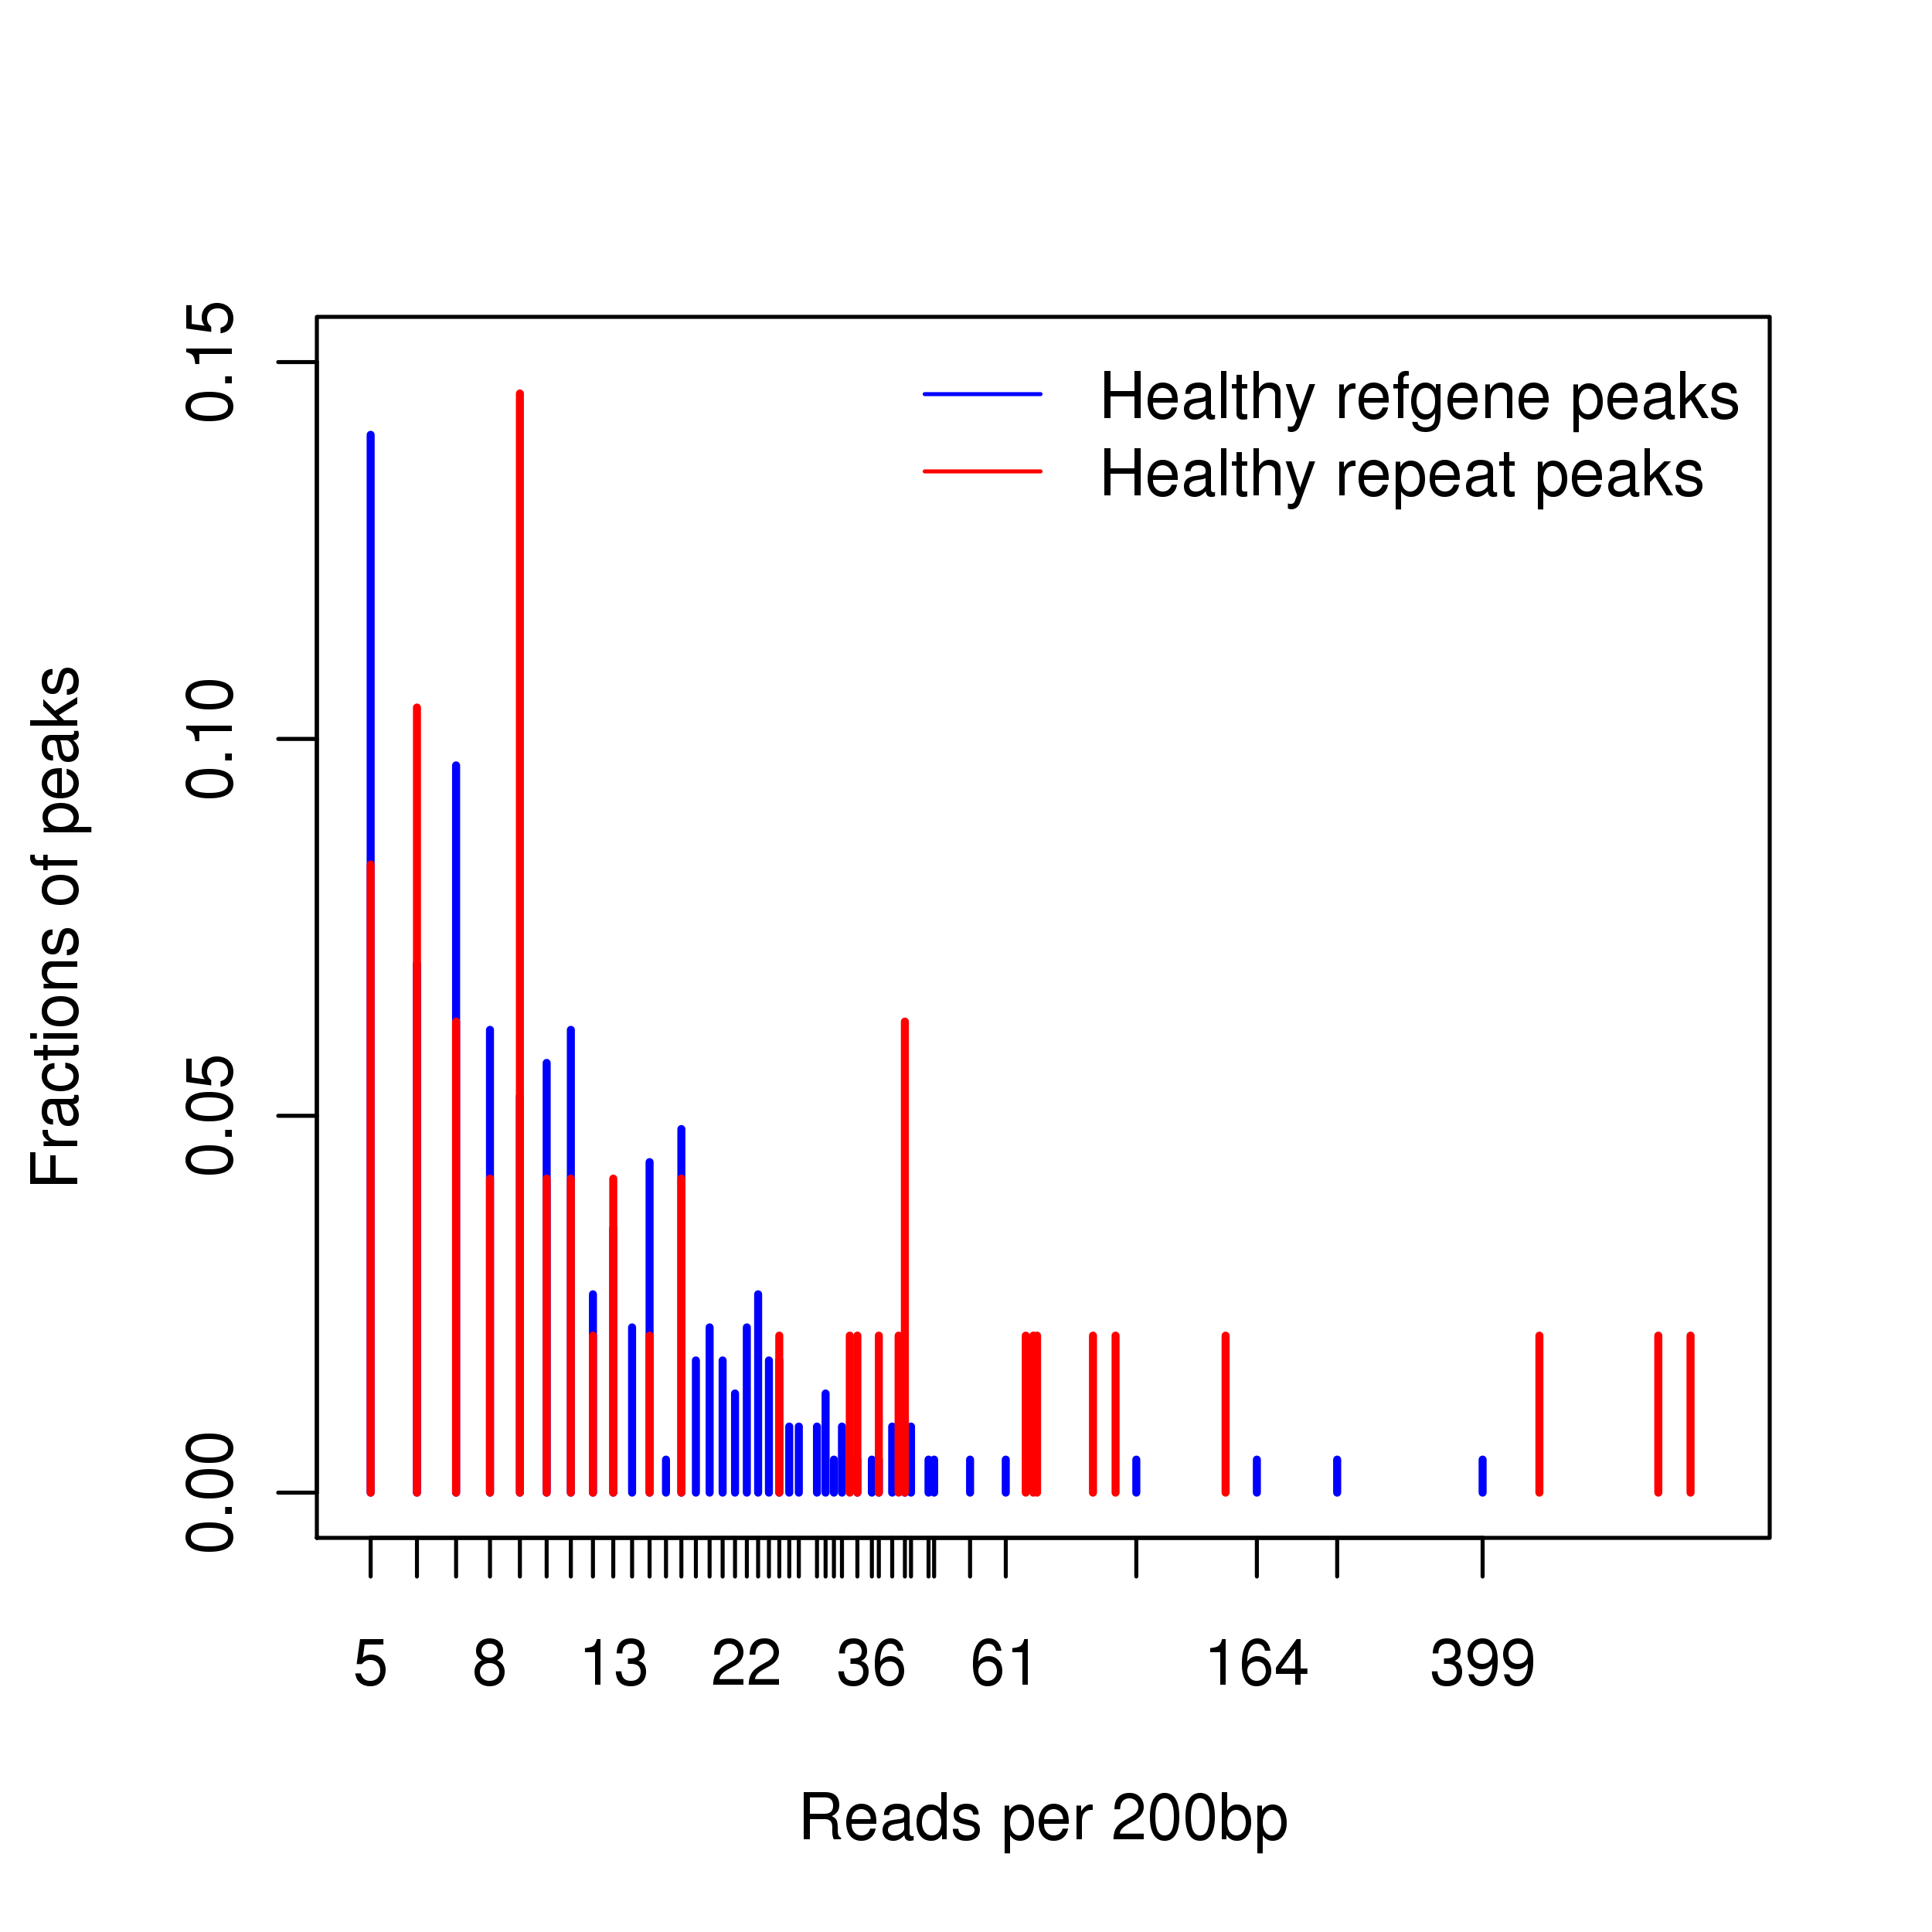

**Figure S1J**

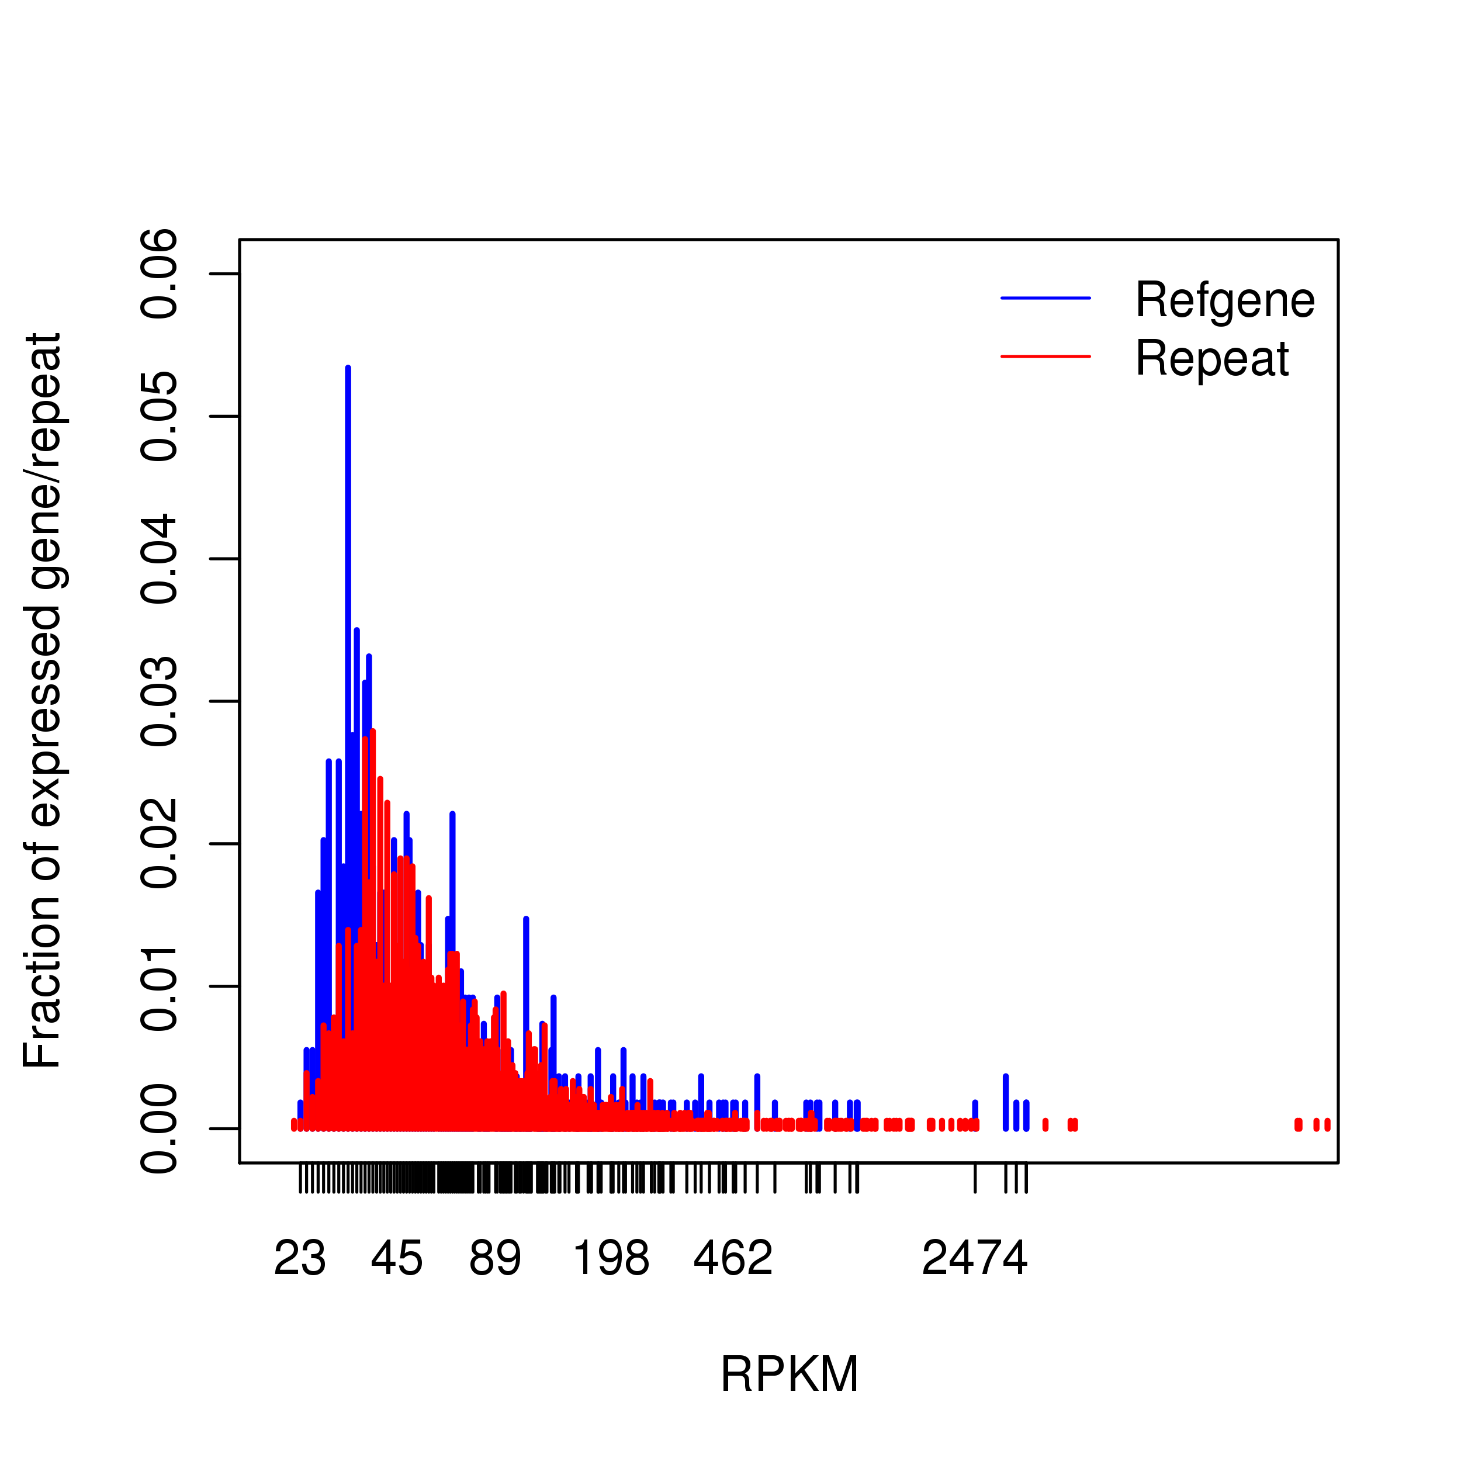

**Supplementary References**

1. Polymenidou M, Lagier-Tourenne C, Hutt KR, Huelga SC, Moran J, et al. (2011) Long pre-mRNA depletion and RNA missplicing contribute to neuronal vulnerability from loss of TDP-43. Nature neuroscience 14: 459-468.

2. Shan X, Chiang PM, Price DL, Wong PC (2010) Altered distributions of Gemini of coiled bodies and mitochondria in motor neurons of TDP-43 transgenic mice. Proceedings of the National Academy of Sciences of the United States of America 107: 16325-16330.

3. Tollervey JR, Curk T, Rogelj B, Briese M, Cereda M, et al. (2011) Characterizing the RNA targets and position-dependent splicing regulation by TDP-43. Nature neuroscience 14: 452-458.

4. Sephton CF, Cenik C, Kucukural A, Dammer EB, Cenik B, et al. (2011) Identification of neuronal RNA targets of TDP-43-containing ribonucleoprotein complexes. The Journal of biological chemistry 286: 1204-1215.

5. Da Cruz S, Cleveland DW (2011) Understanding the role of TDP-43 and FUS/TLS in ALS and beyond. Current opinion in neurobiology 21: 904-919.