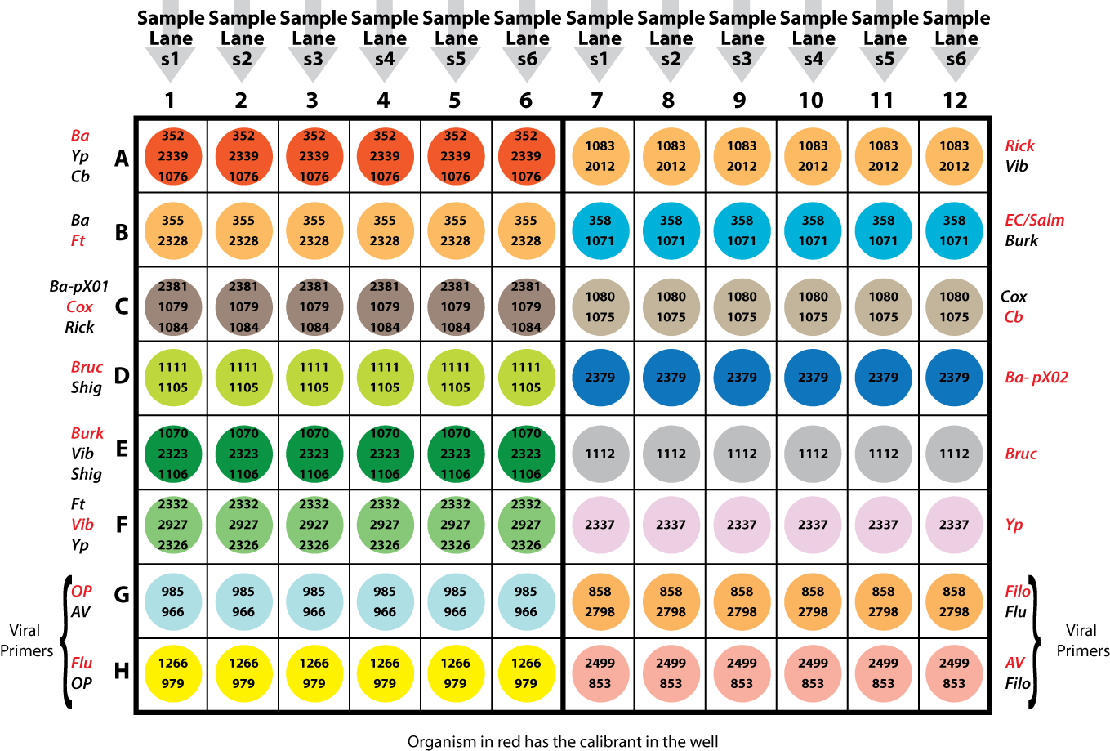

**Figure S1. *Biothreat assay plate layout.***