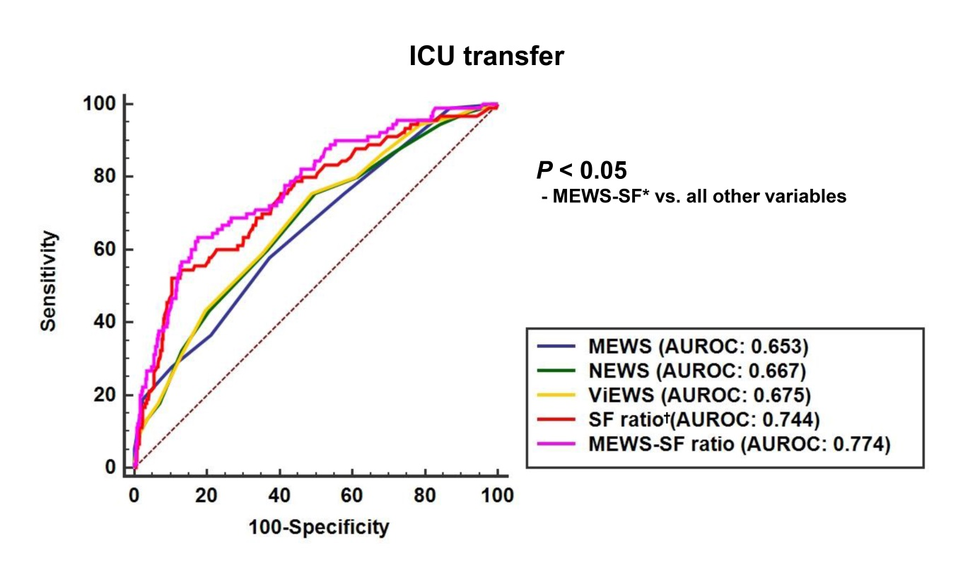

**Fig 1. Comparison of the area of under the receiver operating characteristics curve for intensive care unit transfers within 24 hours of rapid response system activation.** MEWS, Modified Early Warning Score; NEWS, National Early Warning Score; ViEWS, VitalPAC Early Warning Score; AUROC, area under the receiver operating characteristic curve; ICU, intensive care unit. *MEWS-SF ratio:the combination MEWS and SF ratio was calculated using predicted probability; †SF ratio: SpO2/FiO2 ratio.