SUPPORTING FIGURE S2 for

A template-free, ultra-adsorbing, high surface area carbonate nanostructure

Johan Forsgren, Sara Frykstrand, Kathryn Grandfield, Albert Mihranyan, and Maria Strømme

S2. TG analysis of Upsalite
TG analysis was used to investigate the relative proportions of the constituents in the material. The TGA curve can be seen in Fig. S2 where a rapid weight loss, corresponding to the decomposition of the magnesium carbonate to MgO,¹ is observed at ~390 °C in the dTGA curve. Based on the molar fraction of released CO₂ during decomposition at ~450 °C, the relative weight ratio between residual MgO and magnesium carbonate in Upsalite was found to be 1:6 and the corresponding molar ratio 1:2.8. The TG analysis also shows a major weight loss with maximum at 160 °C that is due to the loss of physisorbed water and possible remaining organic groups. Chemisorbed water does not evaporate until the temperature reaches 300 °C,⁴³ thus TGA further establishes the anhydrous character of Upsalite.
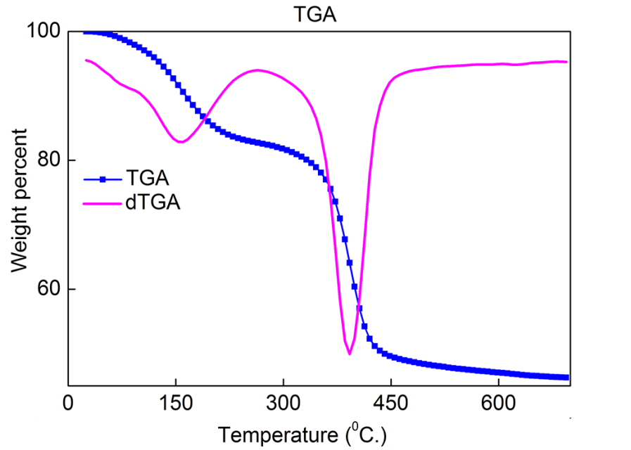
Figure S2. Thermal Gravimetric Analysis of Upsalite. TGA (blue) and dTGA (pink) curves for Upsalite.

SUPPORTING REFERENCES
1 Botha, A.; Strydom, C. A. Dta and Ft-Ir Analysis of the Rehydration of Basic Magnesium Carbonate. J. Therm. Anal. Calorim. 2003, 71, 987-995.

