# **Appendix 8: Risk of bias of studies included in the NMA**

## Risk of bias graph: reviewer’s judgements about each risk of bias item presented as percentages across all included studies

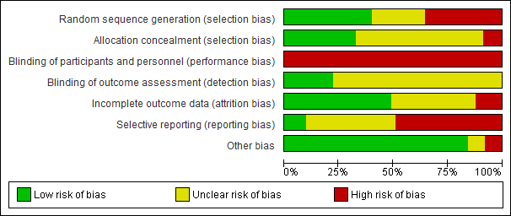

## Risk of bias graph: reviewer’s judgements about each risk of bias item presented by study.

