**S1 Fig. Read length distribution**

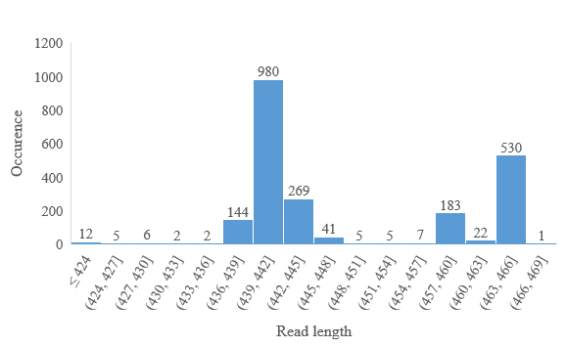

Histogram of read length, reads ranged from 400 bp to 467 bp, with an average length of 448 bp.