S1 Fig.
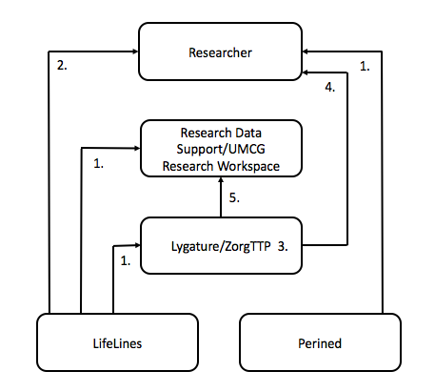
1. Data Processing Agreement; 2. Data transfer Agreement; 3. General Agreement; 4. Data Use and Access Agreement; 5. Data Services and Processor Agreement.
UMCG= University Medical Centre of Groningen, TTP= Trusted Third Party.

