File S1. Miscellaneous supplementary information.
Table A. The radio-tagged little owls: fates, use and availability of land cover categories.
 |  |  |  |  |  |  | Number of telemetry fixes used in the analysis¹ |  |  |  |  |  |  |  |  |  |  |  |  |  |  | Availability, home range level (20-800 m from nest)
ID | sex | pair | UTM coordinate (nest) | Survey period |  | Fate | May-August |  |  |  |  |  |  |  | September-April
 |  |  |  | From | To: |  | CF |  | G/B | PA |  | Misc |  |  | CF |  | G/B | PA |  | Misc |  | CF |  | G/B | PA |  | Misc
 |  |  |  |  |  |  | D | M | D | D | M | D | M |  | D | M | D | D | M | D | M | D | M | D | D | M | D | M
1 | F | A | 32 VNJ-2235-0200 | 03-Apr-05 | 20-Jan-07 | Recaptured and tag removed, Feb ’07. | 0 | 3 | 7 | 12 | 0 | 1 | 0 |  | 0 | 45 | 13 | 20 | 1 | 4 | 2 | 0.662 | 0.000 | 0.024 | 0.126 | 0.092 | 0.090 | 0.006
2 | M | A | 32 VNJ-2235-0200 | 03-Apr-05 | 17-Apr-07 | Recaptured and tag removed, July ‘07 | 0 | 17 | 14 | 9 | 0 | 2 | 0 |  | 0 | 51 | 8 | 19 | 1 | 2 | 2 | 0.662 | 0.000 | 0.024 | 0.126 | 0.092 | 0.090 | 0.006
4 | F | C | 32 VNH-3710-9075 | 11-Apr-05 | 27-Sep-05 | Died or dispersed | 0 | 3 | 2 | 0 | 0 | 1 | 0 |  | 0 | 6 | 3 | 0 | 0 | 1 | 0 | 0.707 | 0.019 | 0.025 | 0.055 | 0.000 | 0.194 | 0.000
6 | M | C | 32 VNH-3710-9075 | 16-May-05 | 18-Apr-06 | Recaptured and tag removed, Jan ’07 | 0 | 6 | 2 | 0 | 3 | 2 | 0 |  | 0 | 20 | 3 | 0 | 0 | 12 | 0 | 0.707 | 0.019 | 0.025 | 0.055 | 0.000 | 0.194 | 0.000
7 | M | D | 32 VNH-3580-8811 | 20-Jun-05 | 28-May-06 | Died | 1 | 2 | 3 | 0 | 1 | 1 | 0 |  | 8 | 28 | 10 | 0 | 10 | 2 | 0 | 0.730 | 0.178 | 0.017 | 0.004 | 0.047 | 0.021 | 0.004
8 | F | D | 32 VNH-3580-8811 | 20-Jun-05 | 28-Feb-07 | Died or dispersed. | 2 | 7 | 8 | 0 | 5 | 6 | 0 |  | 9 | 41 | 12 | 1 | 22 | 2 | 0 | 0.730 | 0.178 | 0.017 | 0.004 | 0.047 | 0.021 | 0.004
9 | M | E | 32 VNH-3019-9227 | 27-Sep-05 | 09-Dec-05 | Died | 0 | 0 | 0 | 0 | 0 | 0 | 0 |  | 0 | 1 | 0 | 0 | 2 | 1 | 0 | 0.749 | 0.005 | 0.043 | 0.115 | 0.004 | 0.084 | 0.000
10 | F | E | 32 VNH-3019-9227 | 27-Sep-05 | 28-Feb-06 | Died | 0 | 0 | 0 | 0 | 0 | 0 | 0 |  | 0 | 11 | 2 | 0 | 4 | 1 | 0 | 0.749 | 0.005 | 0.043 | 0.115 | 0.004 | 0.084 | 0.000
11 | F | F | 32 VNH-2906-9229 | 18-Jan-06 | 07-Dec-06 | Recaptured and tag removed, June ’07 | 0 | 9 | 24 | 0 | 0 | 3 | 0 |  | 0 | 34 | 23 | 0 | 2 | 6 | 0 | 0.795 | 0.025 | 0.041 | 0.043 | 0.020 | 0.076 | 0.000
12 | M | G | 32 VNJ-2165-0163 | 19-Jan-06 | 20-Sep-06 | Recaptured and tag removed, July ’07 | 0 | 8 | 7 | 4 | 1 | 0 | 0 |  | 0 | 13 | 13 | 1 | 1 | 1 | 0 | 0.777 | 0.000 | 0.021 | 0.076 | 0.076 | 0.040 | 0.009
13 | F | H | 32 VNJ-2263-1137 | 20-Jan-06 | 16-Oct-06 | Recaptured and tag removed, June ’07. | 0 | 0 | 2 | 0 | 0 | 0 | 0 |  | 0 | 21 | 3 | 0 | 0 | 0 | 0 | 0.917 | 0.000 | 0.045 | 0.012 | 0.000 | 0.026 | 0.000
14 | F | I | 32 VNH-3702-9204 | 12-Feb-06 | 21-Oct-06 | Recaptured and tag removed, July ’07 | 10 | 7 | 4 | 3 | 0 | 0 | 0 |  | 11 | 13 | 1 | 0 | 0 | 2 | 0 | 0.512 | 0.255 | 0.002 | 0.000 | 0.121 | 0.028 | 0.081
15 | M | F | 32 VNH-2906-9229 | 25-Feb-06 | 25-Jul-06 | Died | 0 | 4 | 8 | 0 | 0 | 4 | 0 |  | 0 | 14 | 12 | 0 | 2 | 5 | 0 | 0.795 | 0.025 | 0.041 | 0.043 | 0.020 | 0.076 | 0.000
16 | F | J | 32 VNH-4139-8932 | 05-Mar-06 | 26-Jul-06 | Recaptured and tag removed, July ’07. | 0 | 0 | 0 | 0 | 1 | 0 | 0 |  | 0 | 12 | 2 | 0 | 0 | 1 | 0 | 0.788 | 0.000 | 0.039 | 0.127 | 0.000 | 0.045 | 0.001
17 | M | J | 32 VNH-4139-8932 | 02-Apr-06 | 04-Aug-06 | Recaptured and tag removed, July ’07. | 0 | 4 | 2 | 0 | 5 | 1 | 0 |  | 0 | 11 | 3 | 0 | 1 | 1 | 0 | 0.788 | 0.000 | 0.039 | 0.127 | 0.000 | 0.045 | 0.001
18 | F | K | 32 VNH-2201-6348 | 04-Apr-06 | 27-Jan-07 | Recaptured and tag removed, June ’08 | 0 | 12 | 2 | 0 | 10 | 1 | 0 |  | 0 | 12 | 1 | 0 | 2 | 5 | 0 | 0.514 | 0.003 | 0.029 | 0.075 | 0.037 | 0.297 | 0.046
19 | M | L | 32 vnh-1650-9121 | 06-Apr-06 | 14-Jul-06 | Died | 0 | 1 | 12 | 0 | 0 | 4 | 0 |  | 0 | 4 | 0 | 0 | 0 | 0 | 0 | 0.807 | 0.000 | 0.046 | 0.021 | 0.000 | 0.126 | 0.000
20 | F | L | 32 vnh-1650-9121 | 06-Apr-06 | 10-Dec-06 | Recaptured and tag removed, Jan ’07 | 0 | 5 | 26 | 0 | 0 | 2 | 0 |  | 0 | 15 | 8 | 0 | 0 | 3 | 0 | 0.807 | 0.000 | 0.046 | 0.021 | 0.000 | 0.126 | 0.000
21 | M | K | 32 VNH-2201-6348 | 30-May-06 | 14-Jul-06 | Died | 0 | 6 | 4 | 0 | 2 | 4 | 0 |  | 0 | 0 | 0 | 0 | 0 | 0 | 0 | 0.514 | 0.003 | 0.029 | 0.075 | 0.037 | 0.297 | 0.046
22 | M | I | 32 VNH-3702-9204 | 08-Jun-06 | 17-Apr-07 | Recaptured and tag removed, July ’07. | 7 | 8 | 4 | 3 | 0 | 0 | 0 |  | 11 | 8 | 2 | 0 | 0 | 0 | 0 | 0.512 | 0.255 | 0.002 | 0.000 | 0.121 | 0.028 | 0.081
23 | F | M | 32 VNH-4021-8557 | 19-Jun-06 | 24-Jul-06 | Recaptured and tag removed, July ’07. | 0 | 3 | 12 | 0 | 0 | 3 | 0 |  | 0 | 0 | 0 | 0 | 0 | 0 | 0 | 0.643 | 0.160 | 0.025 | 0.022 | 0.014 | 0.123 | 0.013
24 | M | M | 32 VNH-4021-8557 | 19-Jun-06 | 07-Mar-07 | Recaptured and tag removed, June’07. | 0 | 4 | 12 | 0 | 0 | 0 | 0 |  | 0 | 18 | 6 | 0 | 0 | 5 | 0 | 0.643 | 0.160 | 0.025 | 0.022 | 0.014 | 0.123 | 0.013
25 | F | N | 32 VNH-2476-9706 | 21-Jun-06 | 17-Apr-07 | Recaptured and tag removed, June’07. | 0 | 10 | 7 | 0 | 0 | 2 | 0 |  | 0 | 35 | 1 | 0 | 0 | 2 | 0 | 0.914 | 0.000 | 0.018 | 0.029 | 0.000 | 0.029 | 0.010
26 | M | N | 32 VNH-2476-9706 | 21-Jun-06 | 26-Jan-07 | Recaptured and tag removed, June ’07. | 0 | 12 | 2 | 0 | 0 | 4 | 0 |  | 0 | 27 | 2 | 0 | 0 | 0 | 0 | 0.914 | 0.000 | 0.018 | 0.029 | 0.000 | 0.029 | 0.010
28 | F | G | 32 VNJ-2165-0163 | 13-Nov-06 | 28-Jun-07 | Recaptured and tag removed, June ’07. | 0 | 0 | 9 | 0 | 0 | 0 | 0 |  | 0 | 18 | 4 | 4 | 2 | 0 | 0 | 0.777 | 0.000 | 0.021 | 0.076 | 0.076 | 0.040 | 0.009
29 | F | B | 32 VNH-3858-9365 | 21-Jan-07 | 27-Jun-07 | Recaptured and tag removed, June’08. | 0 | 4 | 1 | 0 | 0 | 0 | 0 |  | 6 | 9 | 5 | 1 | 0 | 1 | 0 | 0.354 | 0.188 | 0.029 | 0.000 | 0.005 | 0.403 | 0.022
30 | M | B | 32 VNH-3858-9365 | 21-Jan-07 | 27-Jun-07 | Recaptured and tag removed, June’08. | 0 | 4 | 0 | 0 | 0 | 1 | 0 |  | 10 | 5 | 3 | 1 | 0 | 1 | 0 | 0.354 | 0.188 | 0.029 | 0.000 | 0.005 | 0.403 | 0.022
- Precise telemetry fixes of silent owls 20-800 m from the nest/roosting site. Abbreviations for land cover categories: CF=cultivated field, G/B= gardens/buildings, PA=pastures, MISC=miscellaneous (all other land cover categories), D=dry, M=moist.

Figure A. Mistnet for capturing little owls when flying out of building used for roosting.
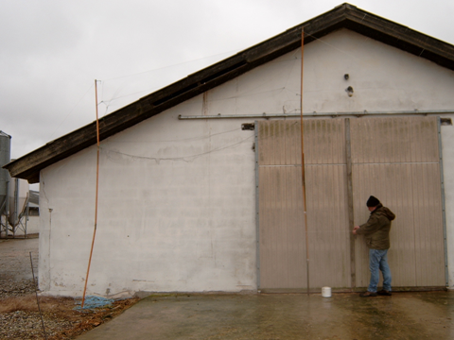

Figure B. Little owl captured in mist net.
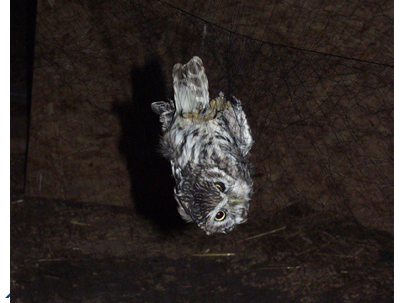

Figure C. Mounting of back-pack radio-tag 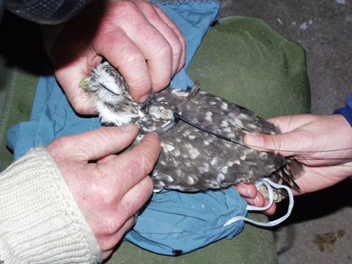

Figure D. Radio-tagged little owls ready for being released.
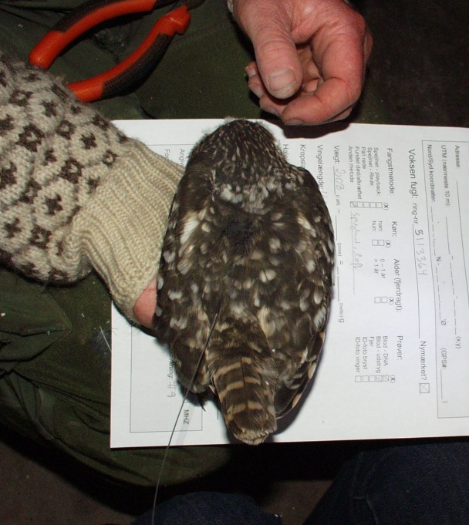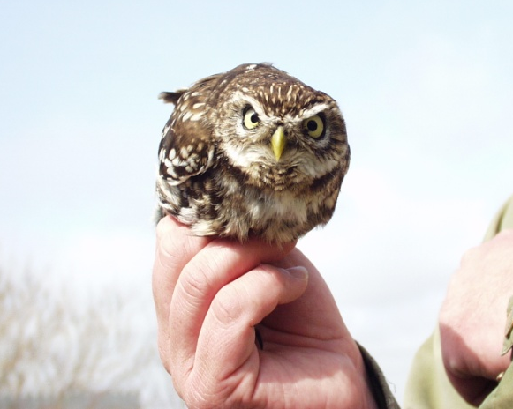

Figure E. Estimated probabilities of nocturnally active little owls being categorized as perching (as opposed to being sitting on the ground) from the type of radio signals received (perching owls emitted a clear radio signal from which it was easy to establish a bearing, whereas radio signals from owls sitting on ground were weaker, and associated with a considerable radio ‘echo’. The analytical method of estimating the probability of an owl displaying a specific hunting behaviour was similar to the method estimating the probability of using a given habitat category, as explained in the article.

Figure F. Predicted probabilities that nocturnally little owls would be perching as a function of variation in temperature and wind strength (generalized linear mixed model with a logit link function and binomially distributed errors, and owl identity treated as a random effect). Equation for predicted functions with SEs in brackets; logit p_{perching} = 0.244 [0.224] – 0.622W [0.126]**** + 0.079 [0.025]W2*** – 0.122[0.023]T**** + 0.010[0.0016]T2**** + 0.0134[0.0068]WT*, where W=wind speed on Beaufort’s scale and T=Temperature in ºC and stars indicate statistical significances: *: p < 0.05, ***: p < 0.001, ****, p < 0.0001.

Figure G. The amount of variation in hunting strategy (perching vs. non-perching) of little ows, expressed as the maximum rescaled R² and Somer’s D, as explained by different variables and combination of variables. This figure shall be interpreted similarly to Figure 4 in the article, and is based on the same type of analysis (just with hunting strategy as binomially distributed response variable instead of use of a focal land cover type).

Table B. Statistical analysis (generalized linear mixed model with a logit link function, binomially distributed errors, and owl identity treated as a random effect) of variation as of whether radio-tagged little owls were categorized as perching as opposed to sitting at or near the ground when located with telemetry as a function of month, weather variables, land cover categories and distance to the nest.
Type III Tests of Fixed Effects | df | F | P
Wind (Beaufort), W | 1,1173 | 13.01 | 0.0003
W² | 1,1173 | 8.17 | 0.0043
Temp (°C), T | 1,1173 | 27.14 | <.0001
T² | 1,1173 | 9.80 | 0.0018
W*T | 1,1173 | 8.68 | 0.0033
Month | 11,1173 | 3.68 | <.0001
land cover category | 3,1173 | 35.22 | <.0001
log(nest distance, m) | 1,1173 | 28.38 | <.0001
Equation | b | SE | df | t | P
Intercept | 3.865 | 0.672 | 1173 | 5.75 | <.0001
W | -0.519 | 0.144 | 1173 | -3.61 | 0.000
W2 | 0.067 | 0.023 | 1173 | 2.86 | 0.004
T | -0.191 | 0.037 | 1173 | -5.21 | <.0001
T2 | 0.007 | 0.002 | 1173 | 3.13 | 0.002
T*W | 0.024 | 0.008 | 1173 | 2.95 | 0.003
Month=Jan | 0.803 | 0.528 | 1173 | 1.52 | 0.129
Month=Feb | 0.168 | 0.492 | 1173 | 0.34 | 0.733
Month=Mar | 0.725 | 0.521 | 1173 | 1.39 | 0.164
Month=Apr | 0.523 | 0.468 | 1173 | 1.12 | 0.264
Month=May | 1.270 | 0.629 | 1173 | 2.02 | 0.044
Month=Jun | 2.349 | 0.550 | 1173 | 4.27 | <.0001
Month=Jul | 1.359 | 0.550 | 1173 | 2.47 | 0.014
Month=Aug | 0.323 | 0.564 | 1173 | 0.57 | 0.567
Month=Sep | 1.424 | 0.524 | 1173 | 2.72 | 0.007
Month=Oct | 0.894 | 0.491 | 1173 | 1.82 | 0.069
Month=Nov | 0.459 | 0.520 | 1173 | 0.88 | 0.377
Month=Dec | 0.000 | . | . | . | .
LCC = CF | -1.832 | 0.215 | 1173 | -8.52 | <.0001
LCC = MISC | -0.104 | 0.304 | 1173 | -0.34 | 0.731
LCC = PA | -1.997 | 0.276 | 1173 | -7.23 | <.0001
LCC = G/B | 0.000 | . | . | . | .
log(nest distance, m) | -1.337 | 0.251 | 1173 | -5.33 | <.0001
Owl ID (covariance parameter) | 0.670 | 0.266

