Funnel plot for the effect of housing intervention on the risk of mosquito-borne diseases stratified by type of mosquito-borne diseases.

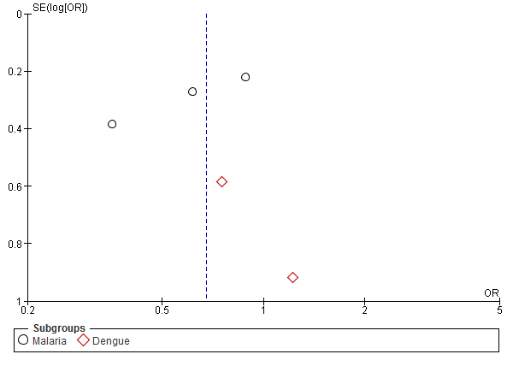

Funnel plot for the effect of housing intervention on the risk of mosquito-borne diseases stratified by type of housing interventions.

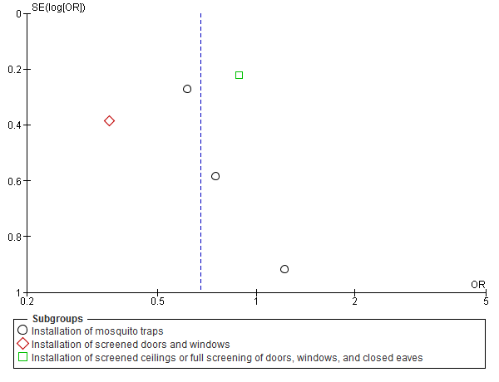

Funnel plot for the effect of housing intervention on the risk of mosquito-borne diseases stratified by urbanicity.

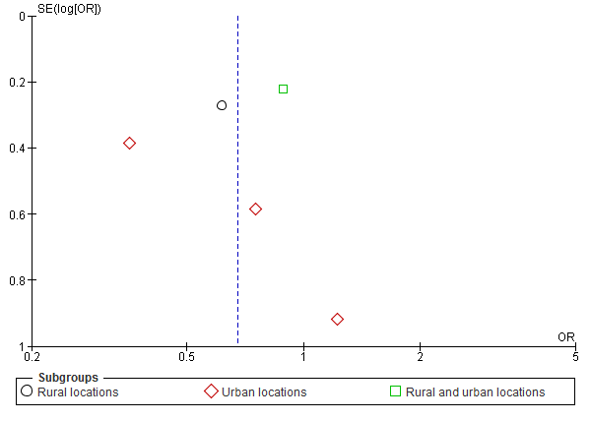

Funnel plot for the effect of housing intervention on the risk of mosquito-borne diseases stratified by type of houses.

