Symptoms observed on plants naturally infected by Cowpea aphid-borne mosaic virus (CABMV)
A. Mosaic (BE255); B. Mild mosaic (BE214); D. Vein yellow mosaic (BE212); E. Yellow mosaic (BE6).
C. BE214
A. BE255

D. BE212
E. BE6

Symptoms observed on cowpea plants naturally co-infected by CABMV and Cowpea mottle virus (CPMoV)
A. Mosaic (BE274); B. Mild mosaic (BE275)
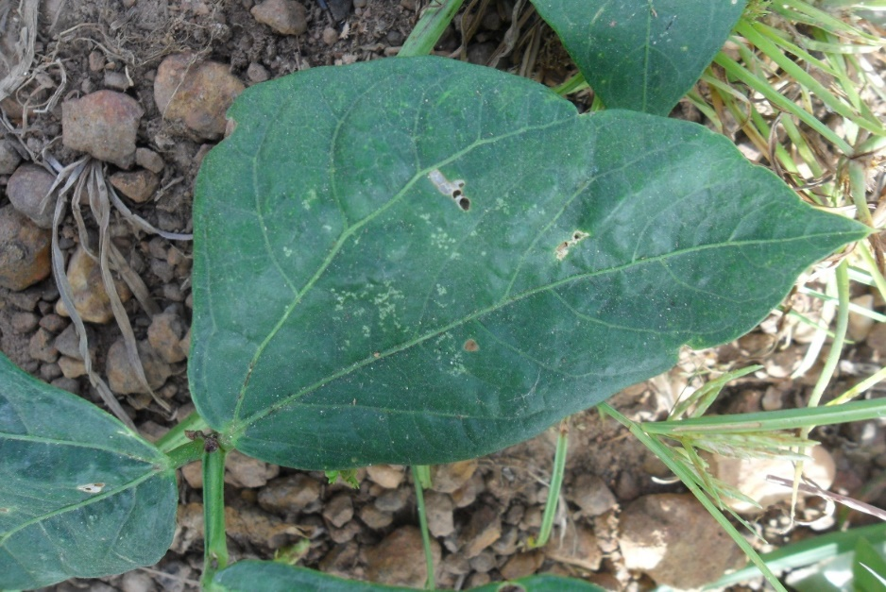
B. BE275
A. BE274

Symptoms observed on cowpea plants naturally co-infected by one polerovirus and CABMV.
A. Yellow mosaic (BE167, Cowpea polerovirus 1 and CABMV); B. Yellowing following vein (BE168, Cowpea polerovirus 1 and CABMV); C. Interveinal yellowing (BE170, Cowpea polerovirus 1 and CABMV) ; D. Mild yellow mosaic (BE179, Cowpea polerovirus 2 and CABMV).
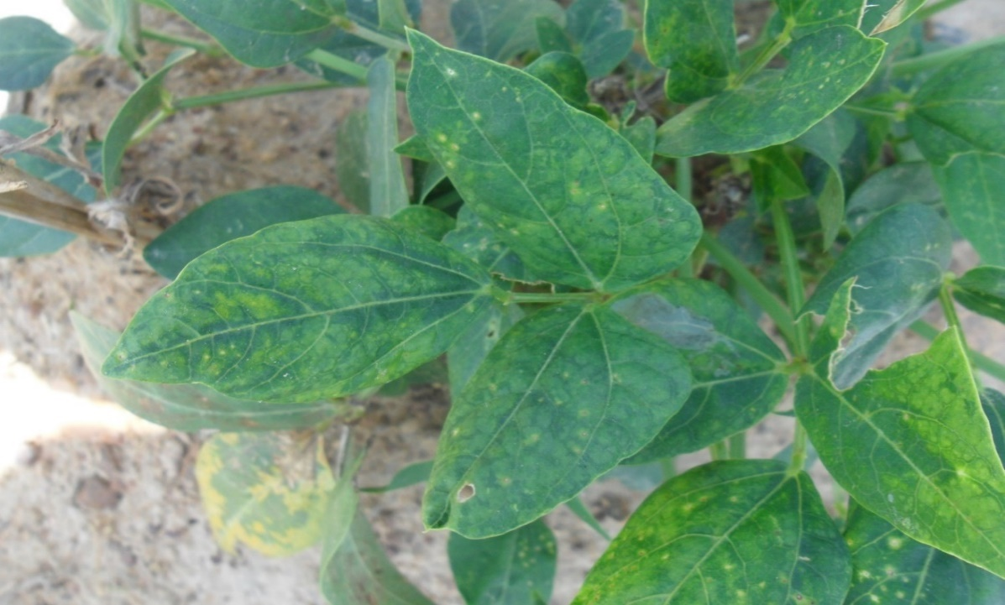
B. BE168
A. BE167

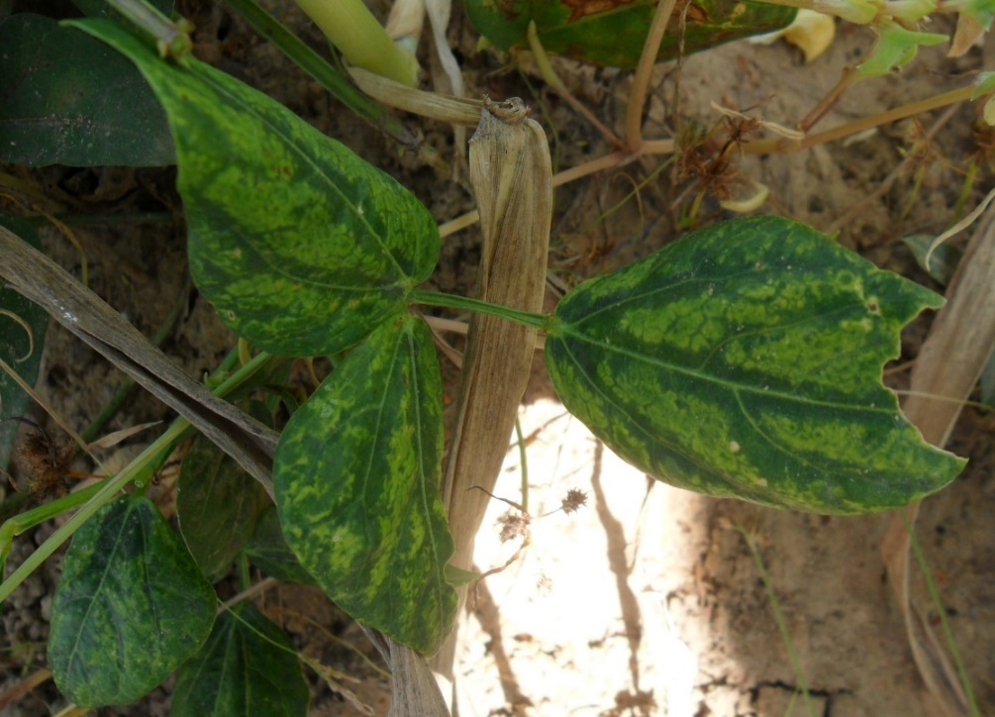
C. BE170
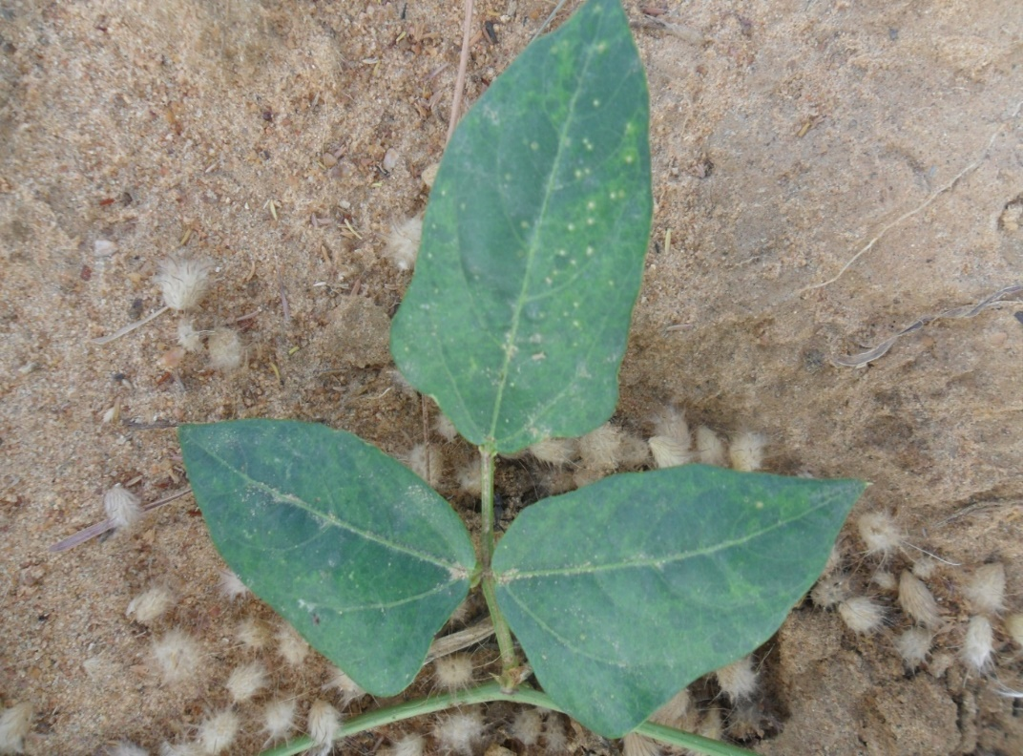
E. BE179

Symptoms observed on cowpea plants naturally infected by Southern cowpea mosaic virus (SCPMV).
Mild mosaic on sample BE250 (A) and sample BE28-14 (B)
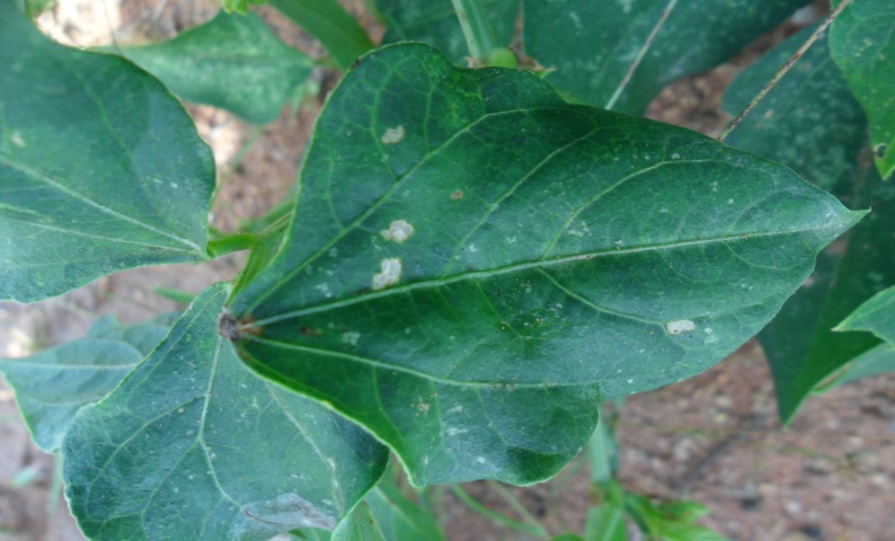
B. BE28-14
A. BE250

Symptoms observed on plants naturally infected by Blackeye cowpea mosaic virus – a strain of Bean common mosaic virus (BlCMV-BCMV)
A. Vein yellow mosaic (BE3); B. Mosaic (BE230).
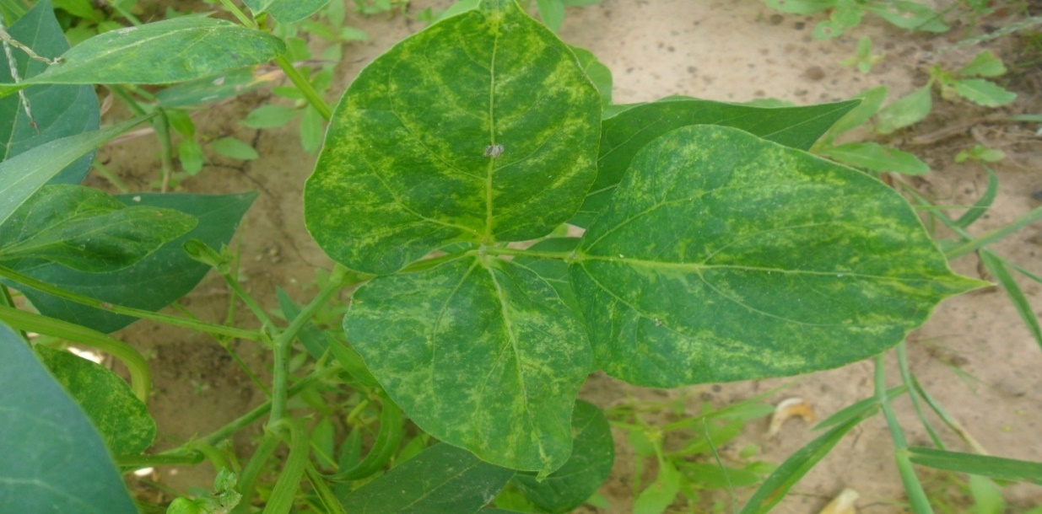
C. BE230
A. BE3

Symptoms observed on plants naturally infected by Cowpea tombusvirid 1
A. Leaf distorsion (BE81).
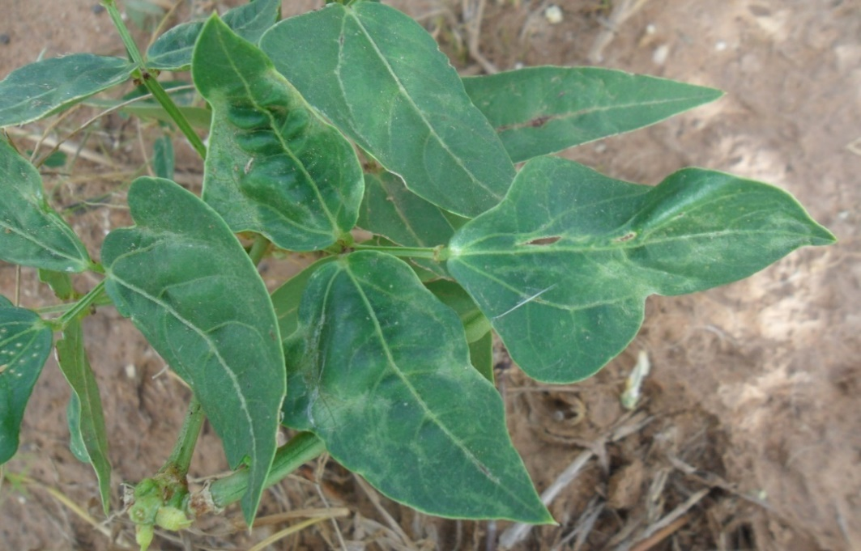
BE81

