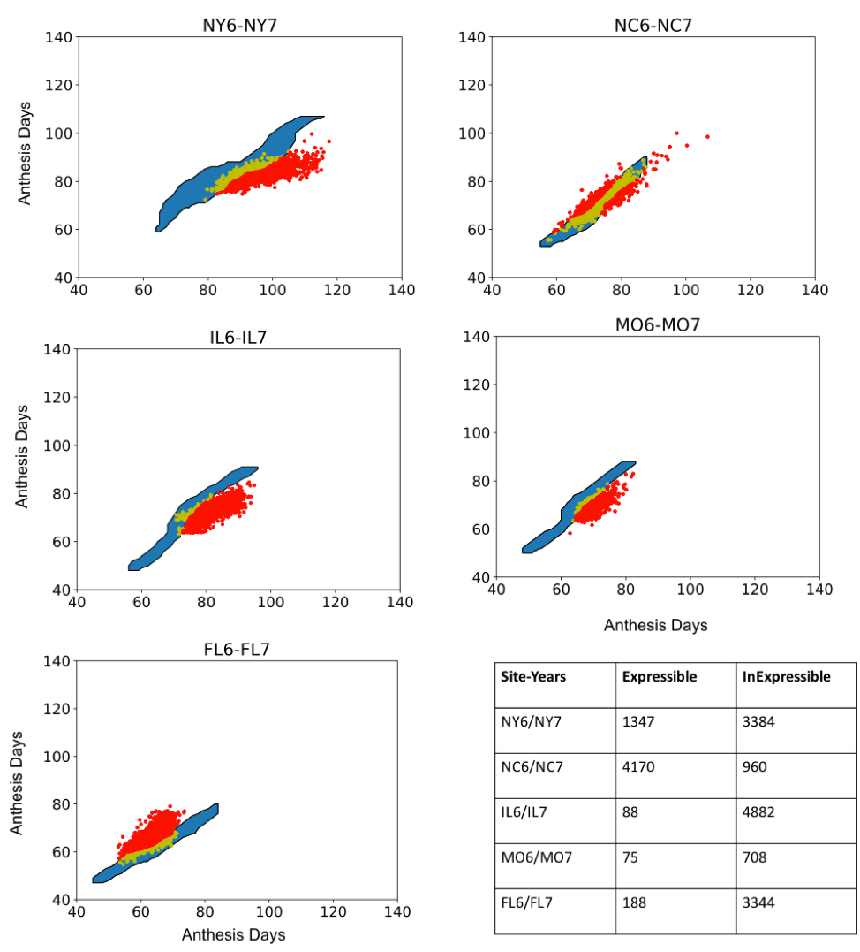

Fig A. Phenotype space plots for simulated and observed anthesis dates for five site-year pairs. Blue regions outline simulated anthesis date pairs using six parameter scan Sobol database estimates. The data symbols depict expressible (yellow) and inexpressible (red) observed anthesis dates.

Table A. Ranges used for estimation of six parameters.
Parameter | Definition | Unit | Max | Min | No. of unique values
P1 | Thermal time from seedling emergence to end of juvenile phase | GDD (ºC) | 150 | 320 | 15001
P2O | Critical Short day length below which daylength does not affect development rate | h | 11 | 13.5 | 4001
P2 | Extent to which development (expressed as days) is delayed for each hour increase in photoperiod above the longest photoperiod at which development proceeds at a maximum rate (i.e, P2O) | rate | 0 | 1.2 | 2001
PHINT | Phyllochron interval (Interval between successive leaf tip appearances) | GDD (ºC) | 38 | 60 | 4501
Tbase | Base temperature (Tbase) for development | (ºC) | 6 | 12 | 4001
Topt | Optimal temperature for development | (ºC) | 26 | 36 | 6001

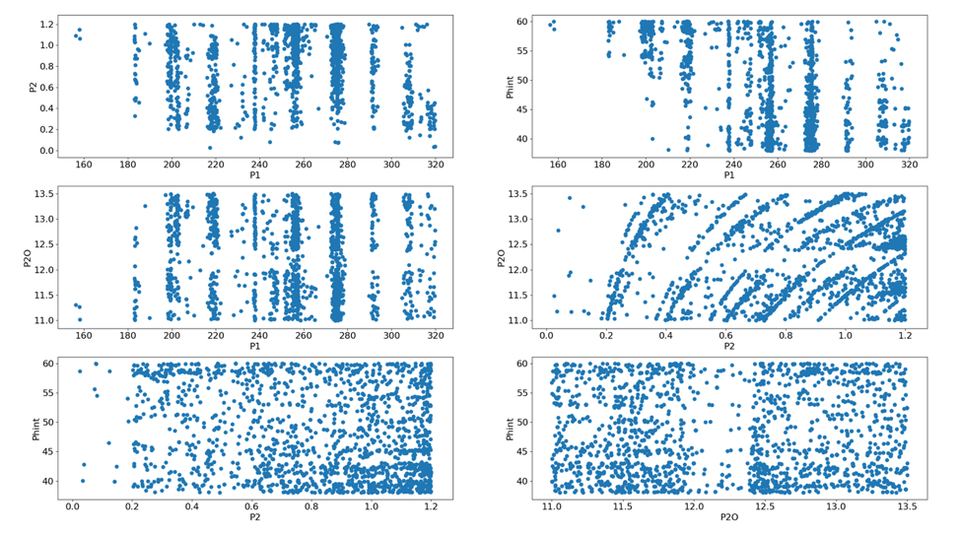

Fig B. Pairwise scatter plot for the parameter estimate resulting from six parameter runs.

