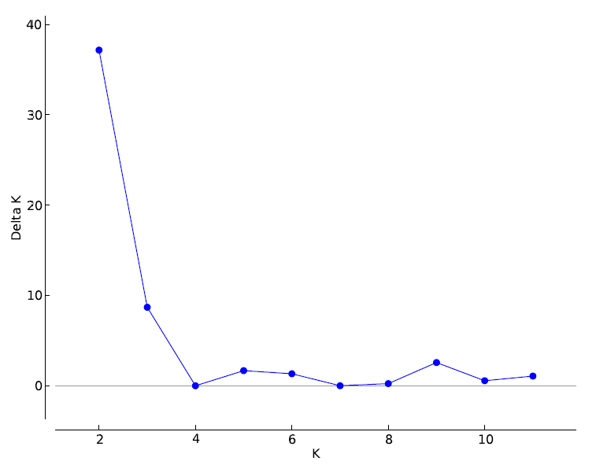

S1 Fig. Plot of the DeltaK statistics (Evanno et al., 2005) for the total sample.

