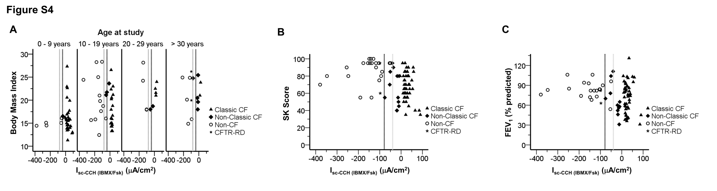
Figure S4: Correlations between CF clinical features and CCH-induced short circuit currents following IBMX/Fsk application (I_{sc-CCH (IBMX/Fsk)}). Scatter-plot summarizing the distribution of I_{sc-CCH (IBMX/Fsk)} against (A) Body Mass Index; (A) Body Mass Index distributed by groups of ages; (C) Shwachman–Kulczycki clinical scores; and (D) forced expiratory volume in 1 second (FEV₁) expressed as a percentage of predicted normal values for sex, age, and height (% predicted).Vertical dashed black line represents subtraction of one standard deviation (STD) of the mean value calculated for CCH induced-ΔI_{sc} following IBMX/CCH application (ΔI_{sc} = -78.77 µA/cm²) in non-CF controls. Vertical dashed grey line represents addition of one STD of the mean value calculated for CCH stimulated-ΔI_{sc} following IBMX/CCH application (ΔI_{sc} = -39.55 µA/cm²) in reference sub-group of Non-Classic CF patients. Classic CF (filled triangles, n = 55); Non-Classic CF (filled diamonds, n = 12); CFTR-RD (star, n= 2) and Non-CF (open circles, n = 26) individuals.

